SUBCOURSE EDITION
OD0476 6

PRINCIPLES OF STARTING AND CHARGING
SYSTEMS - M1 TANK


M1 ABRAMS TANK SYSTEMS MECHANIC

MOS/SKILL LEVEL: 63E30

PRINCIPLES OF STARTING AND CHARGING
SYSTEMS - M1 TANK

SUBCOURSE NO. OD0476
Edition 6

United States Army Combined Arms Support Command
Fort Lee, VA 23801-1809

7 Credit Hours

GENERAL

The purpose of this subcourse is to introduce you to the principles of starting and charging systems and specifically, the starting and charging system utilized within the M1 tank.

Seven credit hours are allowed for this subcourse. It consists of three lessons of two tasks each and an examination, outlined as follows:

Lesson 1: BASIC PRINCIPLES OF STARTING AND CHARGING SYSTEMS

TASK 1: Describe basic starting system principles.

TASK 2: Describe basic charging system principles.

Lesson 2: COMPONENTS OF THE M1 TANK STARTING AND CHARGING SYSTEMS

TASK 1: Describe the components of the M1 tank starting system and identify their internal hull locations.

TASK 2: Describe components of the M1 tank charging system and identify their locations within the M1 tank.

i
PRINCIPLES M1 STARTING & CHARGE SYS - OD0476

Lesson 3: OPERATION OF THE M1 TANK STARTING AND CHARGING SYSTEMS

TASK 1: Describe the operation of the M1 tank starting system.

TASK 2: Describe the operation of the M1 tank charging system.

ii
PRINCIPLES M1 STARTING & CHARGE SYS - OD0476

TABLE OF CONTENTS

Section Page

TITLE i

TABLE OF CONTENTS iii

Lesson 1: BASIC PRINCIPLES OF STARTING AND
CHARGING SYSTEMS 1

Task 1: Describe basic starting system
principles 1

Task 2: Describe basic charging system
principles 11

Practical Exercise 1 17

Answers to Practical Exercise 1 18

Lesson 2: COMPONENTS OF THE M1 TANK STARTING
AND CHARGING SYSTEMS 19

Task 1: Describe the components of the M1
tank starting system and identify their
internal hull locations 19

Task 2: Describe the components of the M1
tank charging system and identify their
locations within the M1 tank 31

Practical Exercise 2 33

Answers to Practical Exercise 2 34

iii
PRINCIPLES M1 STARTING & CHARGE SYS - OD0476

Lesson 3: OPERATION OF THE M1 TANK STARTING
AND CHARGING SYSTEMS 35

Task 1: Describe the operation of the
M1 tank starting system 35

Task 2: Describe the operation of the
M1 tank charging system 47

Practical Exercise 3 51

Answers to Practical Exercise 3 53

REFERENCES 64

iv
PRINCIPLES M1 STARTING & CHARGE SYS - OD0476 - LESSON 1/TASK 1

LESSON 1

BASIC PRINCIPLES OF STARTING
AND CHARGING SYSTEMS

TASK 1. Describe basic starting system principles.

CONDITIONS

Within a self-study environment and given the subcourse text, without assistance.

STANDARDS

Within one hour

REFERENCES

No supplementary references are needed for this task.

1. Introduction

It happens all the time. A young E-4 calls up the motor pool and says, "The tank won't start." The motor sergeant immediately comes back with, "Will it turn over?" And the operator's answer, "Yeh, if I drive it off a cliff, but what's that got to do with it not starting."

Right there is the basis for a beautiful argument, all because the tank operator does not understand the difference between a tank that won't start and one that won't turn over, or crank. The starting system might be in beautiful shape with batteries powerful enough to light up New York City. When the PUSH TO START button on the M1 is pressed, the turbine spins faster than it does during normal operation. But, the tank won't start.

Then, there's the situation in which the batteries and starter give a few weak gasps and then everything is as quiet as a calm day in the desert. In this case, we say that the engine "will not turn over" or "won't crank." We don't know whether it won't start because we can't crank it to find out, due to possible charging system failure.

1
PRINCIPLES M1 STARTING & CHARGE SYS - OD0476 - LESSON 1/TASK 1

This lesson is designed to acquaint you with the basic principles of starting systems. In subsequent lessons contained in this subcourse, you will also learn about basic charging system principles, the components which constitute the M1 tank's starting and charging systems, the location of these components, and their operation.

2. Principles of a Starting System

a. Batteries--General. The storage battery provides electrical energy through chemical reactions.

(1) Construction. A storage battery is used for starting, lighting, and ignition purposes; it consists of a number of cells, depending on the voltage. A battery of three cells (2 volts each) connected in a series is known as a 6 volt battery, and one of six cells connected in a series is known as a 12 volt battery. Typical battery construction is shown in figure 1 below.

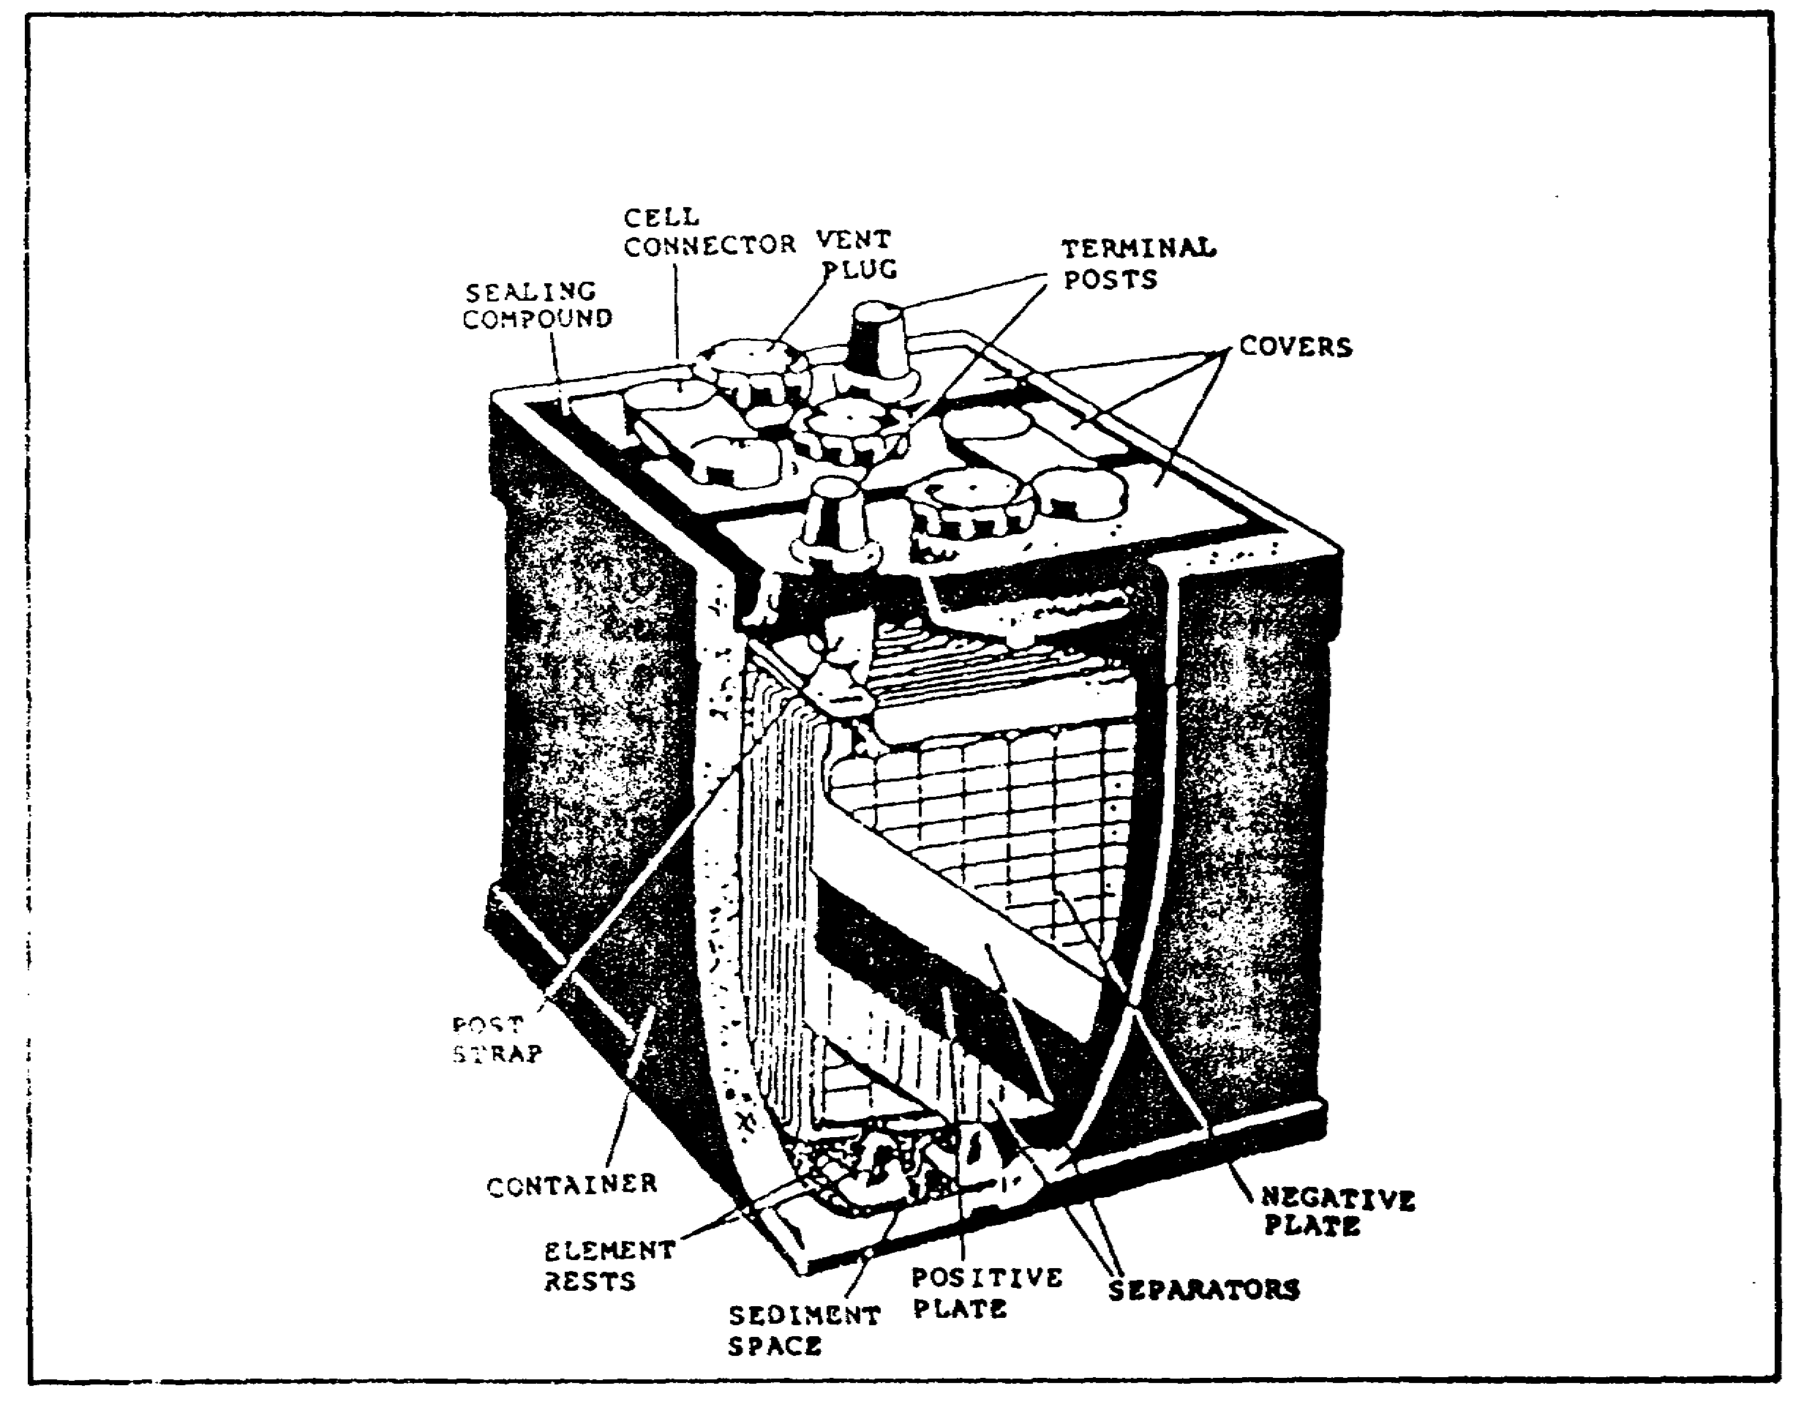
FIGURE 1. STORAGE BATTERY WITH CASE PARTIALLY CUT AWAY TO SHOW CELL CONSTRUCTION.

2
PRINCIPLES M1 STARTING & CHARGE SYS - OD0476 - LESSON 1/TASK 1

(a) Plates.

o Each cell consists of a hard rubber jar or compartment into which are placed two kinds of lead plates, known as POSITIVE and NEGATIVE. These plates are insulated from each other by suitable separators and are submerged in sulfuric acid solution.

o The backbone of both the positive and negative plates is a grid made of stiff lead alloy casting. The grid, usually composed of vertical and horizontal cross members, is carefully designed to give the plates mechanical strength and, at the same time, to provide adequate conductivity for the electric current created by the chemical action of the cell. The active material, composed chiefly of lead oxides, is applied to the grids in paste form, then allowed to dry and harden, like cement. Figure 2 shows part of a grid with a cross section showing the active material in place. The plates are then put through an electrochemical process that converts the hardened active material of the positive plates into brown lead peroxide, and that of the negative plates into gray, spongy, metallic lead. This process is known as FORMING the plates.
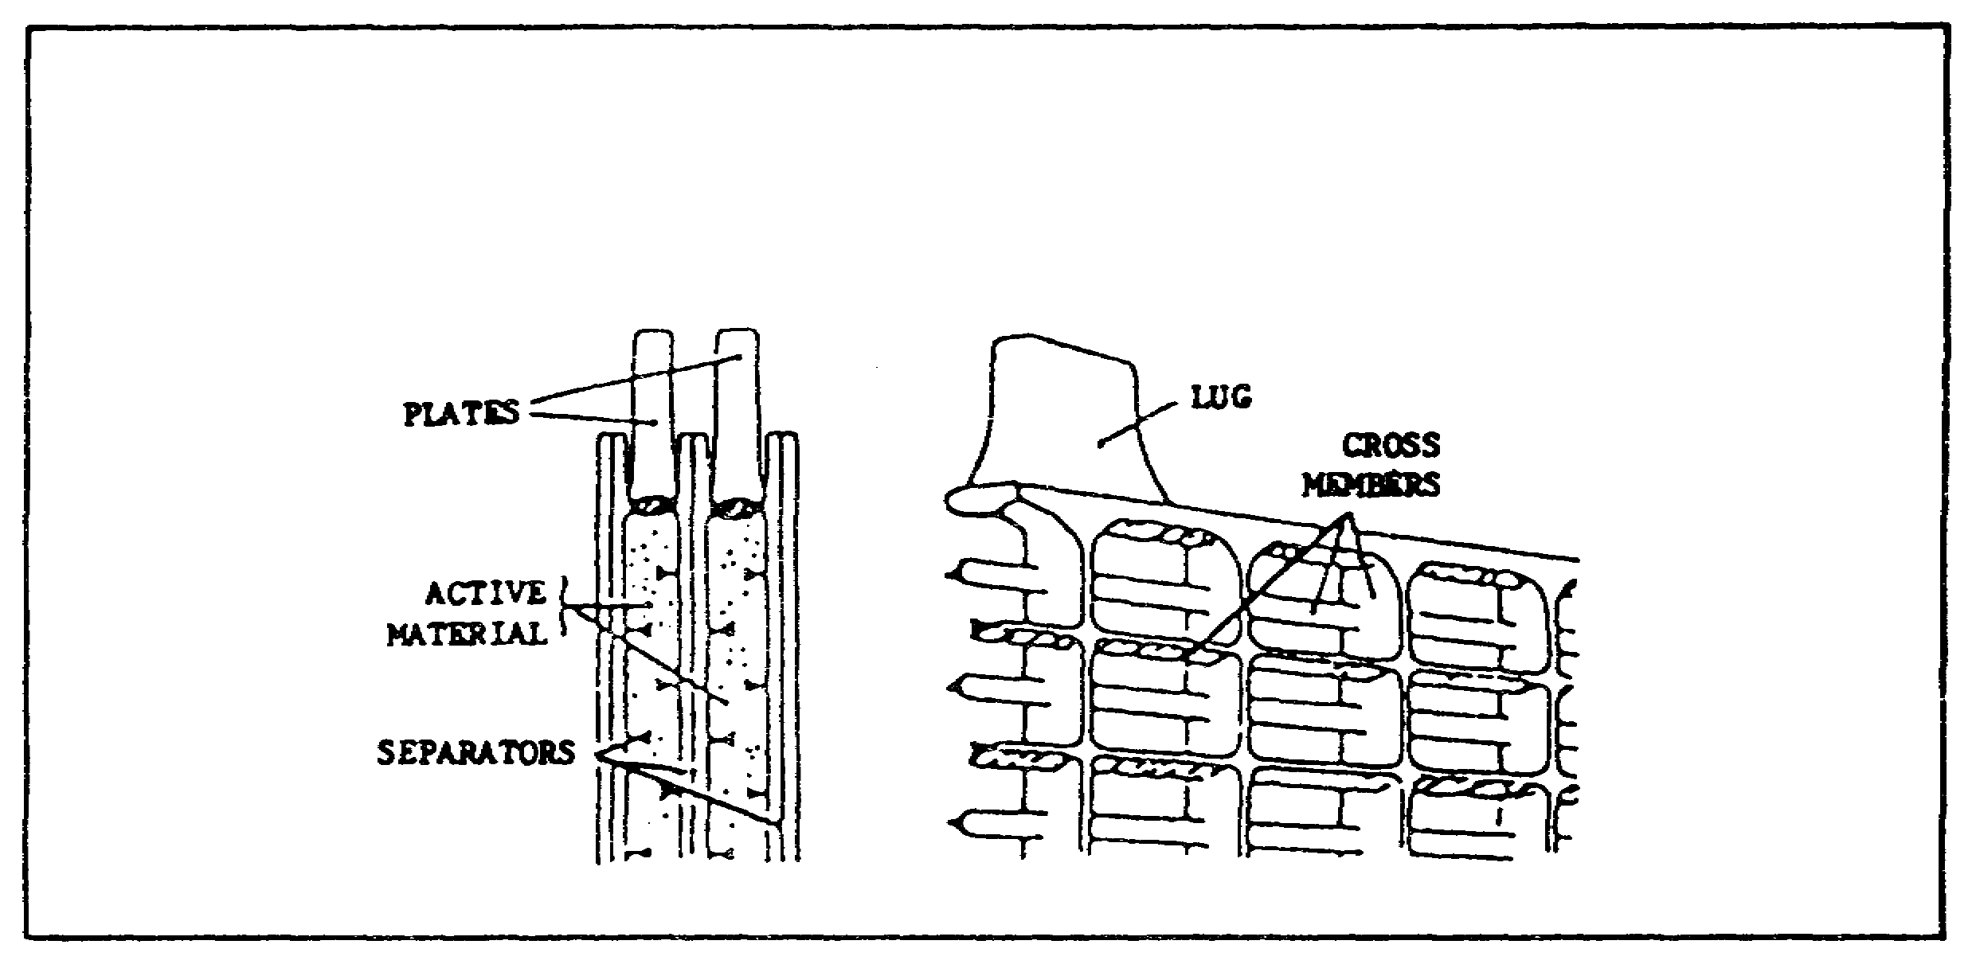
FIGURE 2. SECTION OF BATTERY PLATE GRID WITH
CROSS SECTION SHOWING ACTIVE
MATERIAL IN PLACE.

(b) Groups. Once the plates are formed, they are built into positive and negative groups. The plates of each group are permanently joined by melting a portion of the lug on each plate to form a solid weld with a connecting post strap. The heat for this LEAD BURNING process is produced by a gas flame or an electric arc.

3
PRINCIPLES M1 STARTING & CHARGE SYS - OD0476 - LESSON 1/TASK 1

(c) Elements. The assembly of a positive and negative group, together with the separators, is called an ELEMENT. Since storage battery plates are more or less of standard size, the number of plates in an element is, roughly, a measure of the battery capacity. The distance between the plates of an assembled element is about one eighth inch.

(d) Separators. To prevent the plates from touching and causing a short circuit, sheets of insulating material (wood, porous rubber, or spun glass), called SEPARATORS, are inserted between the plates. These separators are thin and porous so the electrolyte will flow easily between the plates.

(e) Electrolyte. An electrolyte is a liquid which readily conducts electricity and is decomposed when an electric current passes through it. The electrolyte in the lead-acid storage battery has a specific gravity of 1.280. It is composed of one part of chemically pure sulfuric acid and approximately two and three-fourths parts, by volume, of distilled water.

(f) Container. A battery container is a receptacle for the cells that make up the battery. It is made of hard rubber, or of a composition material resistant to acid and mechanical shock. One element, and enough electrolyte to cover the plates, is inserted into each cell compartment.

Stiff ridges, or ribs, molded in the bottom of the container form a support for the plates and a sediment recess for the flakes of active material that drop off the plates over the life of the battery.

(g) Cover. A hard rubber cell cover, provided with openings for the two terminals of the elements and a vent plug, is placed on each cell. The cells are sealed with pitchlike compound and connected in series by burning cell connectors on the terminals. The vent plug allows accumulated gas to escape and prevents the electrolyte from splashing outside the battery. Checking and filling the battery is done by unscrewing and removing the vent plug.

(2) Principle of Operation. When a cell is fully charged, the negative plate is spongy lead, the positive plate is lead peroxide, and the electrolyte contains a maximum proportion of sulfuric acid.

4
PRINCIPLES M1 STARTING & CHARGE SYS - OD0476 - LESSON 1/TASK 1

Both the negative and positive plates are very porous and are readily acted upon by the acid. A cell in this condition, connected to an external circuit, produces electrical energy through reaction of the chemicals.

(a) Charging. To charge the cell, an external source of direct current must be connected to the battery terminals. The chemical reaction is then reversed and returns the positive and negative plates and the electrolyte to their original condition. When all the sulfate on the plates has been returned to the electrolyte to form sulfuric acid, the cell is fully recharged and is ready to be used for the next discharge. Charging must be started before both plates have become entirely sulfated. If this is not done, the plate surfaces are no longer chemically different and will not respond to the charging current, since two dissimilar plates must be in the electrolyte to produce the action. See figure 3 for the chemical processes in the cell during discharge and charge.
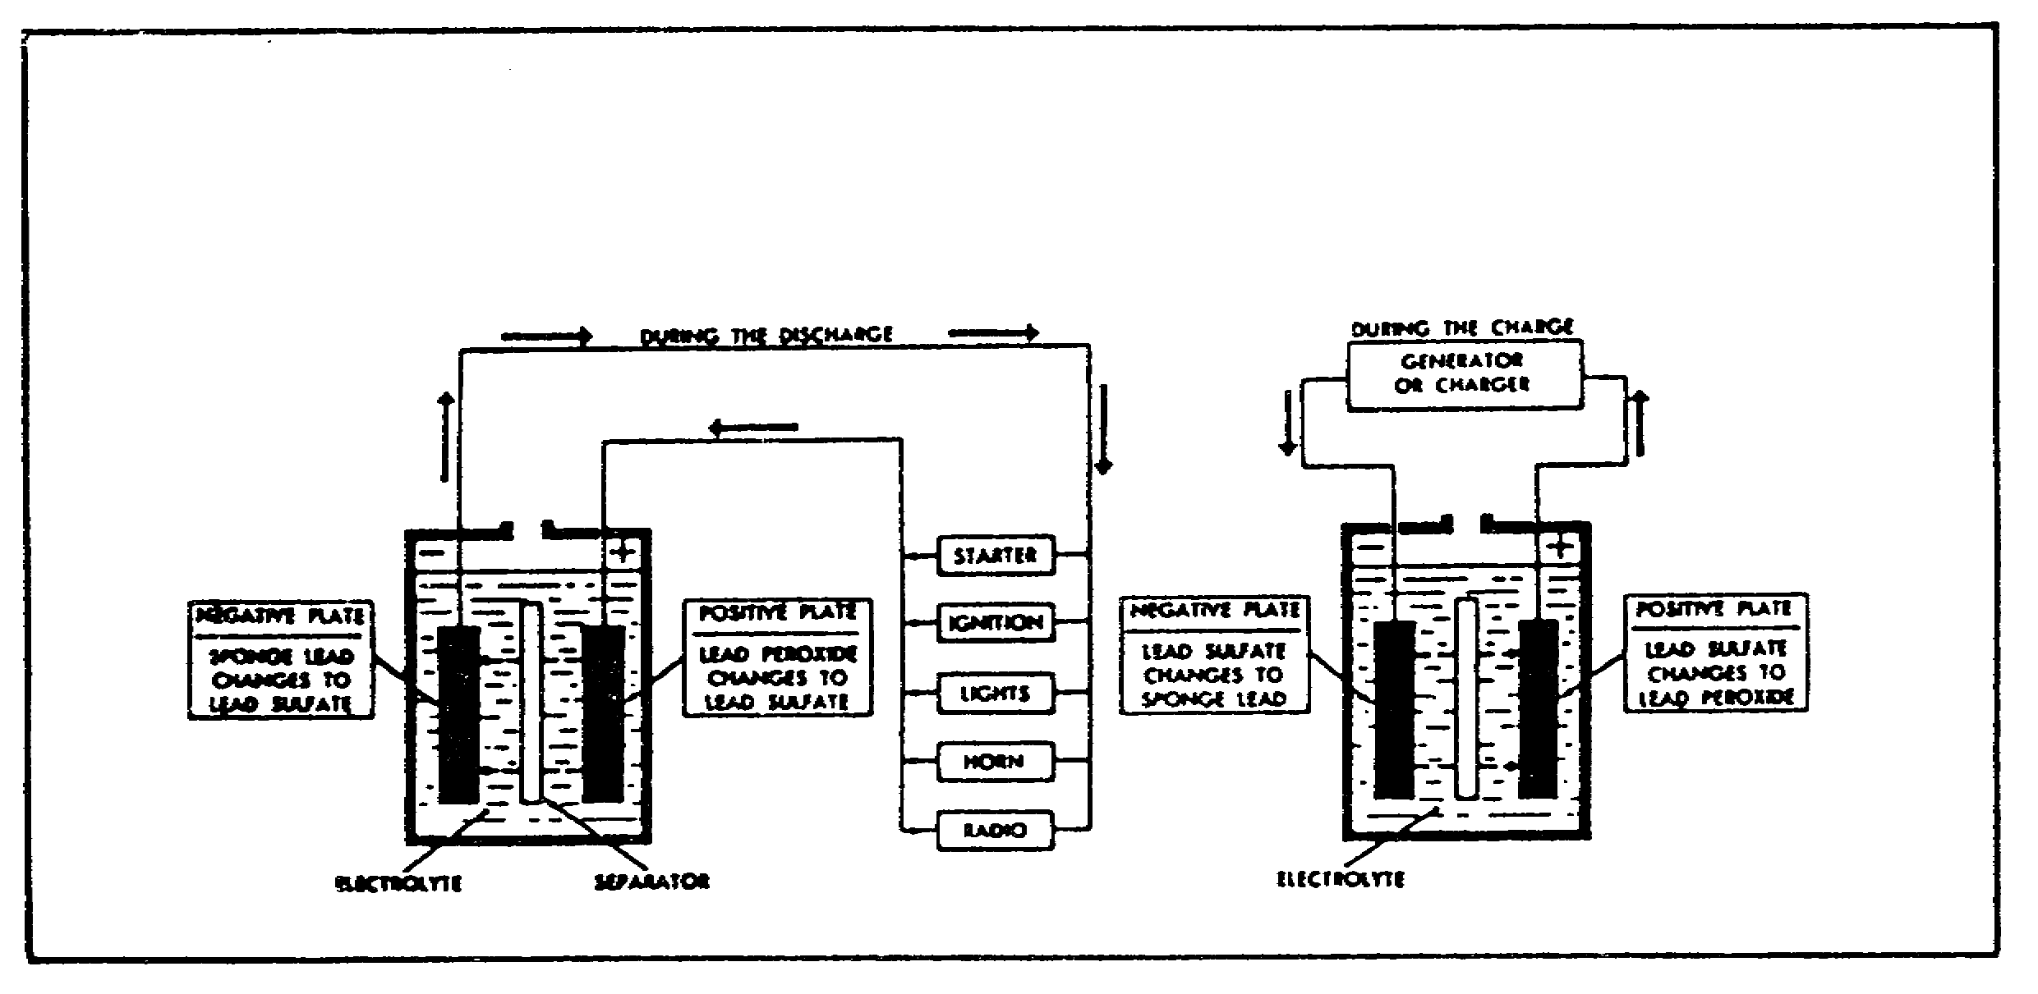
FIGURE 3. CHEMICAL ACTION IN A STORAGE BATTERY.

During discharge During the charge
sulfate ion of water is broken down
sulfuric acid unites by electrolysis.
with active materials Hydrogen combines with
on plates, leaving sulfate ion from plates
weaker acid solution. to form acid, which
Hydrogen of acid and makes electrolyte
oxygen of lead stronger. Oxygen
peroxide combine combines with lead of
to form water, positive plate to
diluting the solution. form lead peroxide.

5
PRINCIPLES M1 STARTING & CHARGE SYS - OD0476 - LESSON 1/TASK 1

(b) Discharge. If the terminals of the battery are connected to a closed circuit, the cell discharges to supply electric current (figure 3, on the previous page). The chemical process, that occurs during discharge, changes both the lead of the negative plate and the lead peroxide of the positive plate to lead sulfate and the sulfuric acid to water. Thus, the electrolyte becomes weaker during discharge, since the water increases and the sulfuric acid decreases. As the discharge progresses, the negative and the positive plates finally contain considerable lead sulfate. The discharge should always be stopped before the plates have entirely changed to lead sulfate.

b. Electric Starter. An electric starter is a low-voltage direct-current motor supplied with current from a battery and capable of developing high torque.

(1) Simple Direct-Current Motor. Fundamentally, an electric motor is constructed the same as a generator. If the brushes of the simple generator are connected to a battery and current is permitted to flow through the loop of wire (figure 4), the loop of wire will rotate in the direction indicated by the arrow. Briefly, this rotation is due to the repulsion between the field magnetism and the magnetic whirl set up around the loop of wire by the current.

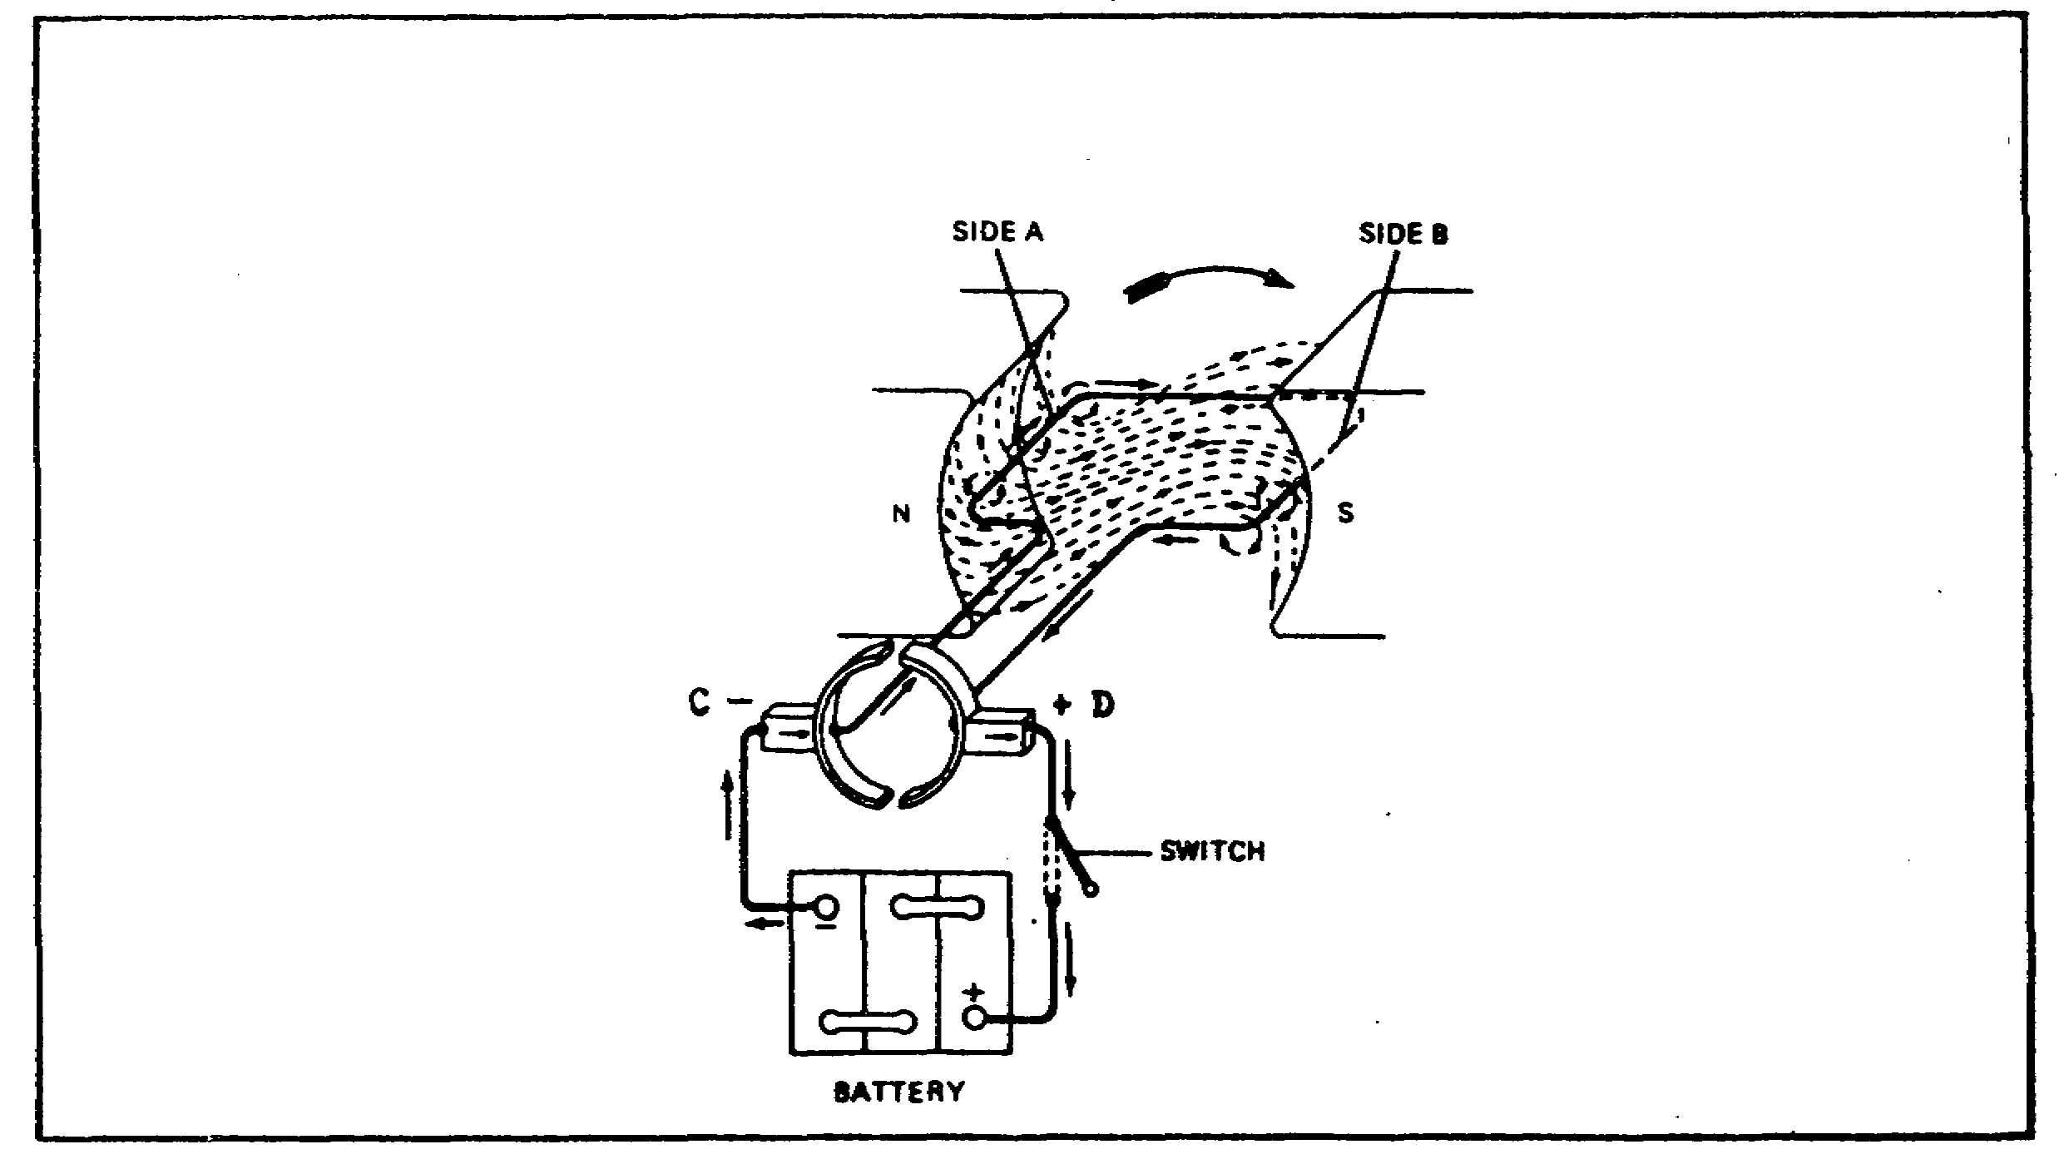
FIGURE 4. SIMPLE SINGLE-LOOP DIRECT-CURRENT MOTOR.

6
PRINCIPLES M1 STARTING & CHARGE SYS - OD0476 - LESSON 1/TASK 1

(a) Effects of a Magnetic Field. Replusion is caused by all the magnetic lines of force tending to flow around the conducting loop of wire in the same direction. This distorts and crowds the magnetic lines on one side of the conductor more than on the other, which results in a repulsion of the conductor (figure 5 (1)). In other words, the rubber-band characteristic of the lines of force, whereby they try to shorten to a minimum length, causes the lines to exert a push on the conductor. If the magnetic field is reversed, with the direction of current unchanged, the magnetic lines of force will crowd to the other side of the conductor, and it will be repelled in the opposite direction (figure 5 (2)). The same action would result if the current instead of the magnetism were reversed. Thus, in figure 4 on the previous page, owing to the current flowing in reverse directions in the two sides of the loop, and the consequent field distortion, one side, C, will be repulsed upward and the other, D, downward, causing the loop to rotate in a clockwise direction.

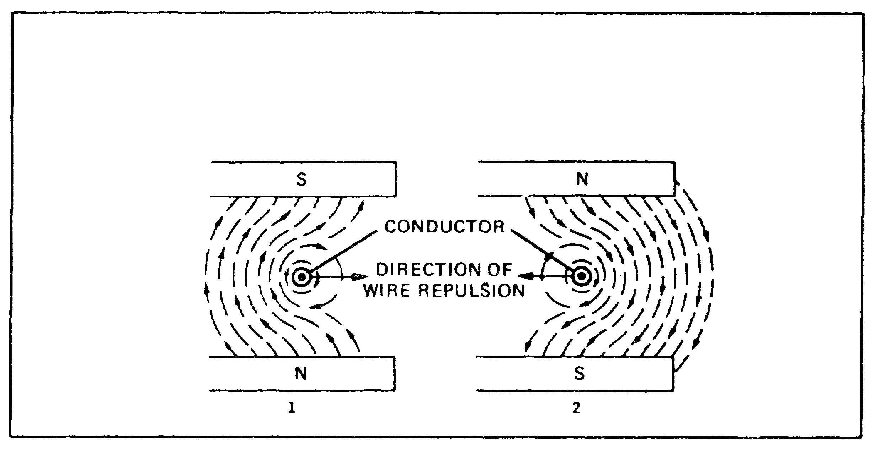
FIGURE 5. WIRE REPULSION IN MAGNETIC FIELD (CURRENT COMING OUT).

(b) Motor Operation. In practice, rather than a single loop of wire, the motor armature has many coils equally spaced around the entire circumference of an armature. Each coil carries current and consequently exerts a force to rotate the armature as it passes the pole pieces. The result is a comparatively high turning power (or torque) which, if applied through suitable gear reductions, is sufficient to crank the engine.

7
PRINCIPLES M1 STARTING & CHARGE SYS - OD0476 - LESSON 1/TASK 1

(2) Starter - Basic Description. Usually the starter will drive the engine through a pinion attached to the starter armature shaft, which is brought into mesh with teeth cut. or the rim of a flywheel, or into mesh with the mating half of a clutch. The drive must be equipped with an overrunning clutch or some other means of quick disengagement. Owing to limitations of size and capacity of the battery, a high-speed starter with a high gear reduction is used to obtain the necessary torque. The great speed reduction required is effected in the majority of cases by utilizing the flywheel as a driven gear. In some instances, the gear is bolted or shrunk on the flywheel, while in others the gear teeth are cut directly in the rim of the flywheel itself (figure 6).

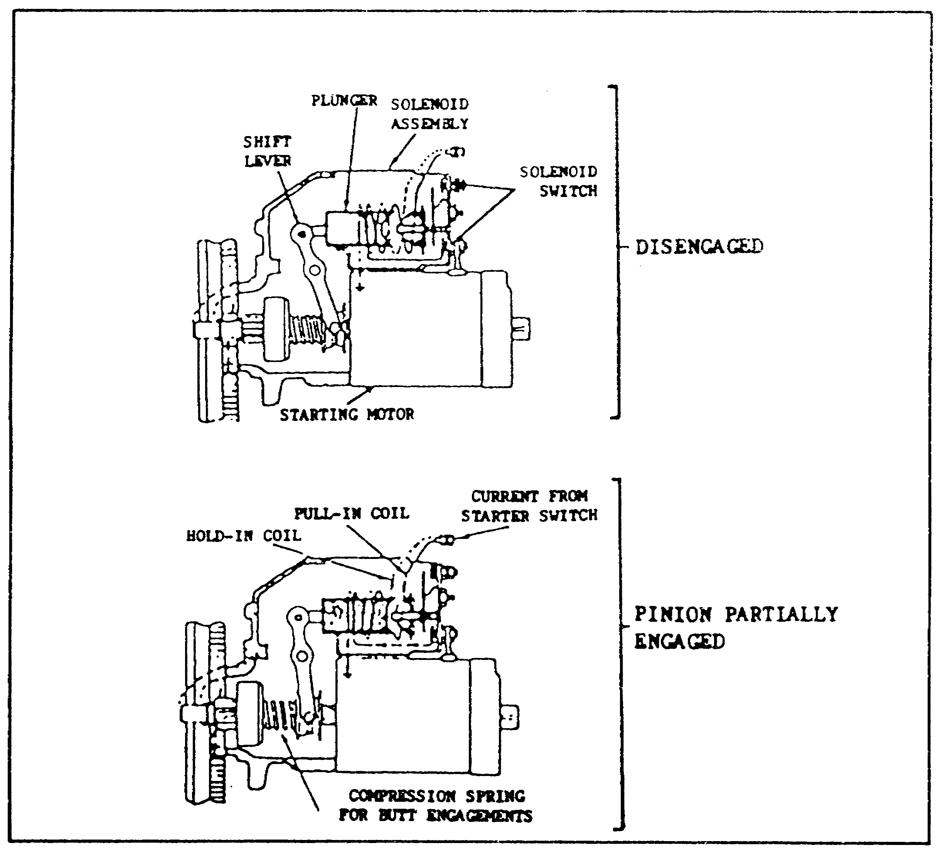
FIGURE 6. STARTER.

8
PRINCIPLES M1 STARTING & CHARGE SYS - OD0476 - LESSON 1/TASK 1

(3) Starter Operation. When the starter is not operating, the pinion is out of mesh and entirely away from the flywheel gear. When the starter switch is closed, and total available battery voltage is impressed on the starter, the armature immediately starts to rotate at high speed. The pinion, being weighted on one side and having internal screw threads, does not rotate immediately with the shaft but, because of its inertia, runs forward on the revolving threaded sleeve until it meets or engages with the flywheel gear. If the teeth of the pinion and the flywheel meet instead of engaging, the drive spring allows the pinion to revolve and forces it to mesh with the flywheel. When the pinion gear is fully engaged with the flywheel gear, the pinion is then driven by the starter through the compressed drive spring and cranks the engine. The drive spring acts as a cushion while the engine is being cranked against compression. It also breaks the severity of the shock on the teeth when the gears engage and when the engine kicks back due to ignition. When the engine fires and runs on its own power, the flywheel drives the pinion at a higher speed than does the starter, causing the pinion to turn in the opposite direction on the threaded sleeve and, therefore, automatically disengages from the flywheel. This prevents the engine from driving the starter. When the pinion is disengaged from the flywheel, it is held in this position by a latch until the starter switch is again closed.

(4) Starter Solenoid. A solenoid is a coil of wire wound in the form of a helix of one or more layers, which produces a magnetic field when a DC battery current is passed through it. The magnetic field, thus produced, flows in concentric circles around the wire.

(a) General Operation. A remote control switch is necessary to operate the solenoid. The ignition switch is connected into the control circuit so that the starter will not operate until the ignition is on. Inside the solenoid coil is a heavy plunger connected to the shift lever (see figure 7, on the following page). The two larger terminal posts on the shift unit are connected in series with the starter. The smaller terminal which leads to the solenoid is connected into the remote control circuit. When the remote control circuit is closed to supply current to the solenoid

9
PRINCIPLES M1 STARTING & CHARGE SYS - OD0476 - LESSON 1/TASK 1

coil, the solenoid exerts a pull on the shift plunger, which shifts the pinion, causing it to engage with the flywheel teeth. After the pinion shift lever has moved the distance required for engaging the pinion gear, the pointed end of the shift plunger presses against the end of a contact plunger and pushes a contact disk on the contact plunger across the switch contacts, operating the starter. An overrunning clutch is required with this system to prevent damage to the starter at the time the engine fires.

(b) Solenoid Relay. The contact points in the solenoid relay close at low voltage (engine cranking) and open after the engine starts (figure 7).

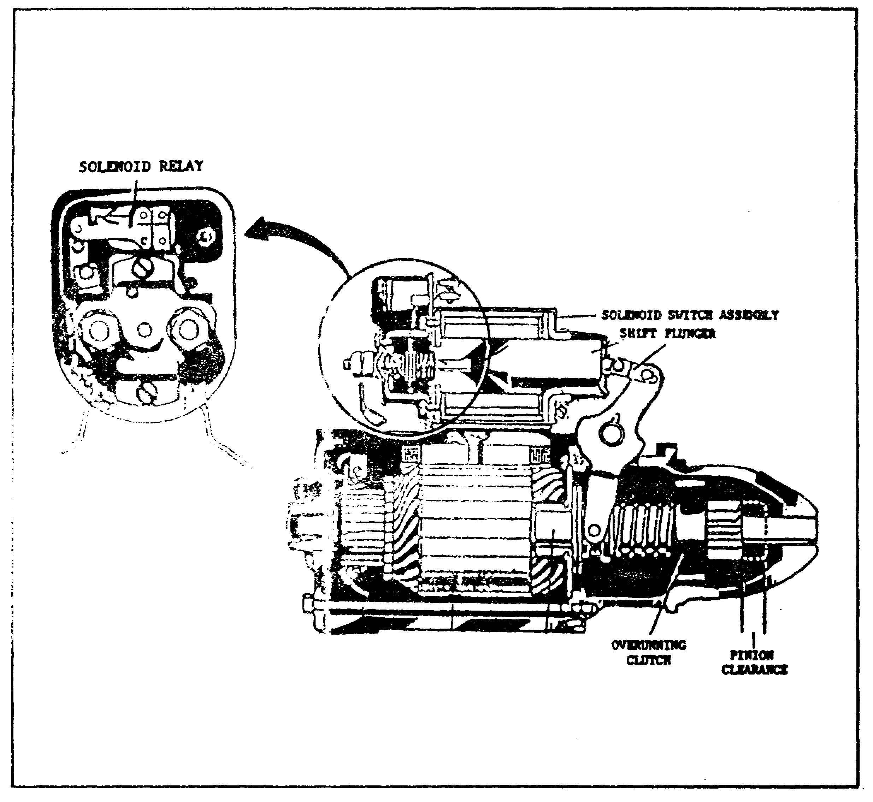
FIGURE 7. SOLENOID AND STARTER WITH OVERRUNNING CLUTCH.

10
PRINCIPLES M1 STARTING & CHARGE SYS - OD0476 - LESSON 1/TASK 1

LESSON 1

BASIC PRINCIPLES OF STARTING
AND CHARGING SYSTEMS

TASK 2. Describe basic charging system principles.

CONDITIONS

Within a self-study environment and given the subcourse text, without assistance.

STANDARDS

Within one hour

REFERENCES

No supplementary references are needed for this task.

1. Introduction

To better understand basic principles of a charging system, specifically the operation of the alternator, some review of current generation within a moving conductor (wire) through a magnetic field is necessary.

a. Current Generation.

(1) Moving a conductor through a magnetic field induces a voltage across the conductor. If the conductor is connected so that a circuit (a complete path for current) is created, then current will flow through the circuit.

(2) Voltage polarity is determined by the direction of conductor motion. When a conductor is "pushed" through a magnetic field, a voltage output of one polarity is produced. When the conductor is "pulled" through the field, a voltage of opposite polarity is produced. If the conductor is left to rest in the field, no output will be present. (See figure 8, on the following page).

11
PRINCIPLES M1 STARTING & CHARGE SYS - OD0476 - LESSON 1/TASK 1

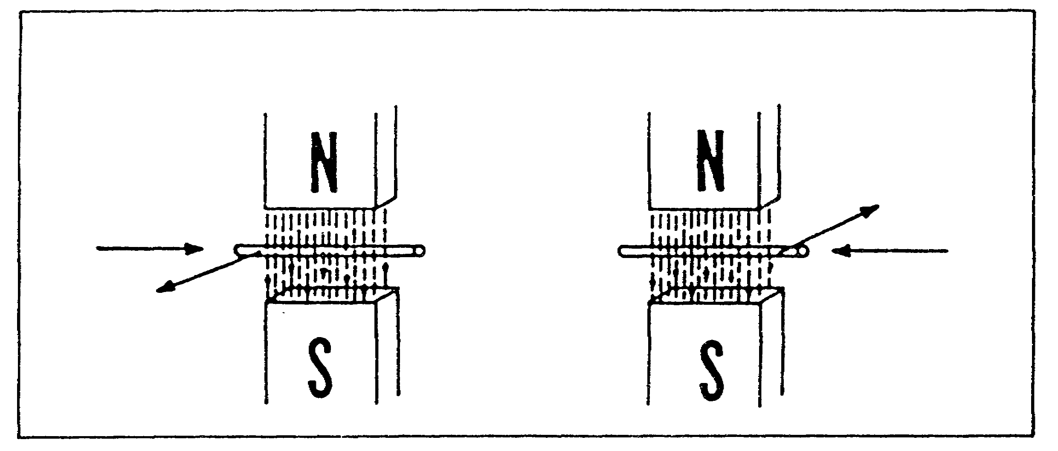
FIGURE 8. CURRENT GENERATION.

(3) AC voltage frequency is determined by the rate at which the conductor passes through the field.

(4) Voltage amplitude is determined by the strength of the magnetic flux field over the number of conductors passing through the flux field.

b. Basic Rotating Alternator. In practice, instead of pushing or pulling conductors through a magnetic field, the conductors of an alternator are rotated through the field. Rotating the conductors produces an output that is sinusoidal ac voltage. What follows is a brief explanation (with figure 9, on the following page) of how a basic rotating alternator produces a sinusoidal wave form.

(1) At point "A", the conductor travels parallel to the lines of flux, cutting none of them. Therefore, no voltage is produced.

(2) At point "B", the conductor travels at right angles to the lines of flux cutting them at the maximum rate and producing the maximum voltage.

(3) At point "C", the conductor, again, travels parallel to the flux lines. No voltage is produced.

12
PRINCIPLES M1 STARTING & CHARGE SYS - OD0476 - LESSON 1/TASK 1

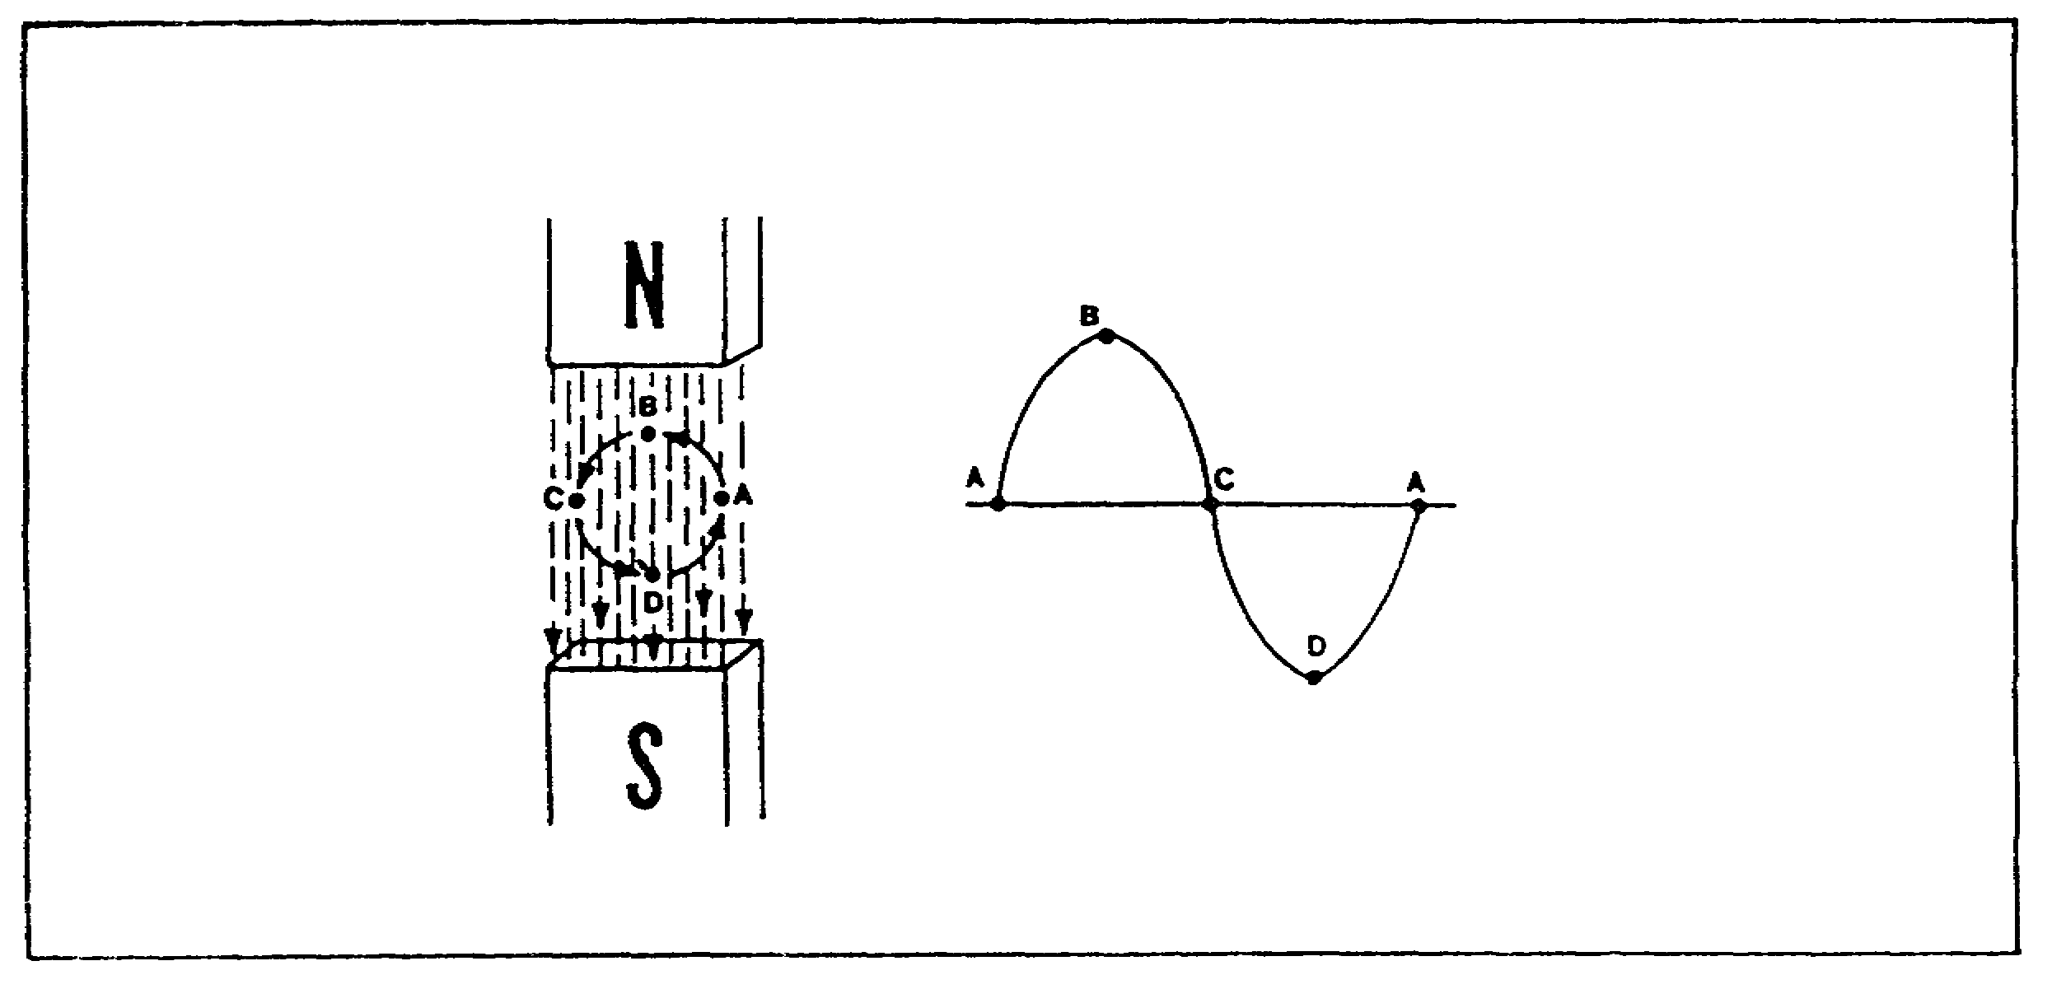
FIGURE 9. BASIC ROTATING ALTERNATOR.

(4) At point "D", the conductor again travels at right angles to the lines of flux, but in the opposite direction. As a result, voltage is maximum, but to the opposite polarity of point "B".

(5) At point "A", the conductor returns to its original starting point resulting in no voltage output. The rotation cycle is completed.

(6) The end result is that the output voltage from a rotating alternator is sinusoidal ac.

c. The Alternator in Practice. Now that the basic rotating alternator has been discussed, we can turn our attention to a practical alternator to understand its functions and make up.

(1) Functions. In its relation to the charging system, the alternator serves three functions: to change mechanical energy to electrical energy, to charge the batteries, and regulate voltage and current.

(2) Parts. An alternator consists of three major parts: an electromagnet, an armature, and an output device. The electromagnet is made up of a field winding and iron core. The field winding in conjunction with the iron core produces a magnetic field, similar to that shown above in the basic rotating alternator. However, with a field coil the strength of the field increases with an increase in field voltage, whereas with the basic

13
PRINCIPLES M1 STARTING & CHARGE SYS - OD0476 - LESSON 1/TASK 1

rotating alternator, the magnet is permanent and the strength of the field cannot be changed. The field winding is also called the stationary winding or STATOR. The armature (illustrated in figure 10 as a single wire loop) is the rotating winding (conductor) and is known as the ROTOR. The output device consists of slip rings and brushes.

(3) Output. When dc voltage is applied to the field winding, a magnetic field is generated between the poles of the field coil core. As the armature is rotated through the field, an ac sinusoidal voltage is produced and distributed to the slip rings. The slip rings allow the output voltage to be applied to a fixed load through carbon brushes (figure 10). The rings rotate against stationary brushes. This allows the voltage generated on a moving device to be distributed to a load or an immobile device.

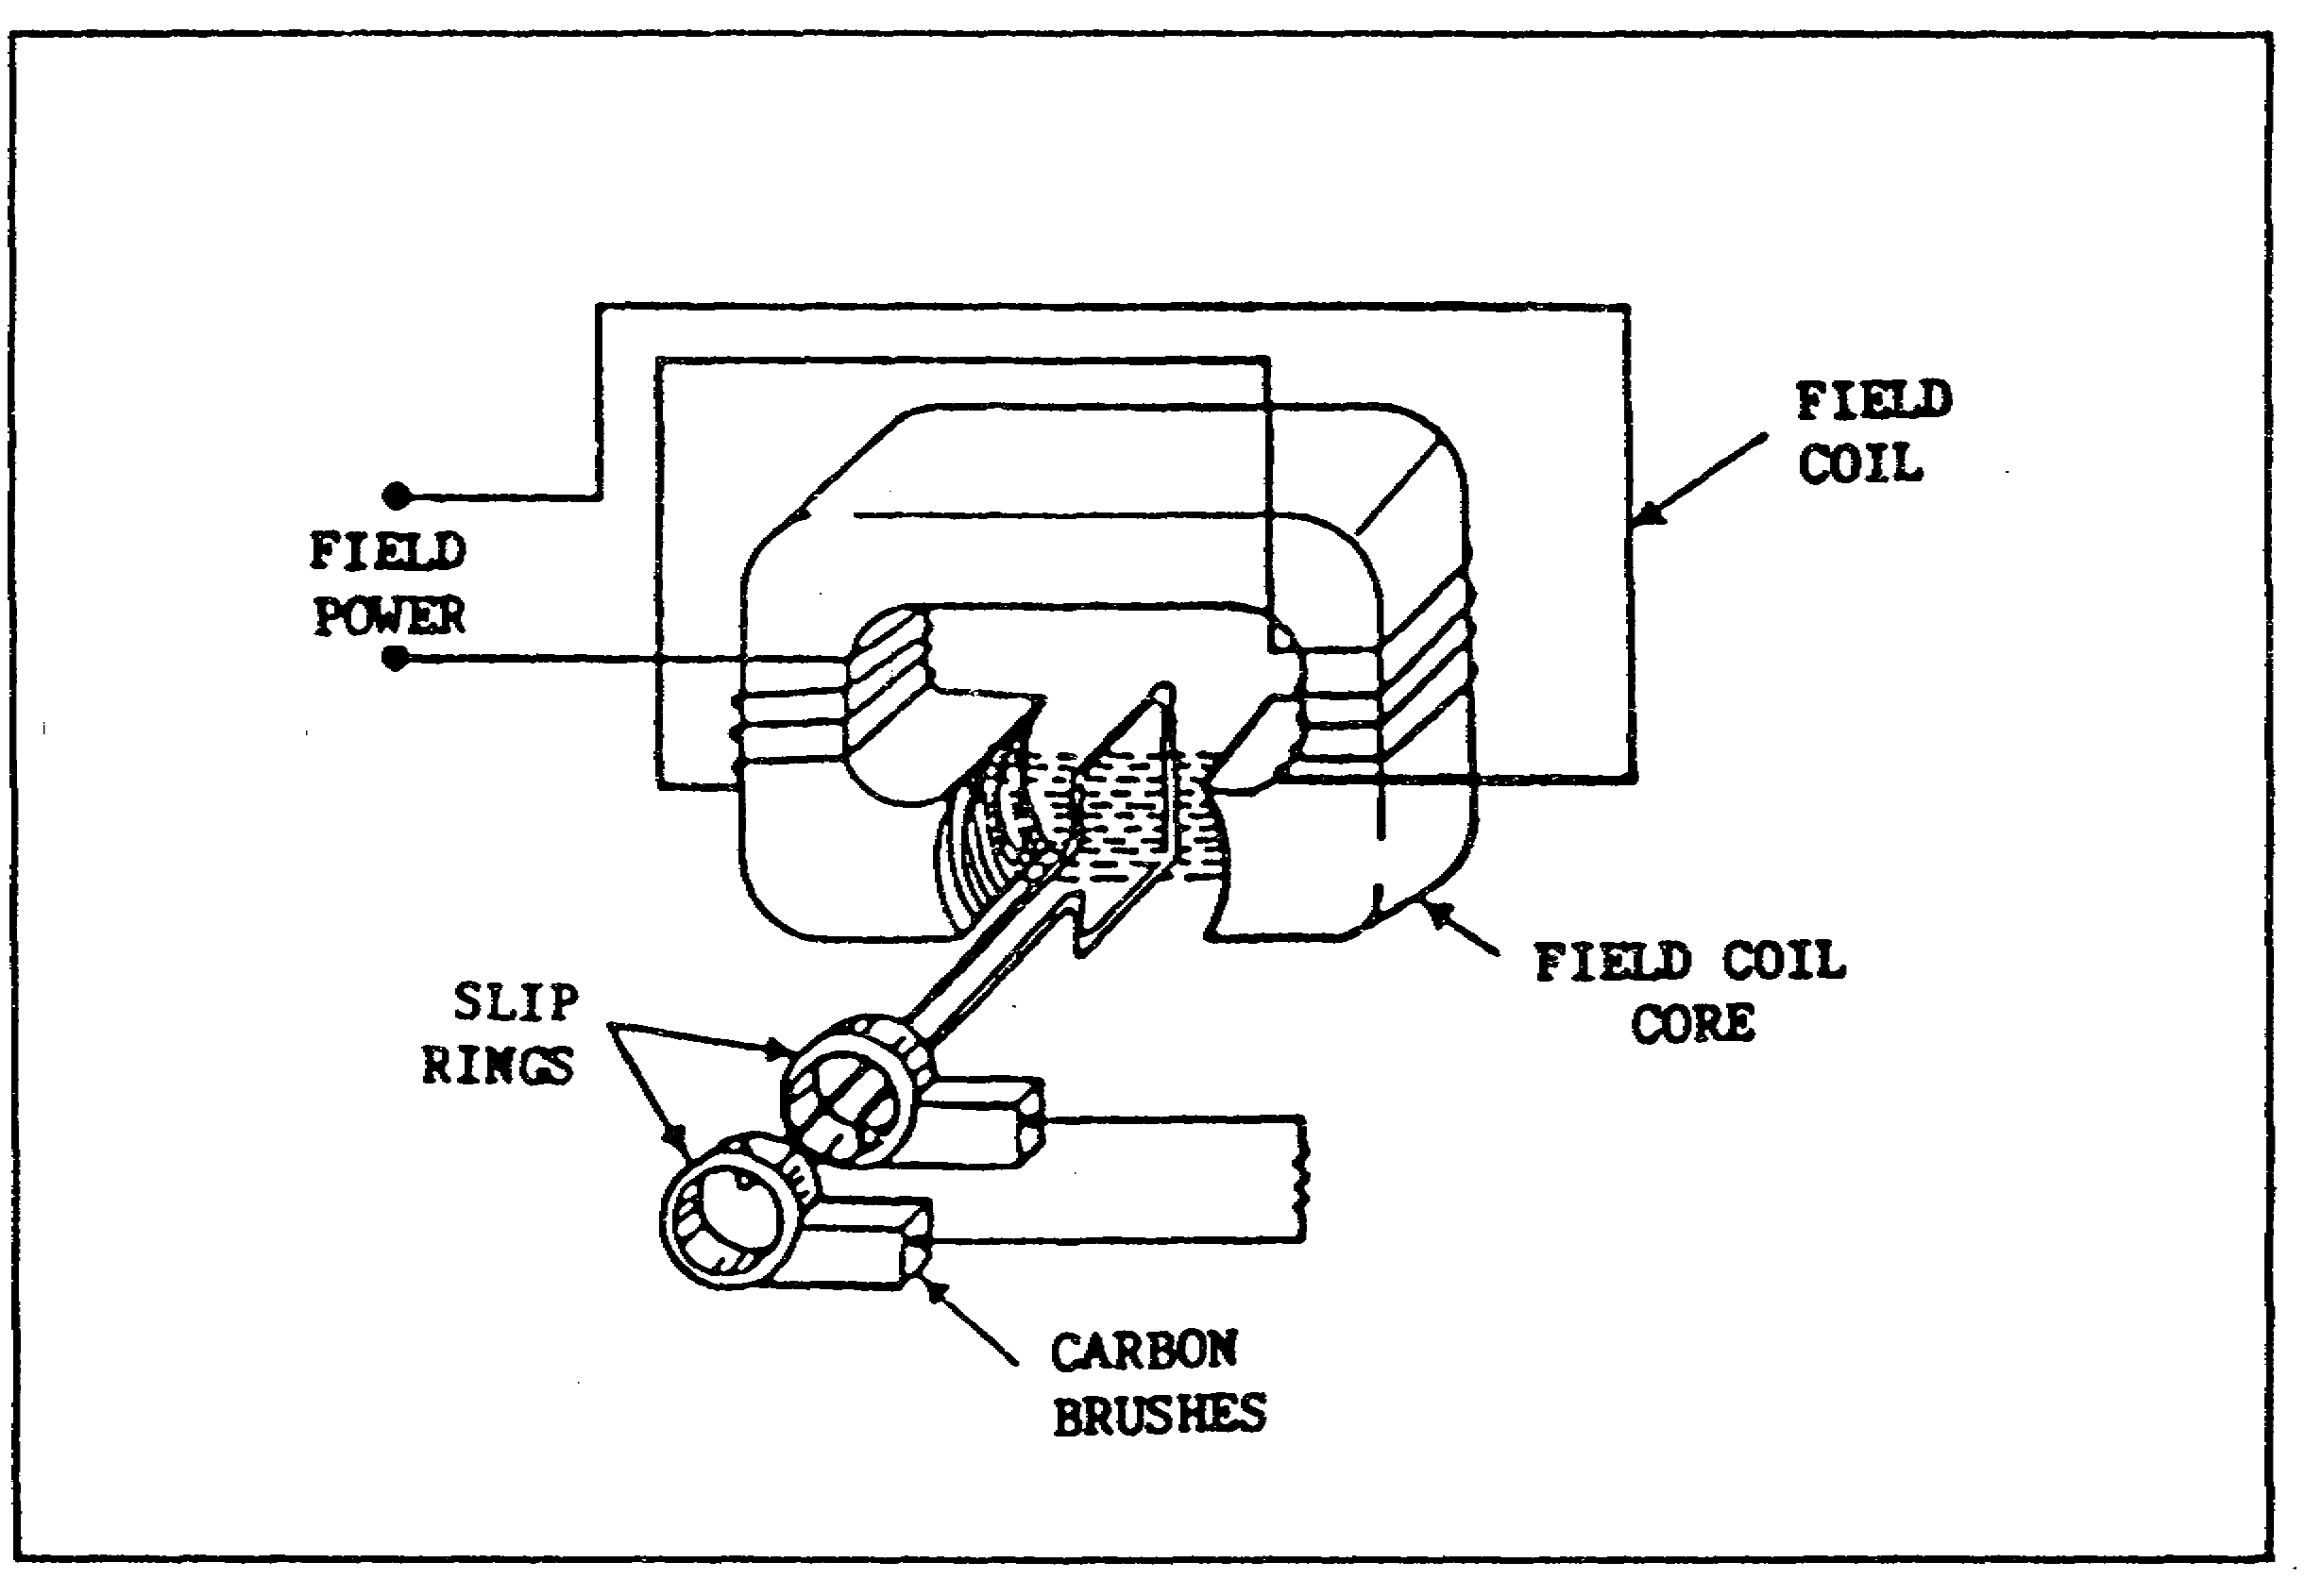
FIGURE 10. ALTERNATOR ACTION.

(4) Advantage of an Electro-Magnetic Field. There is one major advantage in employing an electromagnetic field rather than a permanent magnet. The output voltage of the armature can be increased or decreased by varying the field current without changing the speed of the armature. This is very important,

14
PRINCIPLES M1 STARTING & CHARGE SYS - OD0476 - LESSON 1/TASK 1

because in most cases, the alternator armature speed is fixed and cannot be varied.

NOTE

It should be recognized that the use of slip rings and brushes have disadvantages, which are as follows:

- They must be periodically inspected for wear and possible replacement.

- They create radio frequency interference (RFI).

- Excessive current causes an undesirable voltage drop across them, thereby decreasing voltage to the load.

d. Voltage Regulator. Although this part is commonly called a voltage regulator, regulating voltage is only one of its functions. Most voltage regulators are constructed with two or three coil-like units called RELAYS. Each operates at least one pair of electrical contacts. The first relay is the circuit breaker or cutout. This relay is identified by its heavy windings, larger or dual contacts, and by the fact that it is located at one end of a 3 unit regulator adjacent to the BAT (battery) terminal. It is also the only relay whose contact points are held OPEN by spring pressure rather than closed. The circuit breaker relay prevents battery current from flowing backward into the regulator and alternator when the engine is idling or the ignition is turned off.

The centermost relay is usually the current regulator (figure 11, on the following page). It too has a heavy winding, but less of it. The purpose of this unit is to limit the maximum flow of electricity.

As a unit, the voltage regulator assembly is a relay that consists of many turns of fine wire which act as a limiter, protecting the electrical system by keeping voltage below a set limit.

15
PRINCIPLES M1 STARTING & CHARGE SYS - OD0476 - LESSON 1/TASK 1

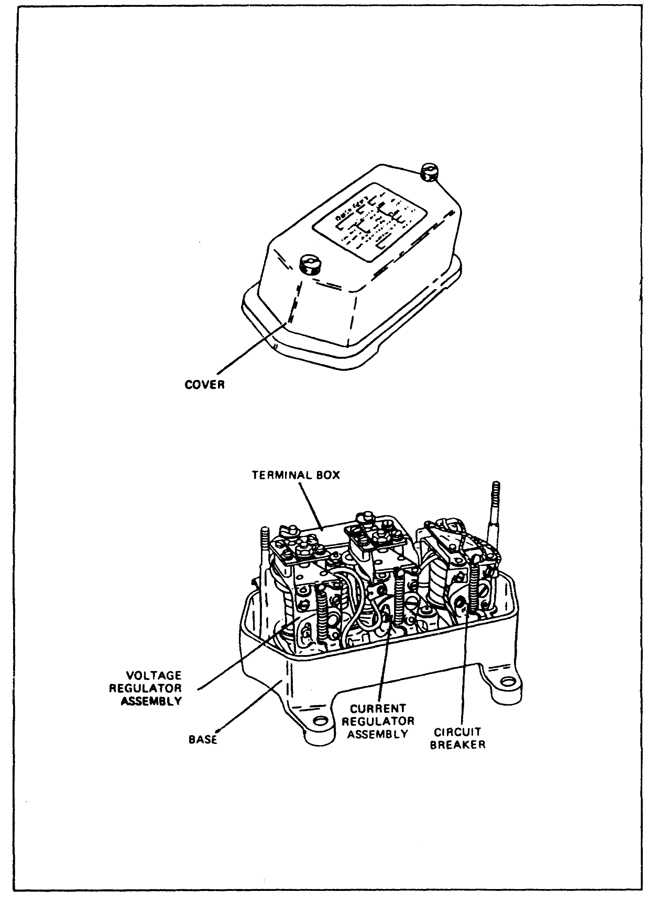
FIGURE 11. VOLTAGE REGULATOR.

16
PRINCIPLES M1 STARTING & CHARGE SYS - OD0476 - LESSON 1/PE 1

PRACTICAL EXERCISE 1

Instructions

On a plain sheet of paper, write down the answers to the following questions. When you have answered them, turn the page and check your answers.

1. How does a storage battery produce electrical energy?

2. The electrolyte in the lead-acid storage battery is composed of one part chemically pure sulfuric acid and approximately two and three-fourths parts of distilled water. What is the specific gravity of the electrolyte?

3. An electric starter is supplied with current from a battery and is capable of developing high torque. What level of voltage (high or low) and what type of current is this motor capable of producing?

4. Generally, when the starter is not operating, is the pinion meshed with the flywheel gear or disengaged from it?

5. What switch is connected into the control circuit so that a starter will not operate after the engine has started?

6. How is voltage polarity usually determined?

7. In practice, instead of pushing or pulling conductors through a magnetic field, how will the conductors of an alternator pass through a magnetic field?

8. An alternator consists of three major parts. Name these three major alternator components.

9. What is the primary function of a voltage regulator?

17
PRINCIPLES M1 STARTING & CHARGE SYS - OD0476 - LESSON 1/TASK 1

LESSON 1. PRACTICAL EXERCISE - ANSWERS

1. Chemical reactions.

2. 1.280.

3. Low voltage direct current (dc).

4. Disengaged from the flywheel gear.

5. Ignition switch.

6. By the direction of conductor motion.

7. Rotation.

8. a. An electromagnet.

b. Armature.

c. Output device.

9. Keeping voltage below a set limit.

18
PRINCIPLES M1 STARTING & CHARGE SYS - OD0476 - LESSON 2/TASK 1

LESSON 2

COMPONENTS OF THE M1 TANK
STARTING AND CHARGING SYSTEMS

TASK 1. Describe the components of the M1 tank starting system and identify their internal hull locations.

CONDITIONS

Within a self-study environment and given the subcourse text, without assistance.

STANDARDS

Within one hour

REFERENCES

No supplementary references are needed for this task.

1. Introduction

The components that embody the starting system are a part of the M1 tank engine electrical system. It is the engine electrical system that provides the circuitry to facilitate starting, ignition and electrical monitoring accessories.

Major components of the starting system include the batteries, electronic control unit (ECU), starter pilot relay, starter, accessory gearbox module, ignition exciter, ignition lead and igniter plug (figure 12, on the following page).

a. Batteries. The M1 tank uses a 24 volt direct current electrical system. When the engine is not running, power is supplied by six lead-acid batteries connected in a series/parallel configuration as shown in figure 13, on page 21. This series/parallel configuration provides 24 volt direct current (vdc) 300 amp-hour capacity to meet the critical cold starting and silent watch requirements of the M1.

19
PRINCIPLES M1 STARTING & CHARGE SYS - OD0476 - LESSON 2/TASK 1

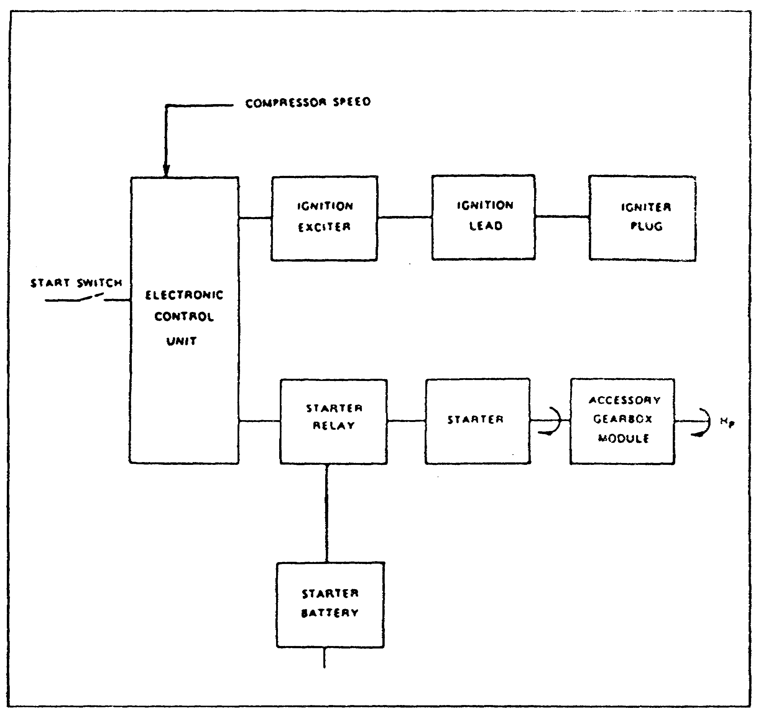
FIGURE 12. FUNCTIONAL BLOCK DIAGRAM, STARTER AND IGNITION SYSTEM.

The batteries are located in the sponson area to the right rear of the engine compartment. The water level and charge of the batteries are easily checked by viewing the battery water indicators located on each battery cell.

b. Electronic Control Unit (ECU). The electronic control unit is an electronic computer. It makes computations for controlling the engine's fuel management system, engine accessories (starter and ignition exciter), and driver's monitoring devices, such as the engine speed meter, engine overtemperature light and engine overspeed light. The electronic control unit is located in the center compartment on the left forward wall (figure 14, on page 22).

20
PRINCIPLES M1 STARTING & CHARGE SYS - OD0476 - LESSON 2/TASK 1

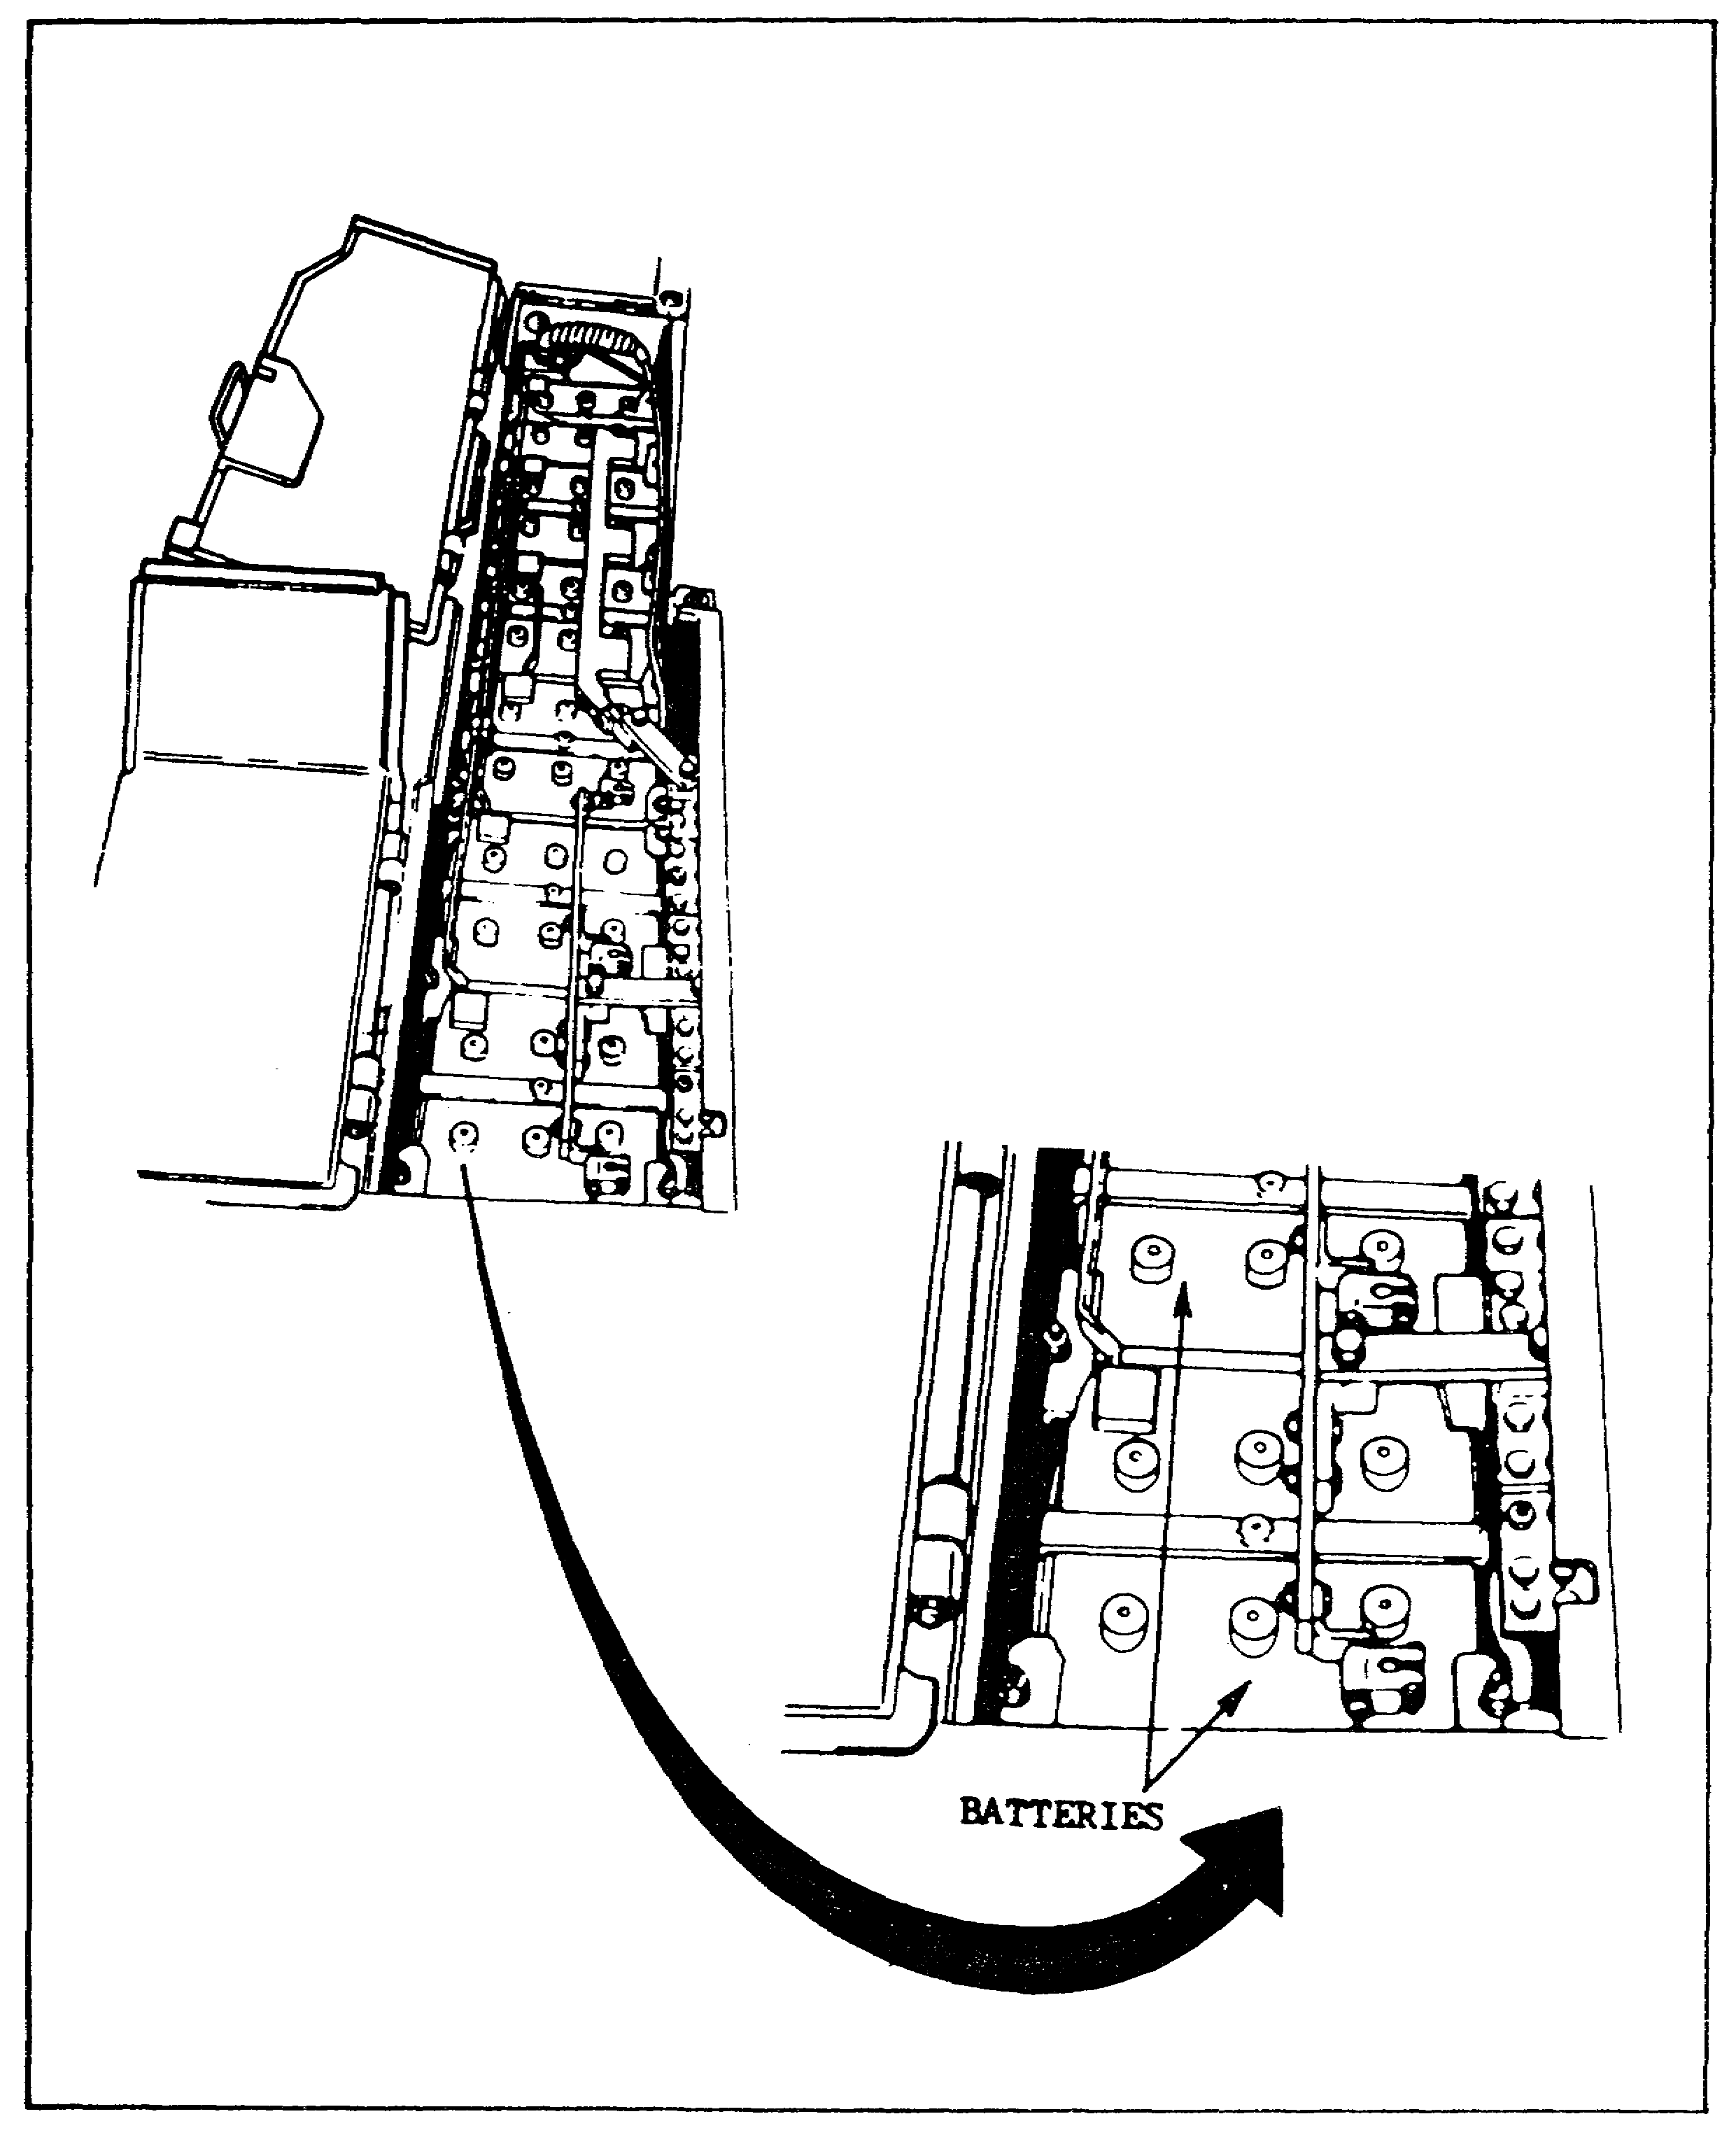
FIGURE 13. BATTERY COMPARTMENT AND BATTERY CONFIGURATION.

c. Ignition Exciter, Ignition Lead, and Igniter Plug. The ignition exciter provides both high voltage and an exceptionally hot spark. The ignition exciter is mounted on the forward face of the oil tank (figure 15, on the following page).

21
PRINCIPLES M1 STARTING & CHARGE SYS - OD0476 - LESSON 2/TASK 1

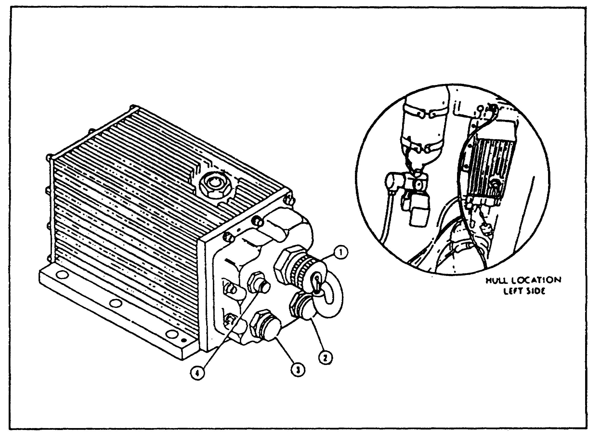
FIGURE 14. ELECTRONIC CONTROL UNIT.

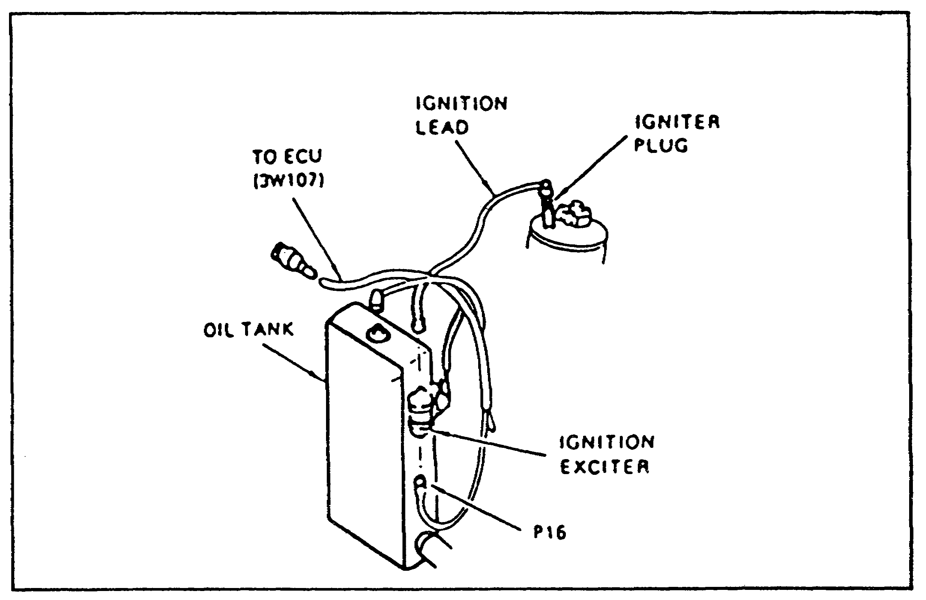
FIGURE 15. IGNITION EXCITER, IGNITION LEAD, AND IGNITER PLUG.

22
PRINCIPLES M1 STARTING & CHARGE SYS - OD0476 - LESSON 2/TASK 1

The ignition lead and igniter plug are located at the front center section of the engine (figure 16).

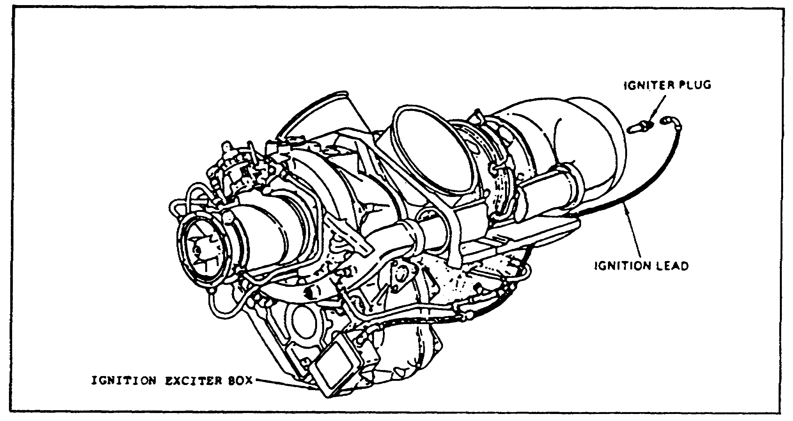
FIGURE 16. IGNITION LEAD AND IGNITER PLUG.

d. Starter Pilot Relay. The starter pilot relay (figure 17) is mounted on the forward face of the oil tank. Its purpose is to provide a signal to complete the circuit to the starter solenoid. After completing the circuit, the relay deenergizes automatically when the engine speed reaches approximately 55 percent rpm.

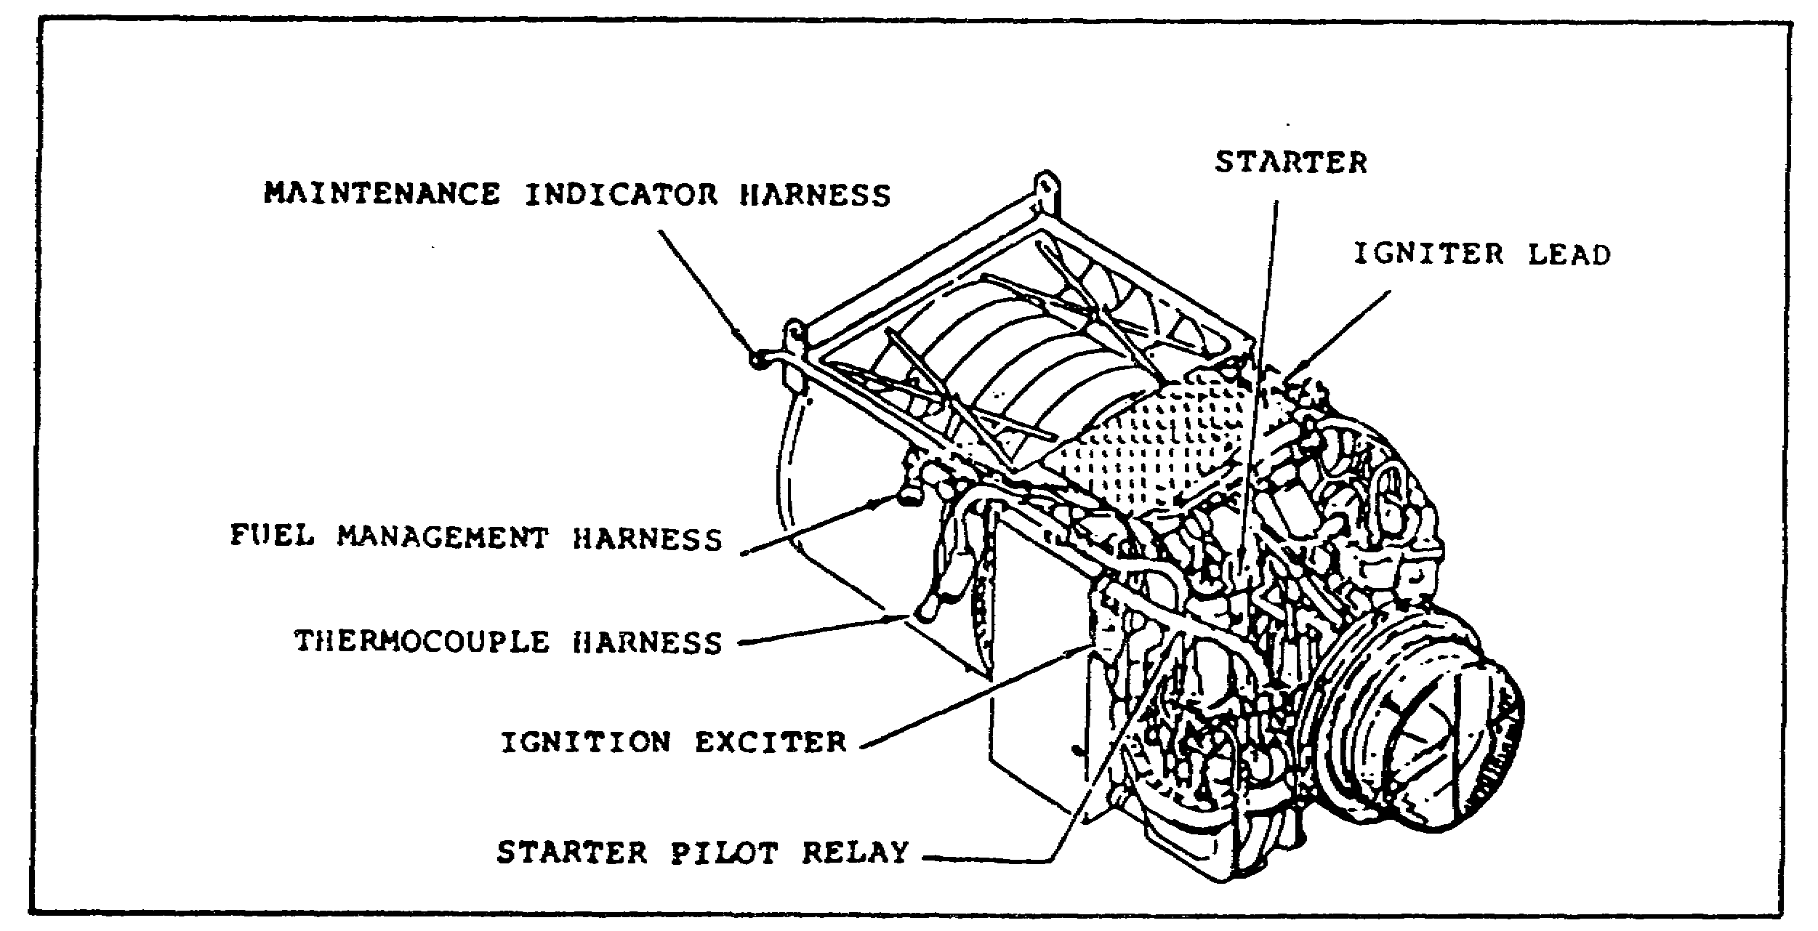
FIGURE 17. STARTER PILOT RELAY.

23
PRINCIPLES M1 STARTING & CHARGE SYS - OD0476 - LESSON 2/TASK 1

e. Starter Solenoid. The starter solenoid (figure 18) is attached to the M1 starter. It is operated by a smaller voltage from the starter pilot relay and switches the heavy current on and off to operate the starter.

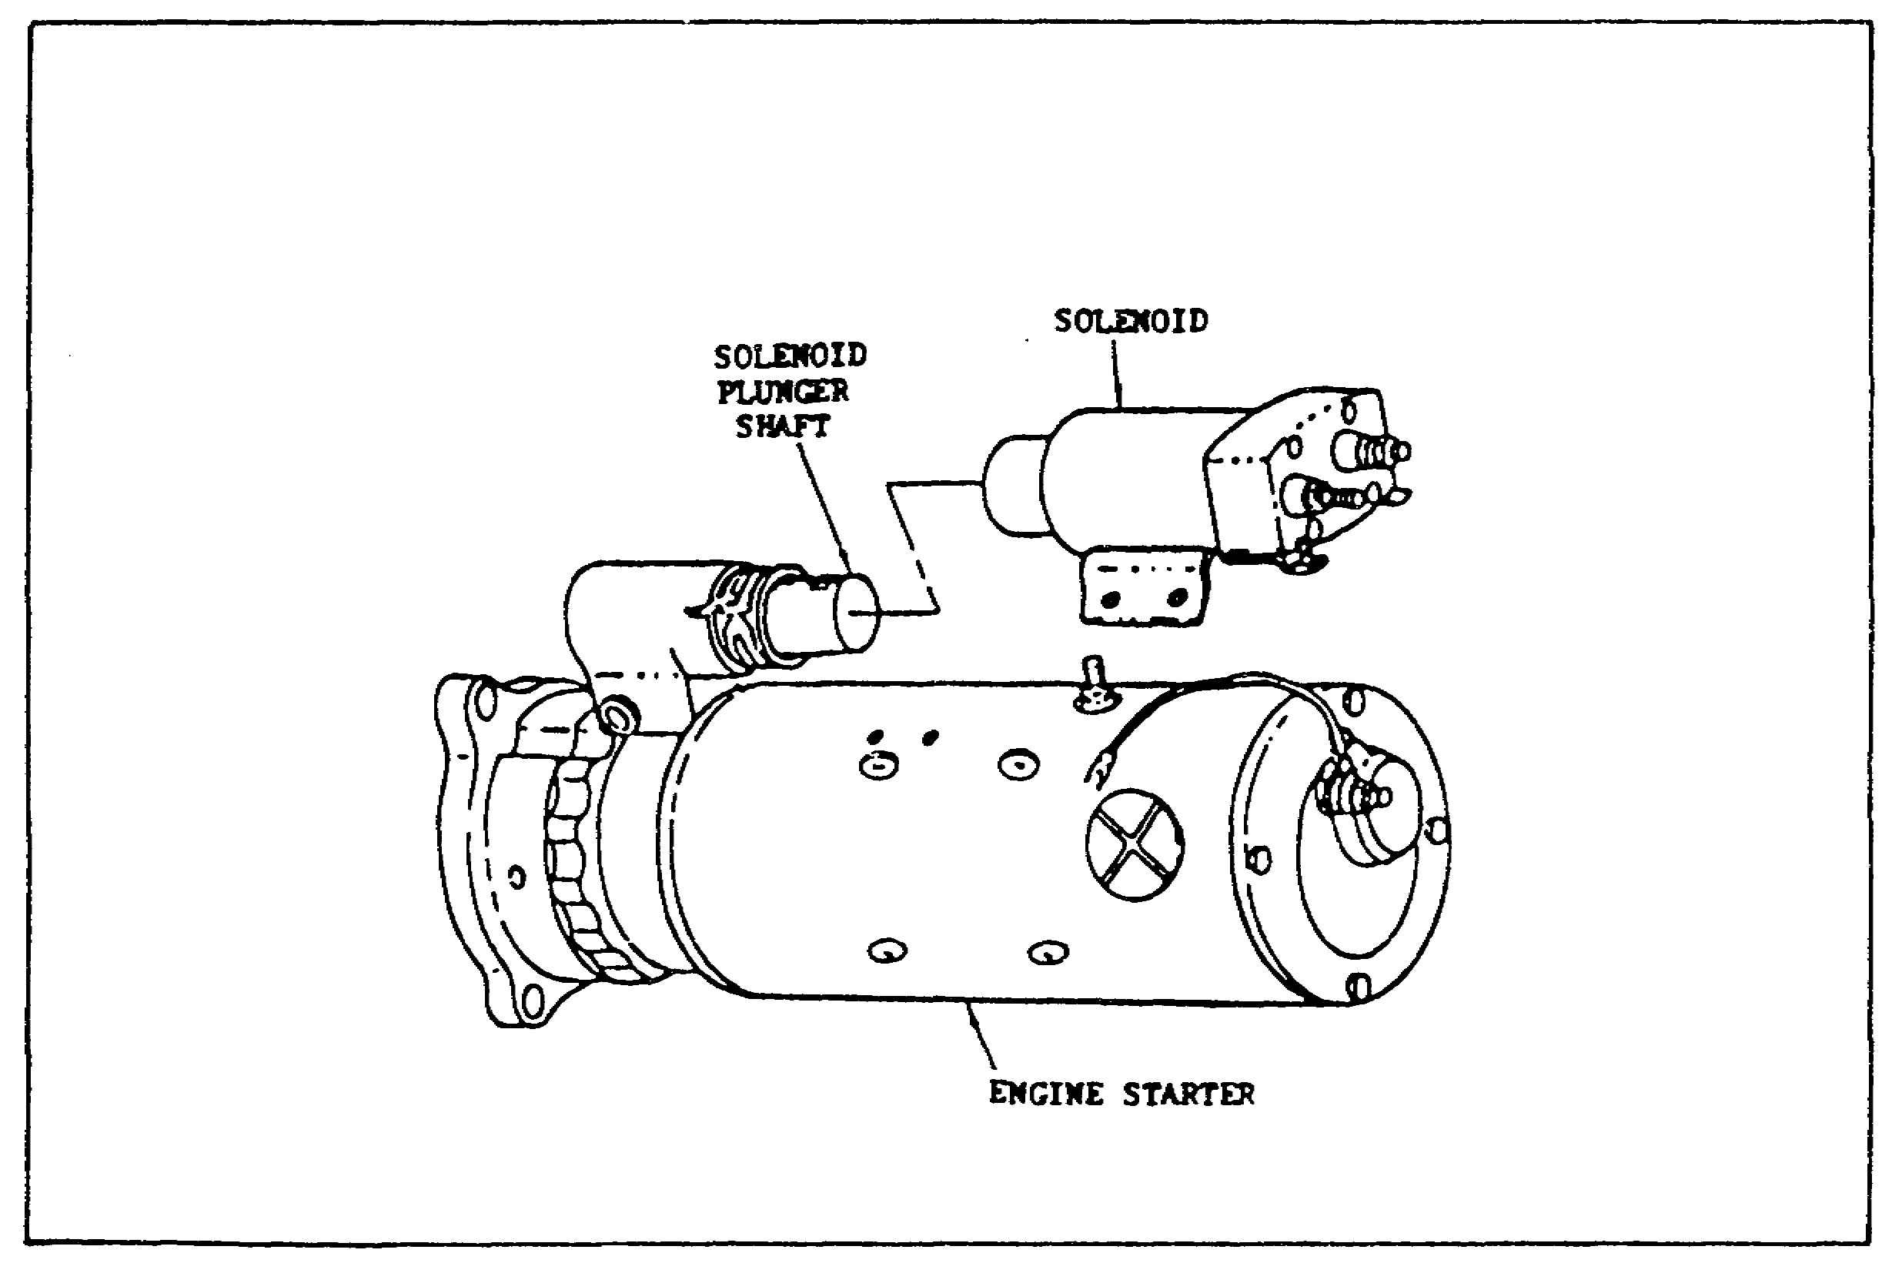
FIGURE 18. M1 STARTER SOLENOID AND STARTER.

f. Starter. The starter, shown above in figure 18, is a 24 vdc electrical motor that runs when 24 vdc is applied to it from the battery. Power to the starter is controlled by the driver's engine start switch and starter pilot relay. The starter is mounted to the accessory gearbox (AGB) and transmits power directly to the AGB.

2. Introduction to Other Components and Assemblies

The previously described components are considered those that make up the starting system. However, to complete the actual starting sequence of the M1, requires the interplay of other assemblies and components within the tank hull. These other assemblies and components are as follows:

24
PRINCIPLES M1 STARTING & CHARGE SYS - OD0476 - LESSON 2/TASK 1

a. Driver's Master Panel (DMP). The driver's master panel provides electrical circuitry, controls and indicators for operation of vehicle master power, control of engine start and shutoff, and activates auxiliary systems such as, personnel heater, night perisope, gas filter, bilge pump, smoke generator and lights. The panel is mounted on the right vertical wall of the drivers compartment (see figure 19 on page 26).

b. Driver's Instrument Panel (DIP). The primary monitoring of the M1's hull's performance is accomplished through the driver's instrument panel, located on the wall to the driver's left. It provides visual indicators (lights and gages) for monitoring of engine/transmission parameters, fuel status, electrical system voltage, vehicle speed and fire warning. See figure 19 on page 26 and figure 20 on page 27.

c. Maintenance Indicator Harness. The maintenance indicator harness incorporates connectors for the hull interface panel, oil float switch, ignition lead harness, oil pressure transmitter, oil temperature transmitter, clogged oil filter switch, ignition exciter input lead, and the starter pilot relay (see figure 21 on page 27 and figure 22 on page 28).

d. Electrical Disconnect Panel (EDC). The electrical disconnect panel provides for interfacing of the engine electrical system to the vehicle electrical system. Electrical connections are provided for the maintenance indicator, thermocouple, and fuel management harness (see figure 23 on page 28).

25
PRINCIPLES M1 STARTING & CHARGE SYS - OD0476 - LESSON 2/TASK 1
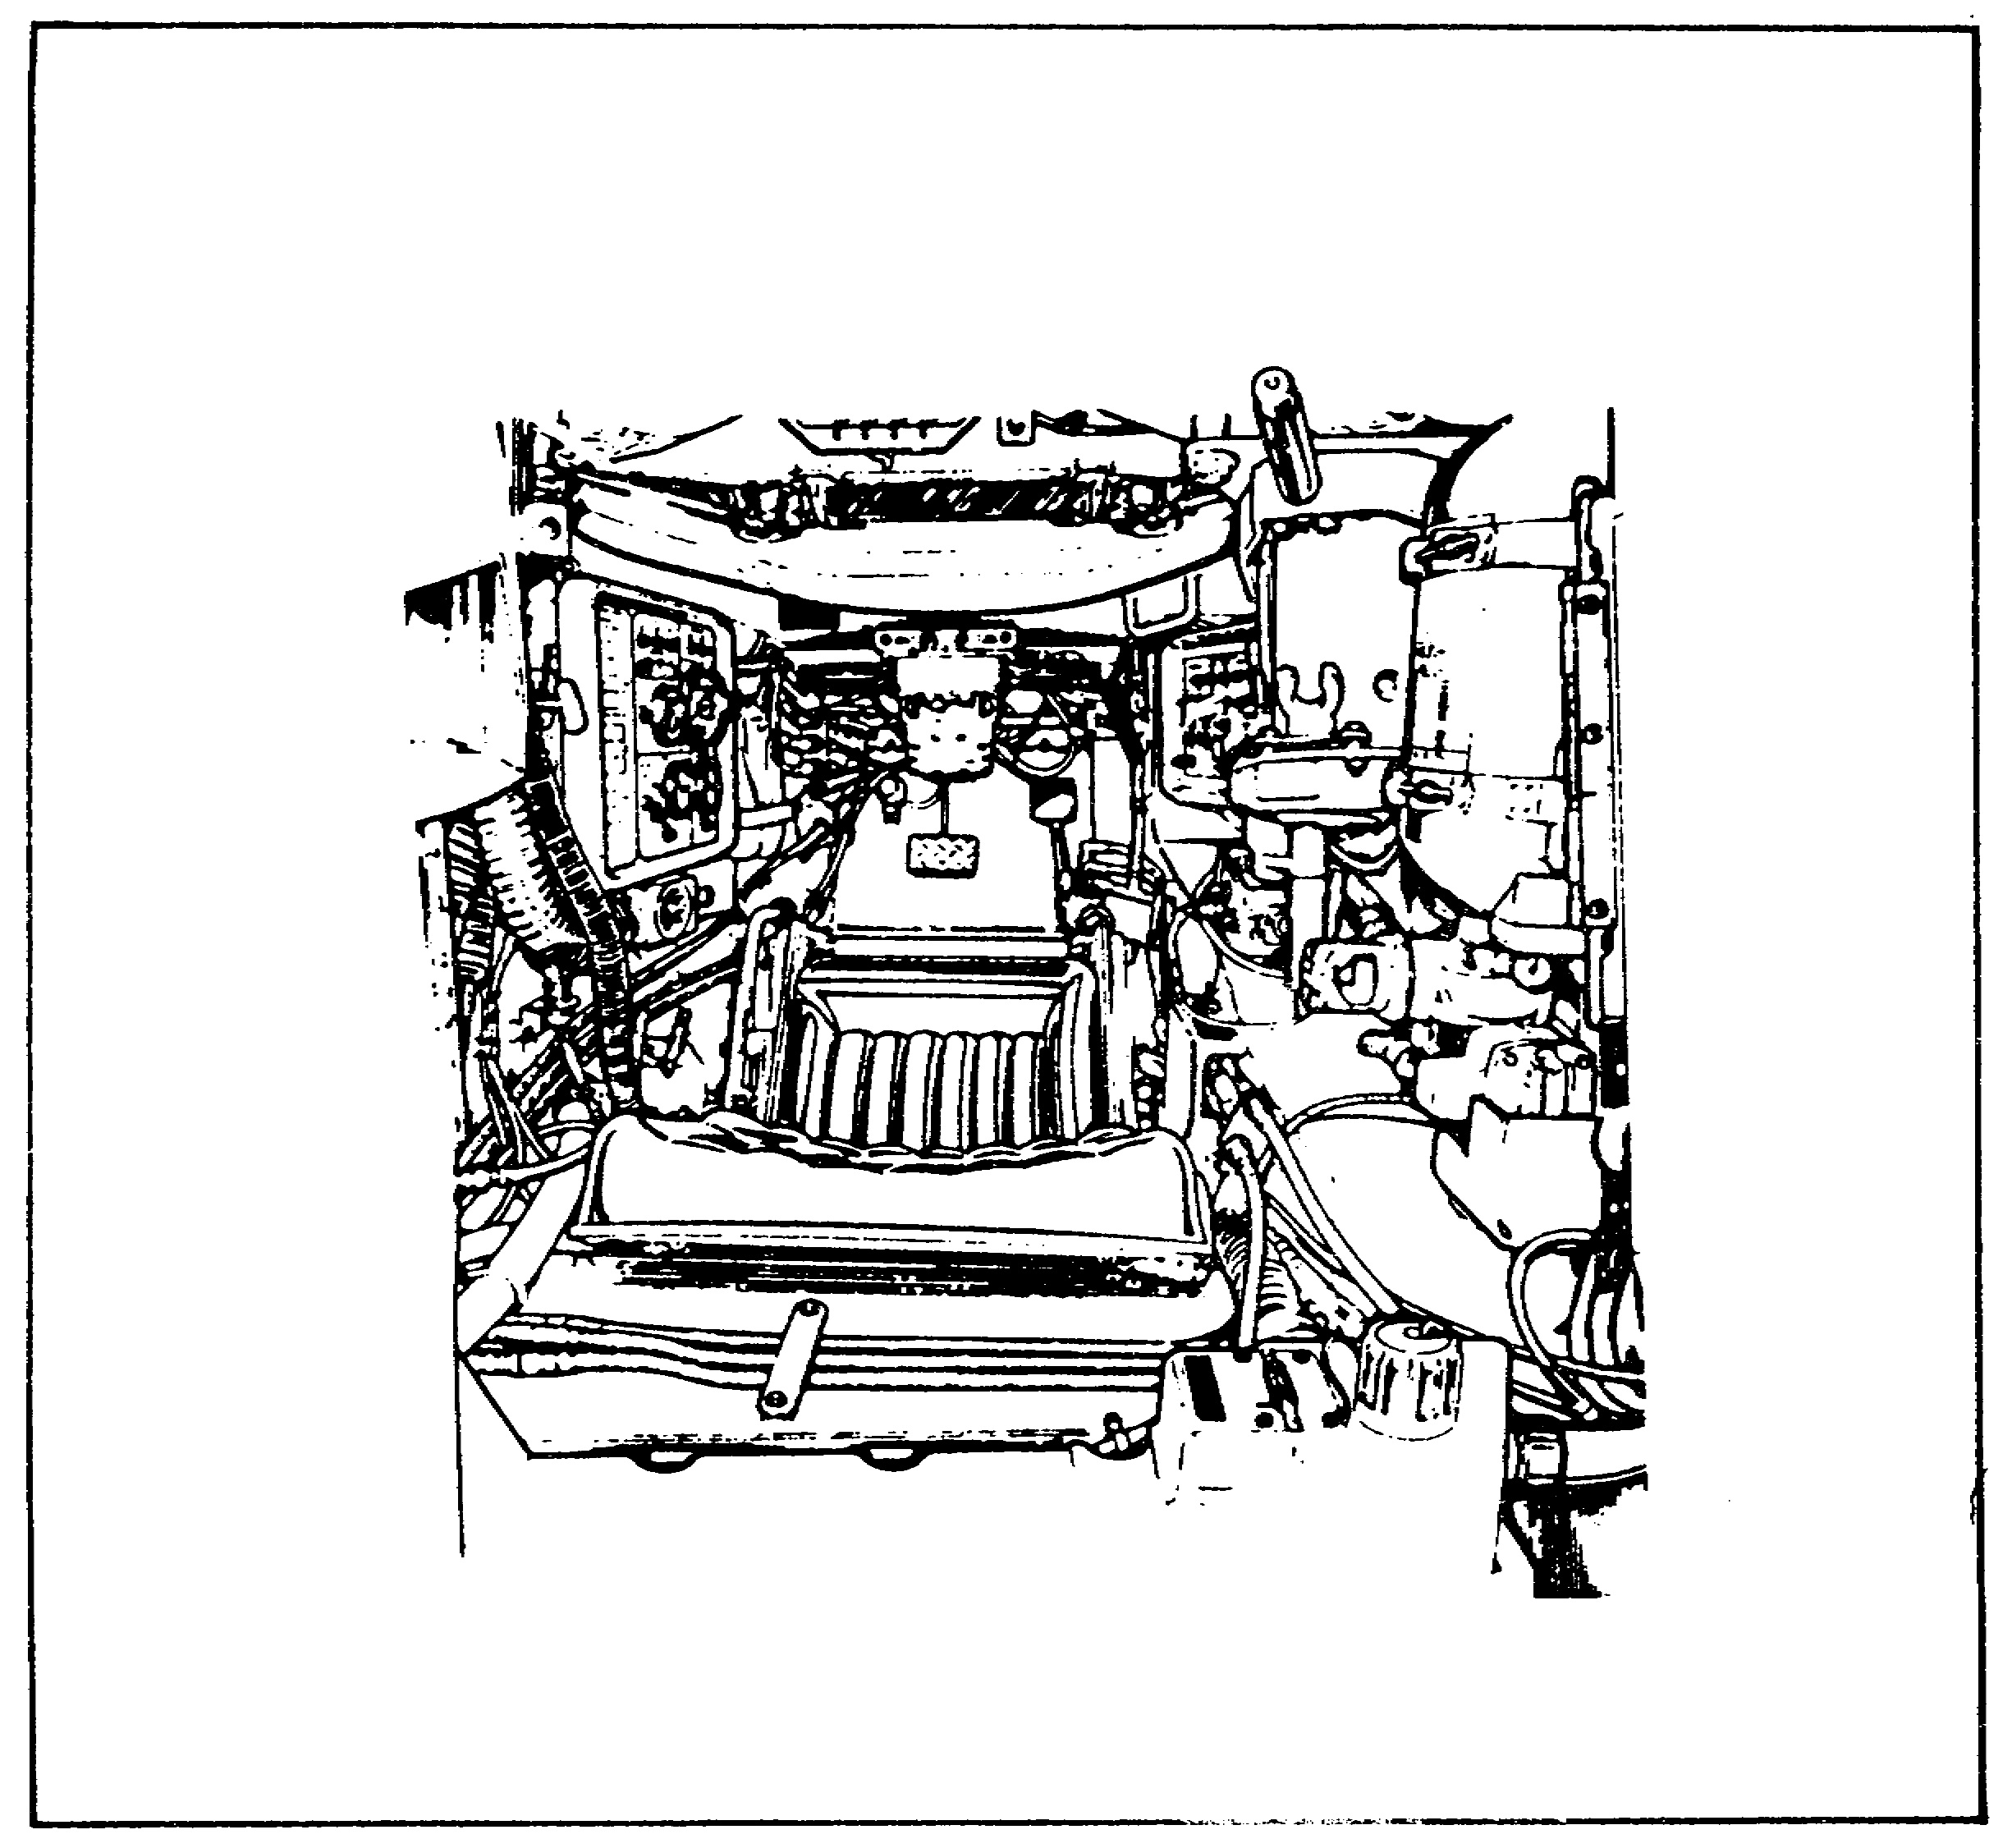

FIGURE 19. DRIVER'S MASTER PANEL AND DRIVER'S INSTRUMENT PANEL.

e. Hull Distribution Box (HDB). The environmentally sealed hull distribution box provides a terminating point for the vehicle main power inputs from the batteries and alternator. The main power is distributed from this box to the hull and turret. The box is located on the hull floor behind the driver’s seat (see figure 24 on page 29).

f. Hull Networks Box (HNB). The environmentally sealed hull networks box provides an electrical power distribution point and circuit protection for all major hull electrical components and subsystems. The box is located to the right rear of the driver on the hull wall (see figure 25 on page 30).

26
PRINCIPLES M1 STARTING & CHARGE SYS - OD0476 - LESSON 2/TASK 1

3. The operation and component interplay of all the previously described starting systems and tank components will be covered later in this subcourse.

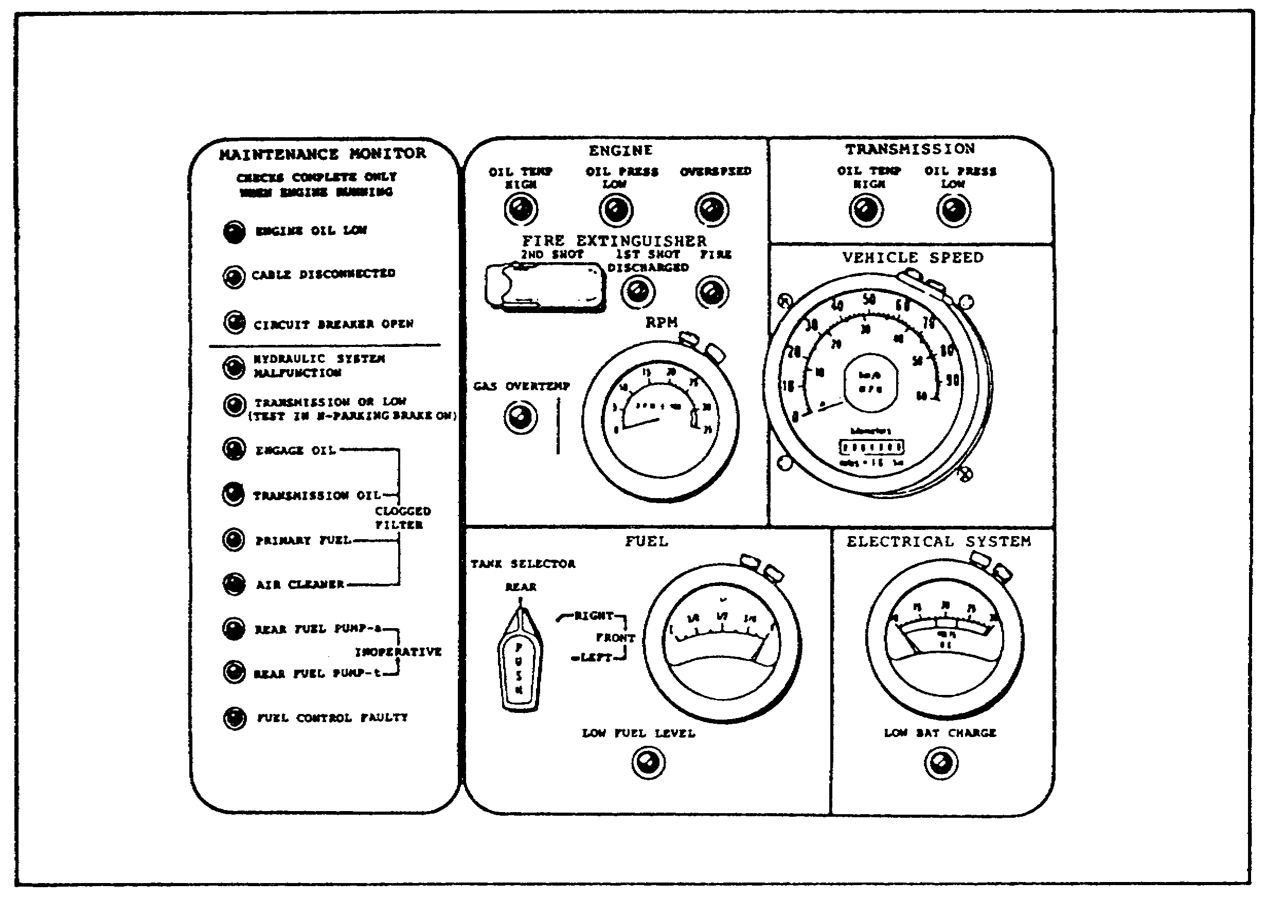
FIGURE 20. DRIVER'S INSTRUMENT PANEL.

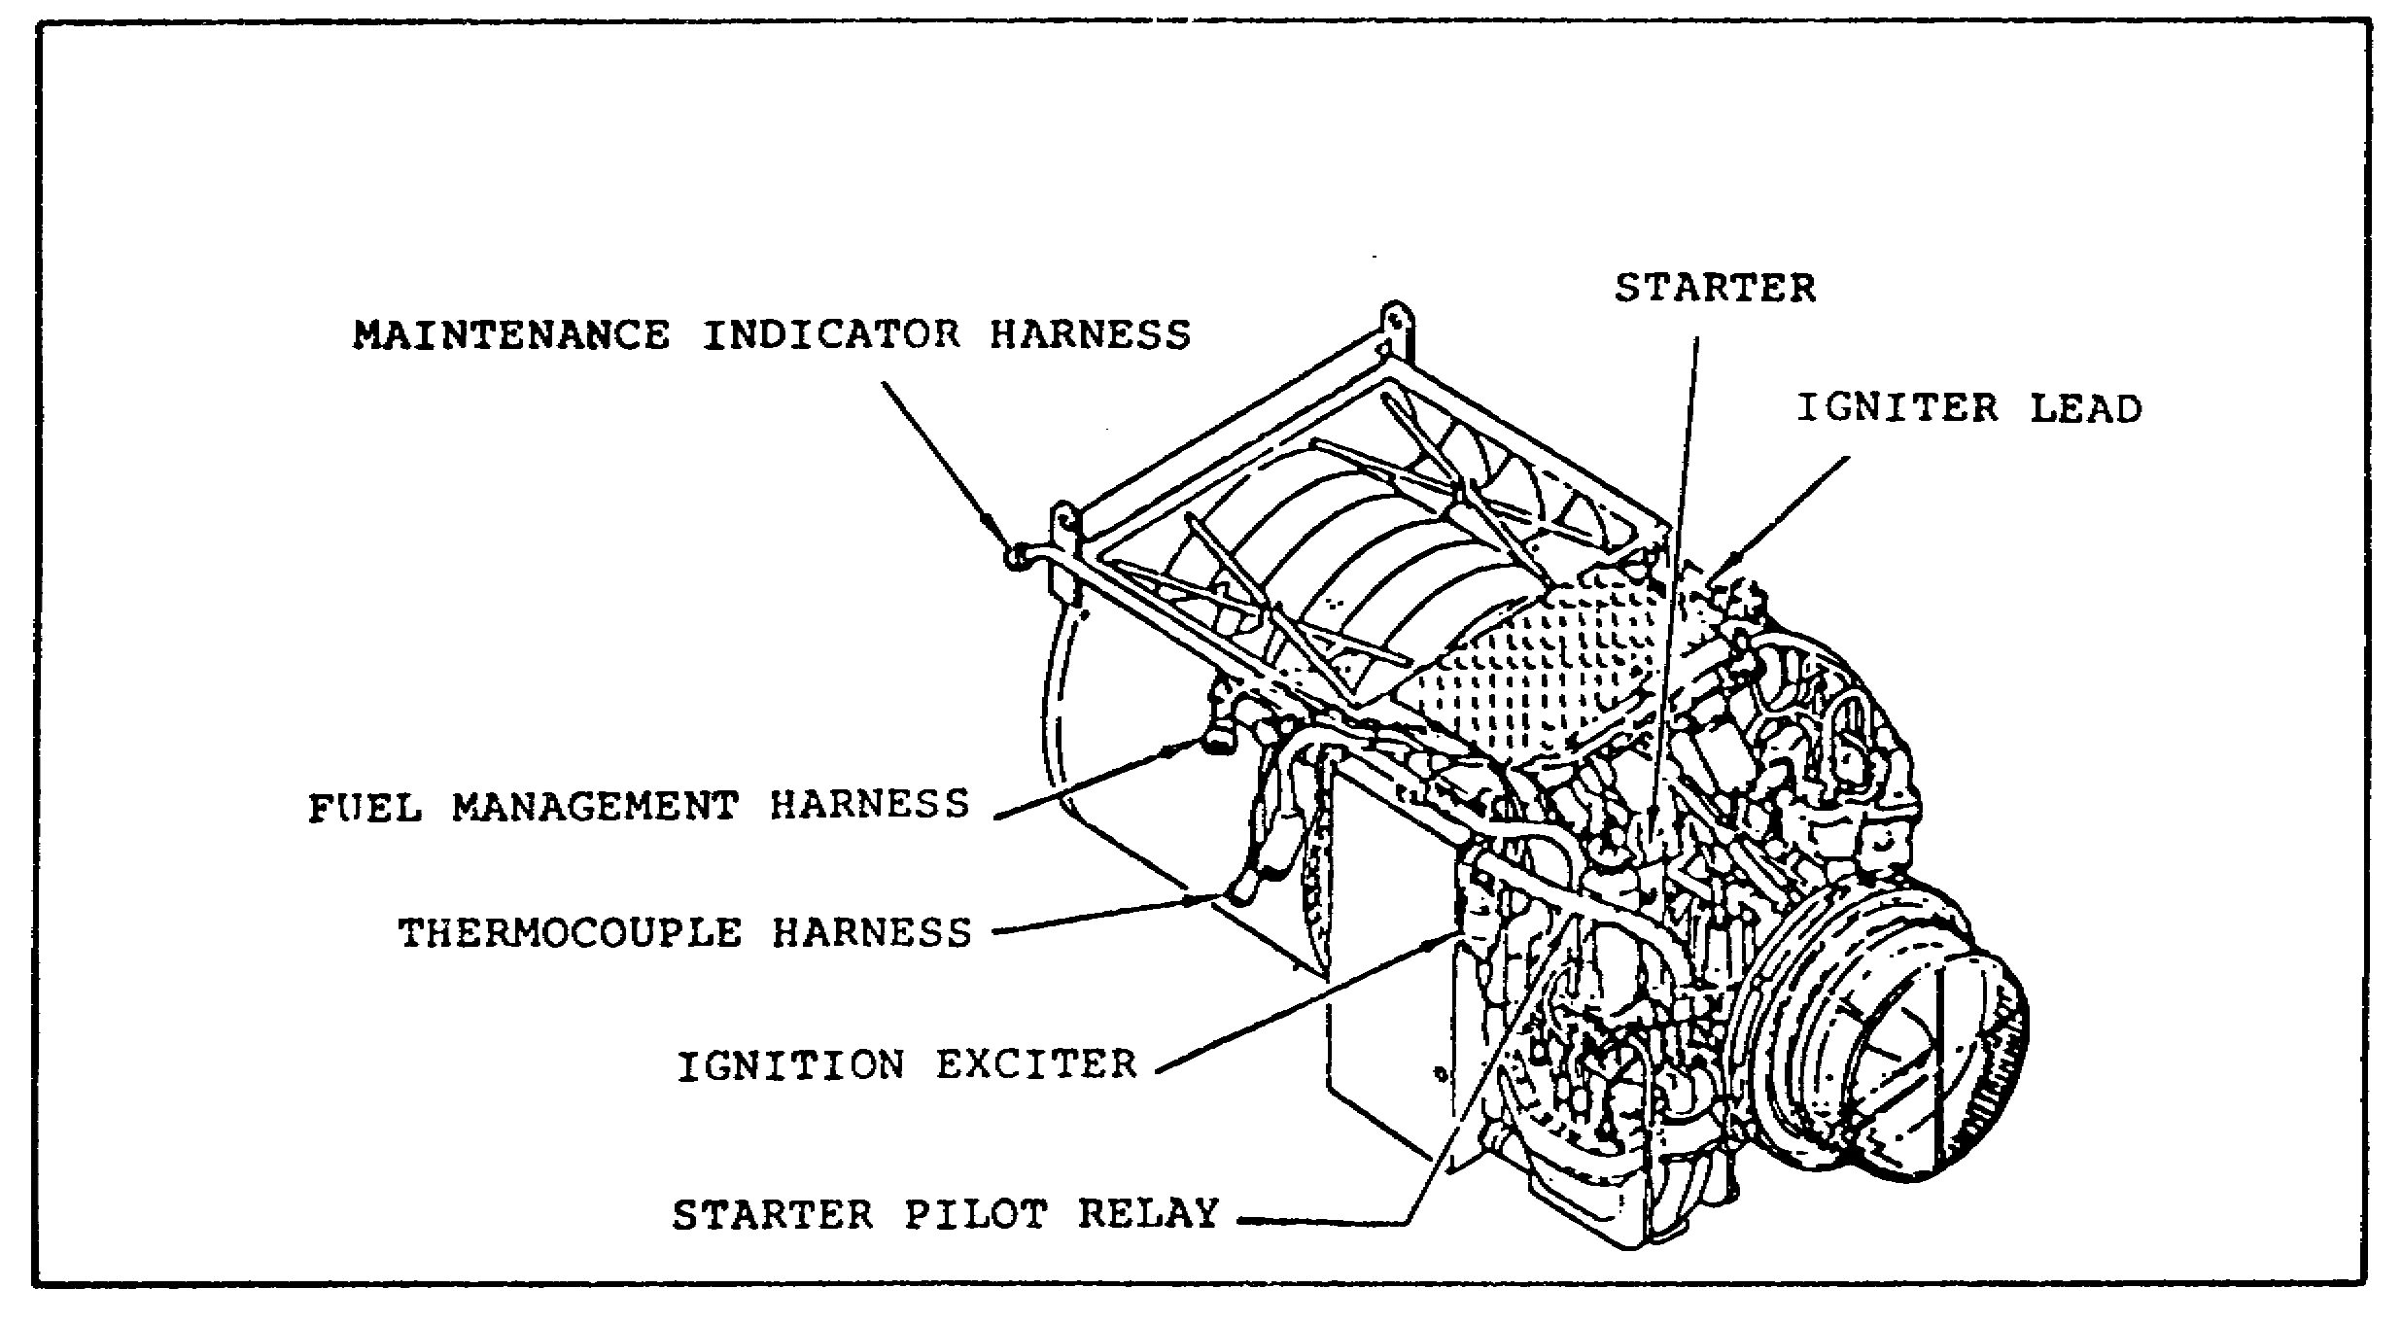
FIGURE 21. LOCATION OF MAINTENANCE INDICATOR HARNESS.

27
PRINCIPLES M1 STARTING & CHARGE SYS - OD0476 - LESSON 2/TASK 1

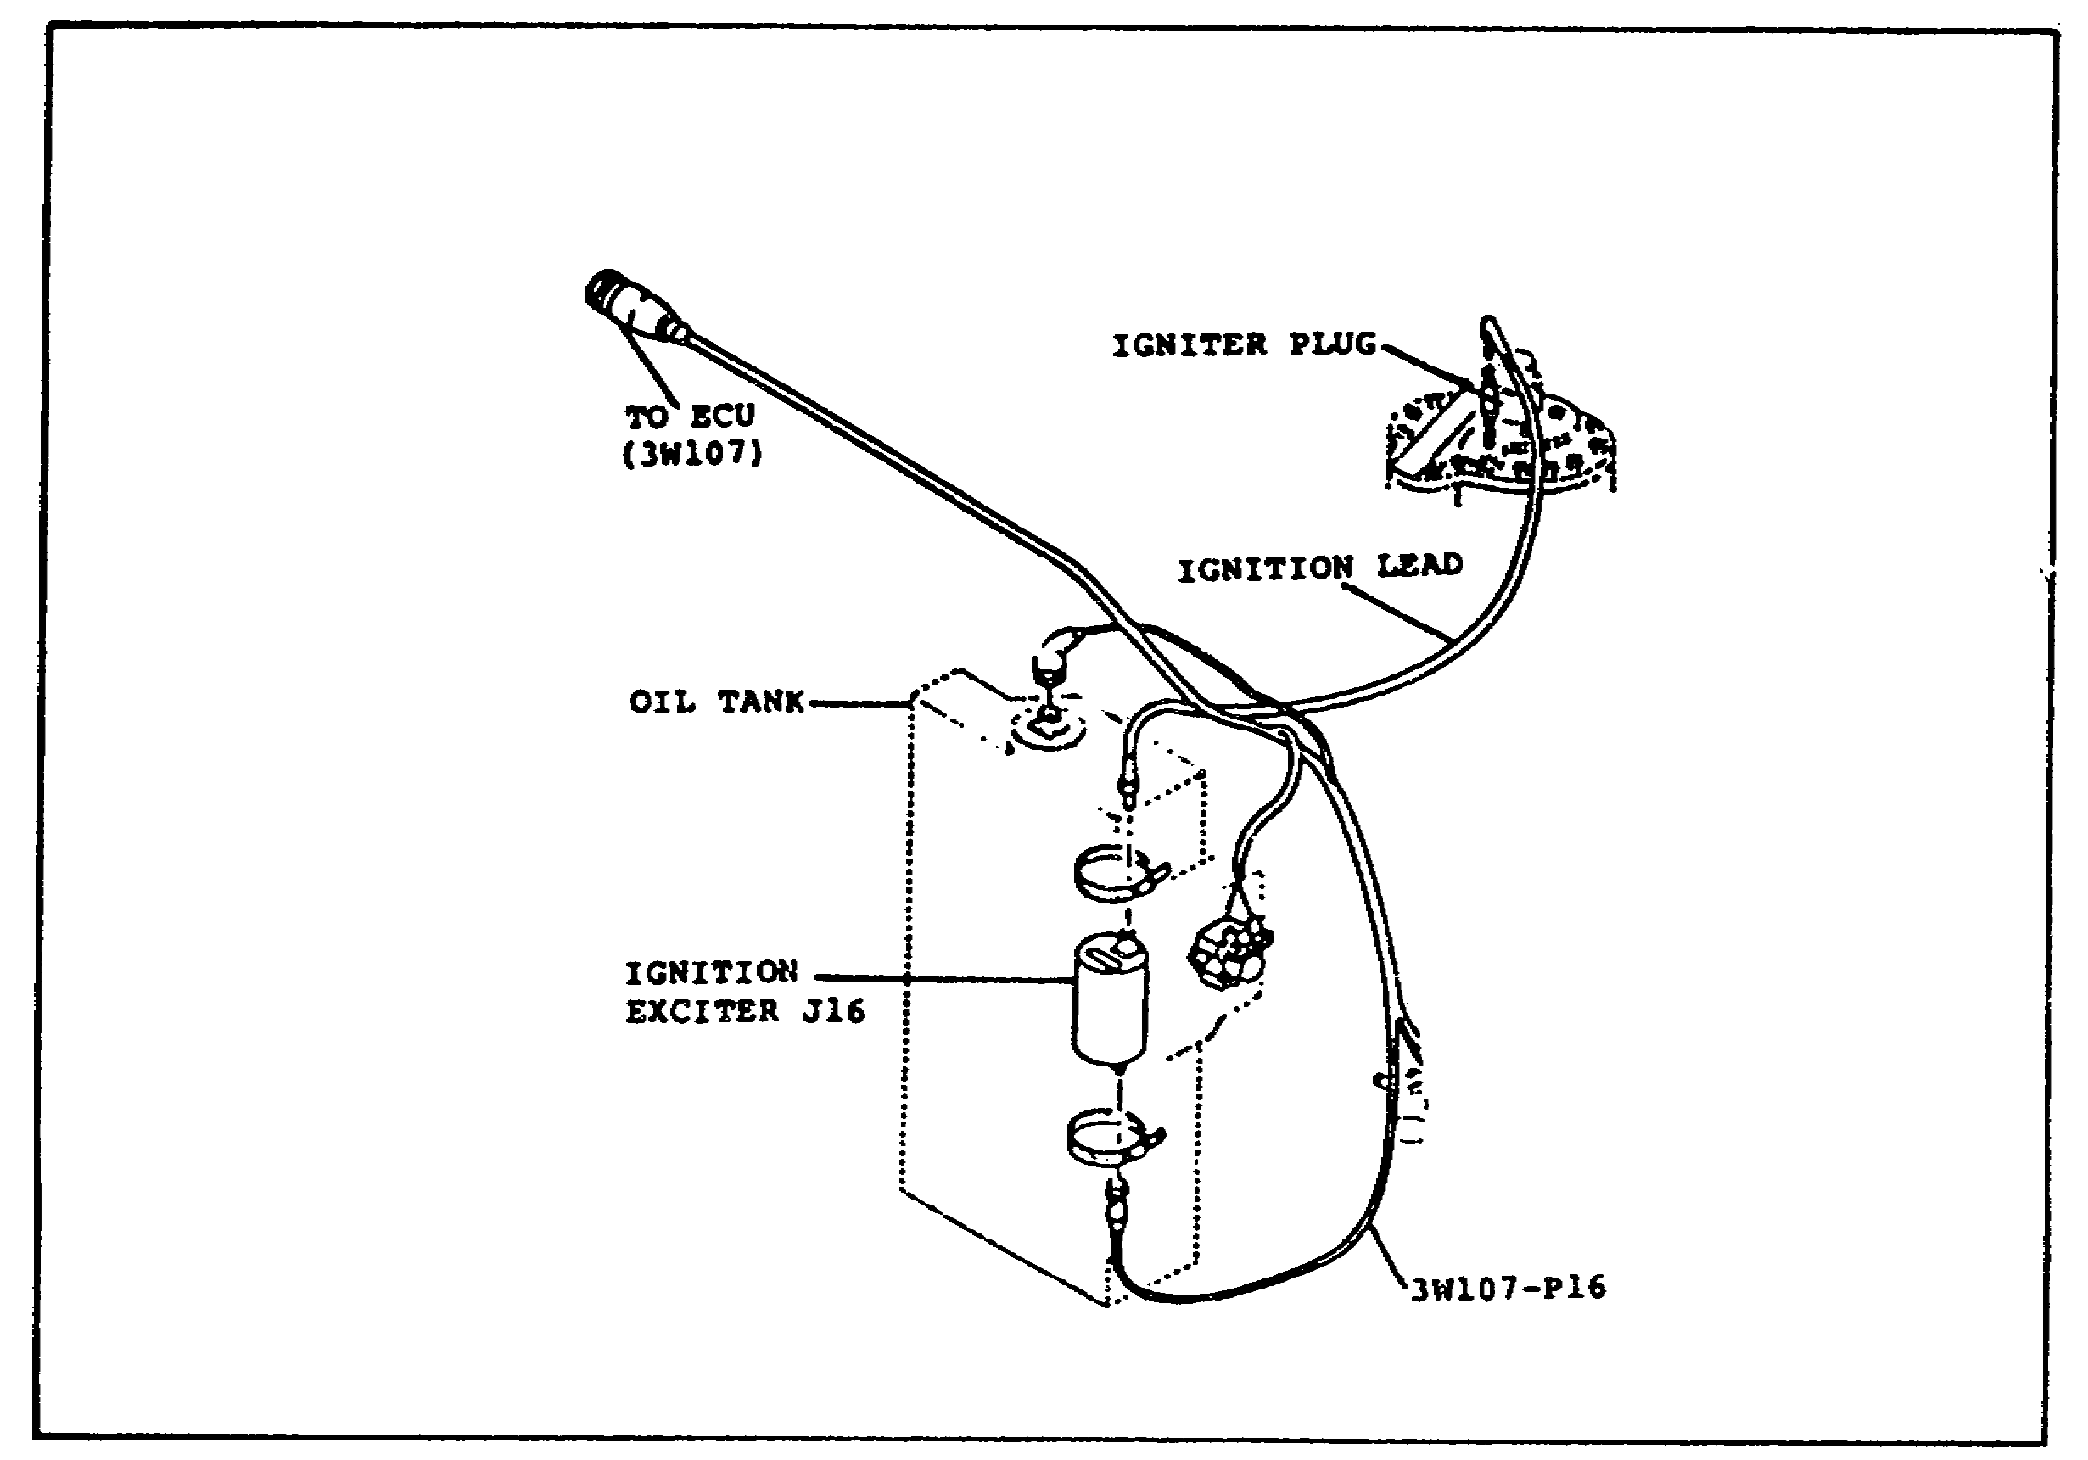
FIGURE 22. MAINTENANCE INDICATOR HARNESS.

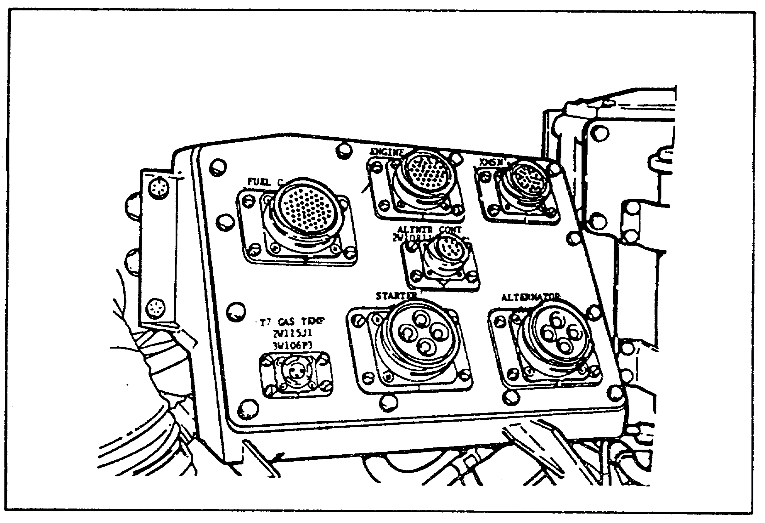
FIGURE 23. ELECTRICAL DISCONNECT PANEL.

28
PRINCIPLES M1 STARTING & CHARGE SYS - OD0476 - LESSON 2/TASK 1

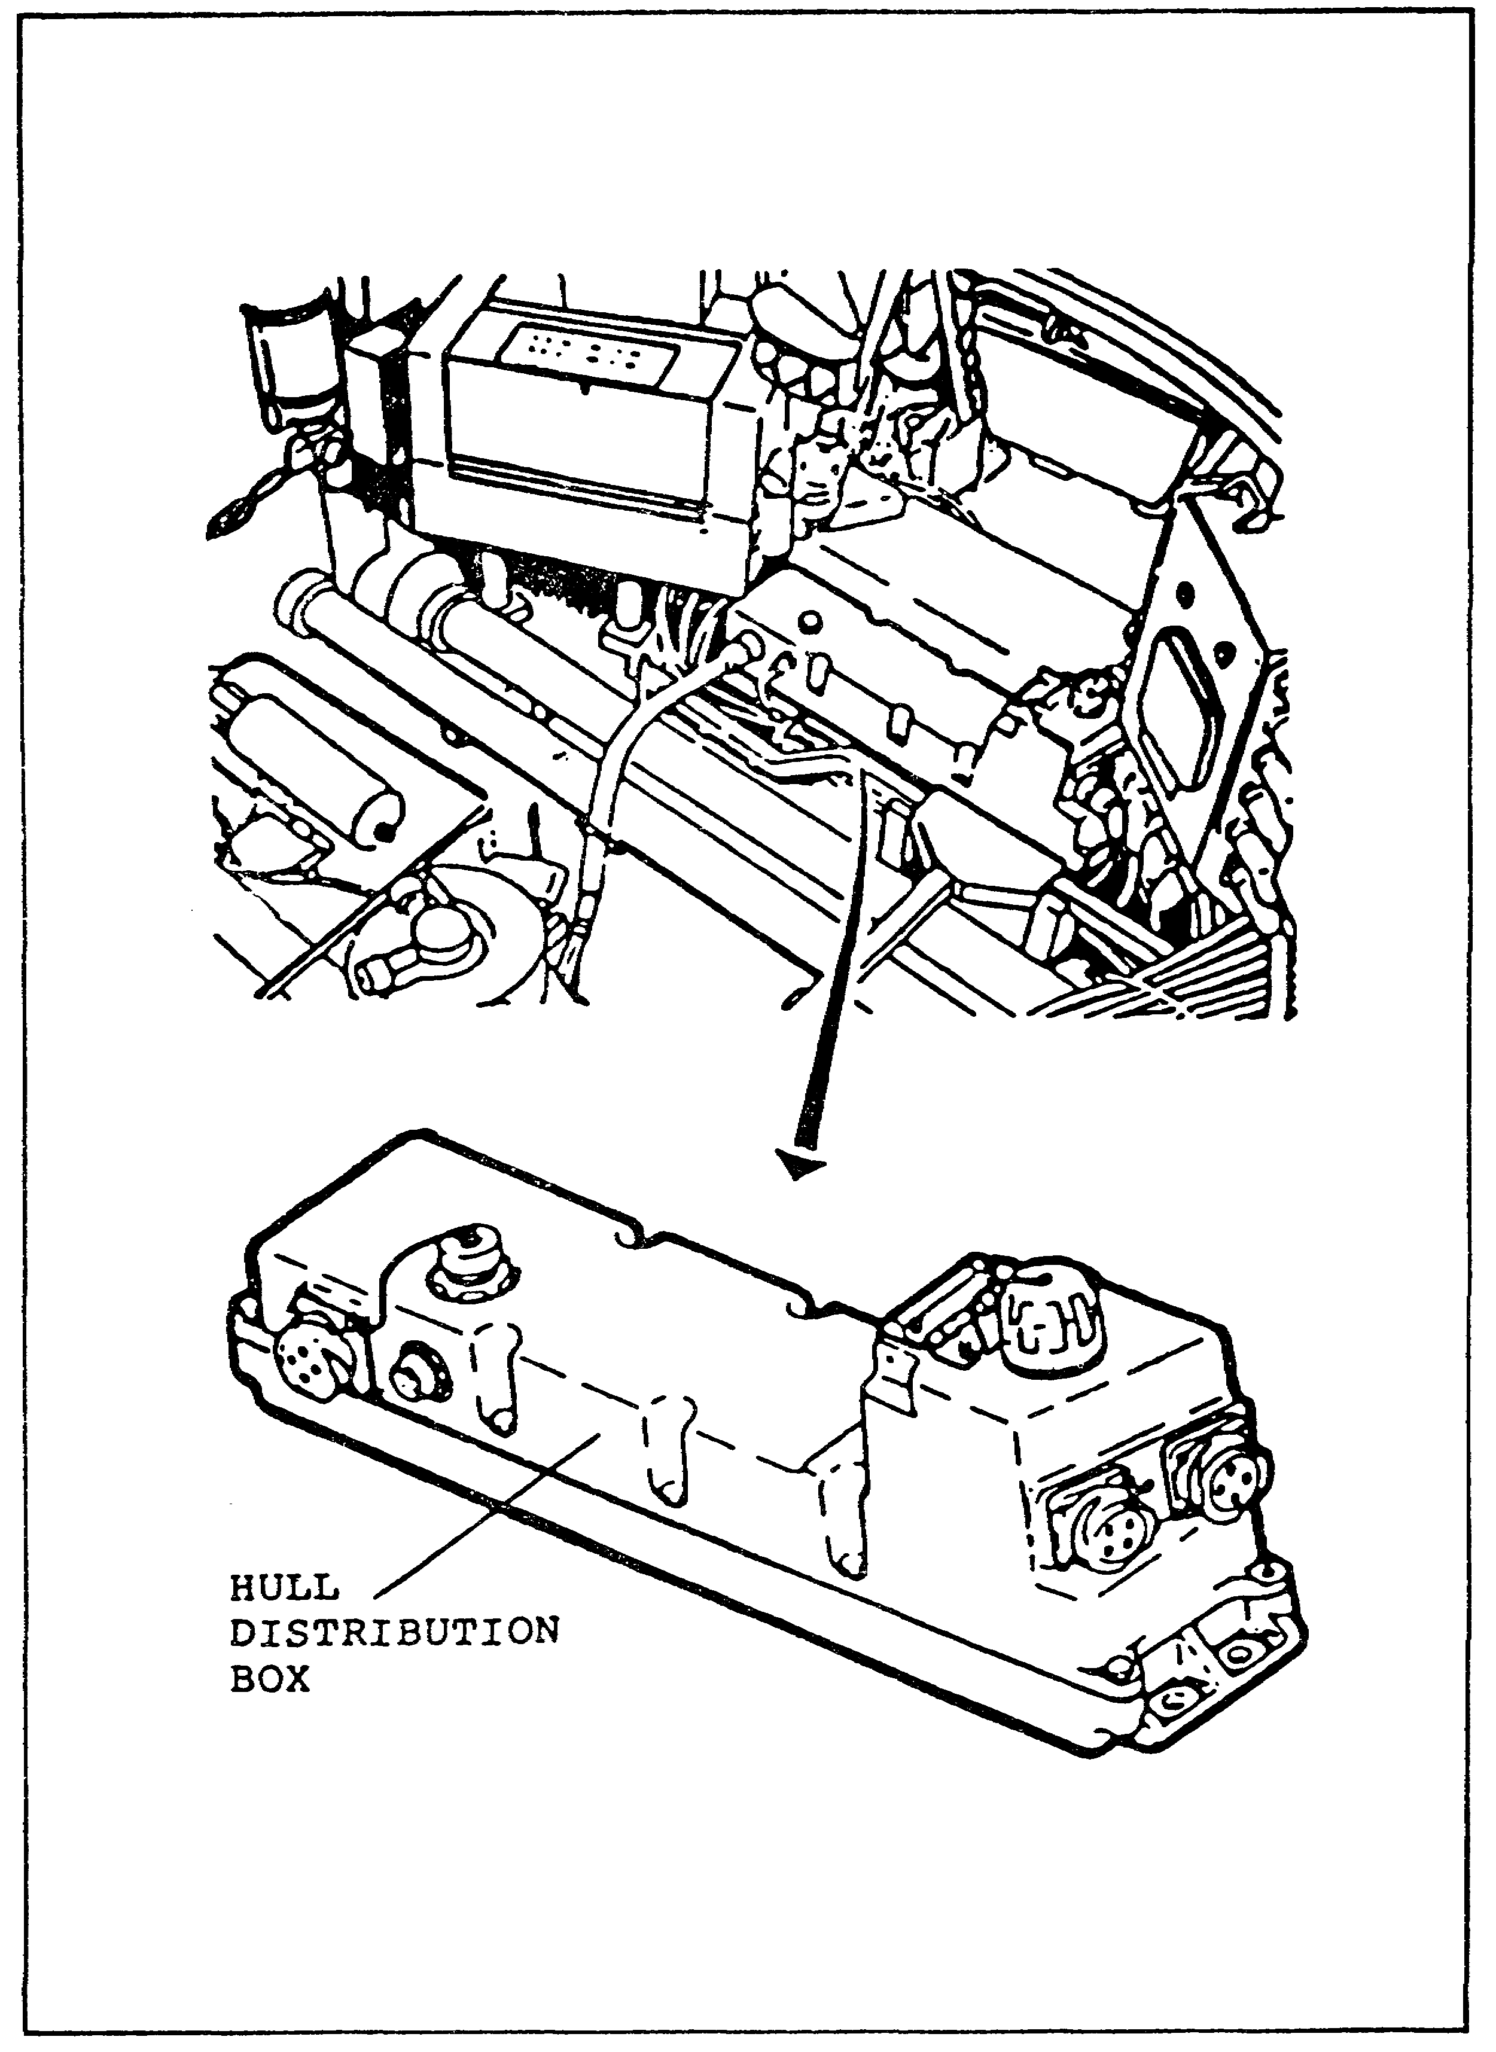
FIGURE 24. HULL DISTRIBUTION BOX.

29
PRINCIPLES M1 STARTING & CHARGE SYS - OD0476 - LESSON 2/TASK 1

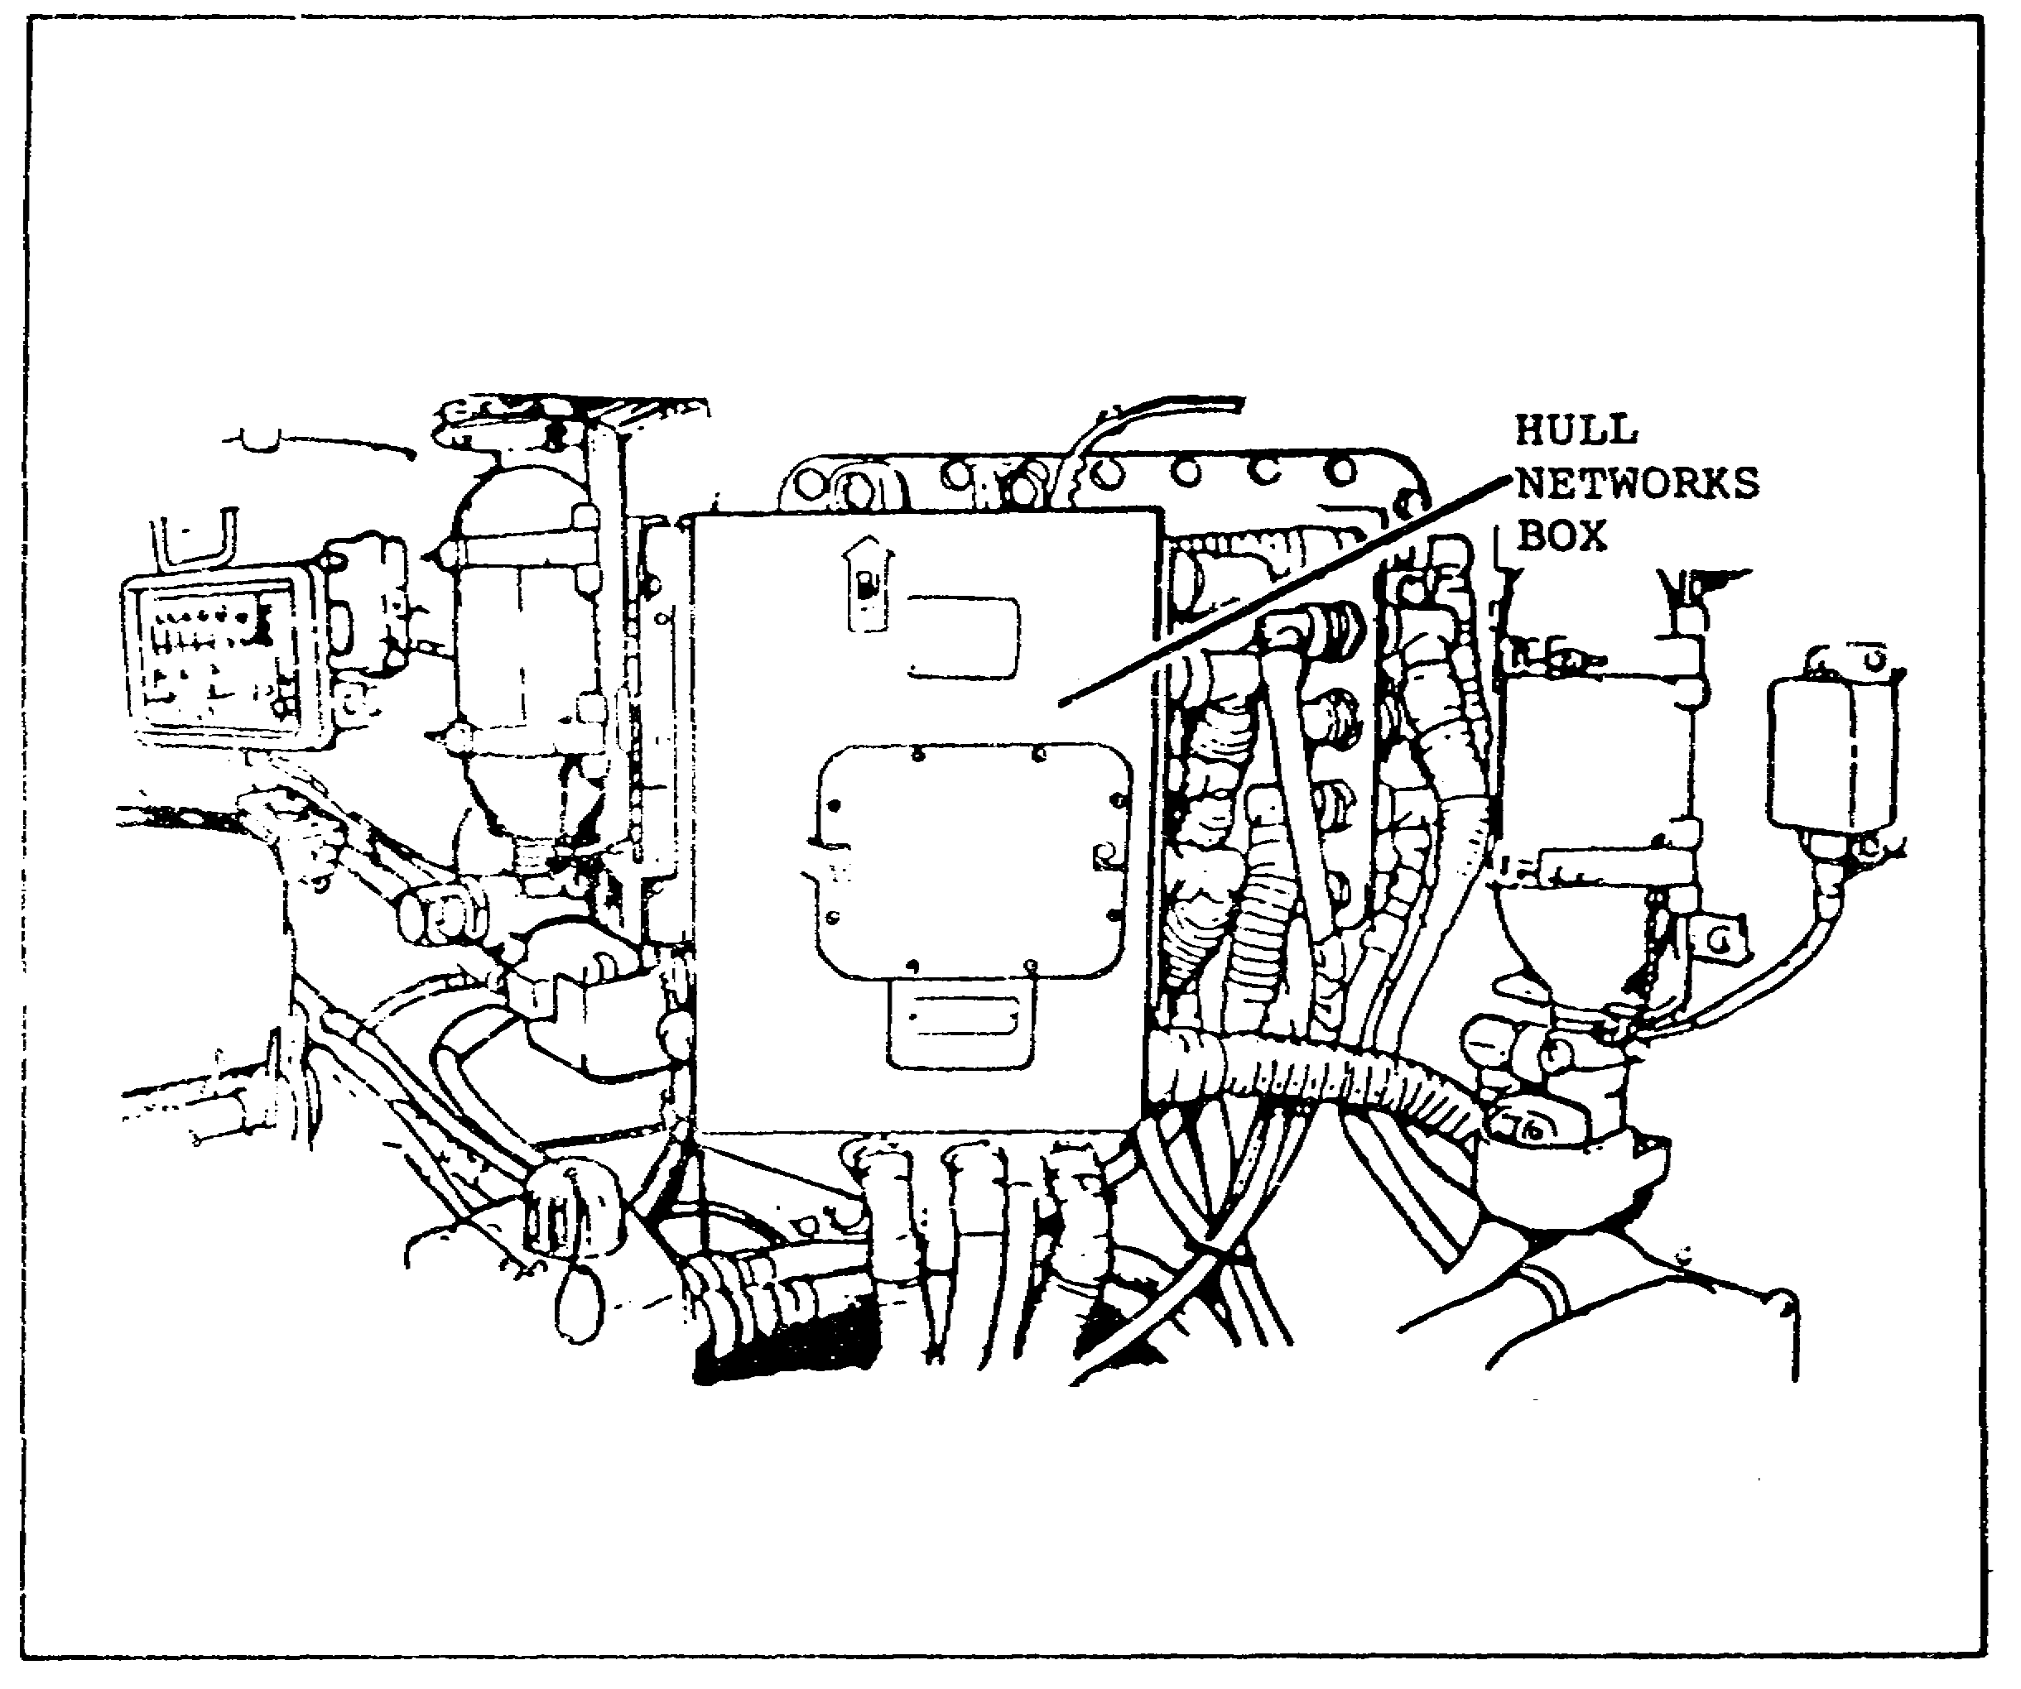
FIGURE 25. HULL NETWORKS BOX.

30
PRINCIPLES M1 STARTING & CHARGE SYS - OD0476 - LESSON 2/TASK 2

LESSON 2

COMPONENTS OF THE M1 TANK STARTING
AND CHARGING SYSTEMS

TASK 2. Describe the components of the M1 tank charging system and identify their locations within the M1 tank.

CONDITIONS

Within a self-study environment and given the subcourse text, without assistance.

STANDARDS

Within one hour

REFERENCES

No supplementary references are needed for this task.

1. Introduction

The components which comprise the charging system are part of the M1 tank's electrical power system. The electrical power system consists of electrical and electronic circuits. These circuits provide power distribution and control, and monitor the vehicle's battery power and charging system. This task will cover the identification and location of the M1 tank charging system components.

a. Alternator. In order to maintain fully charged batteries, as well as provide vehicle electrical power when the engine is running, a 650 amp alternator is used (figure 26, on the following page). The ac alternator is mounted to the rear of the transmission and is driven by the transmission. The M1 alternator is an alternating current (ac) generator which is waterproof and is oil cooled by the engine oil system.

The alternator is basically an alternating current (ac) generator with direct current (dc) rectification. It is capable of providing dc rectified voltage to the batteries and the vehicle electrical system without the use of slip rings or

31
PRINCIPLES M1 STARTING & CHARGE SYS - OD0476 - LESSON 2/TASK 2

brushes. The output of the alternator is regulated by a voltage regulator.

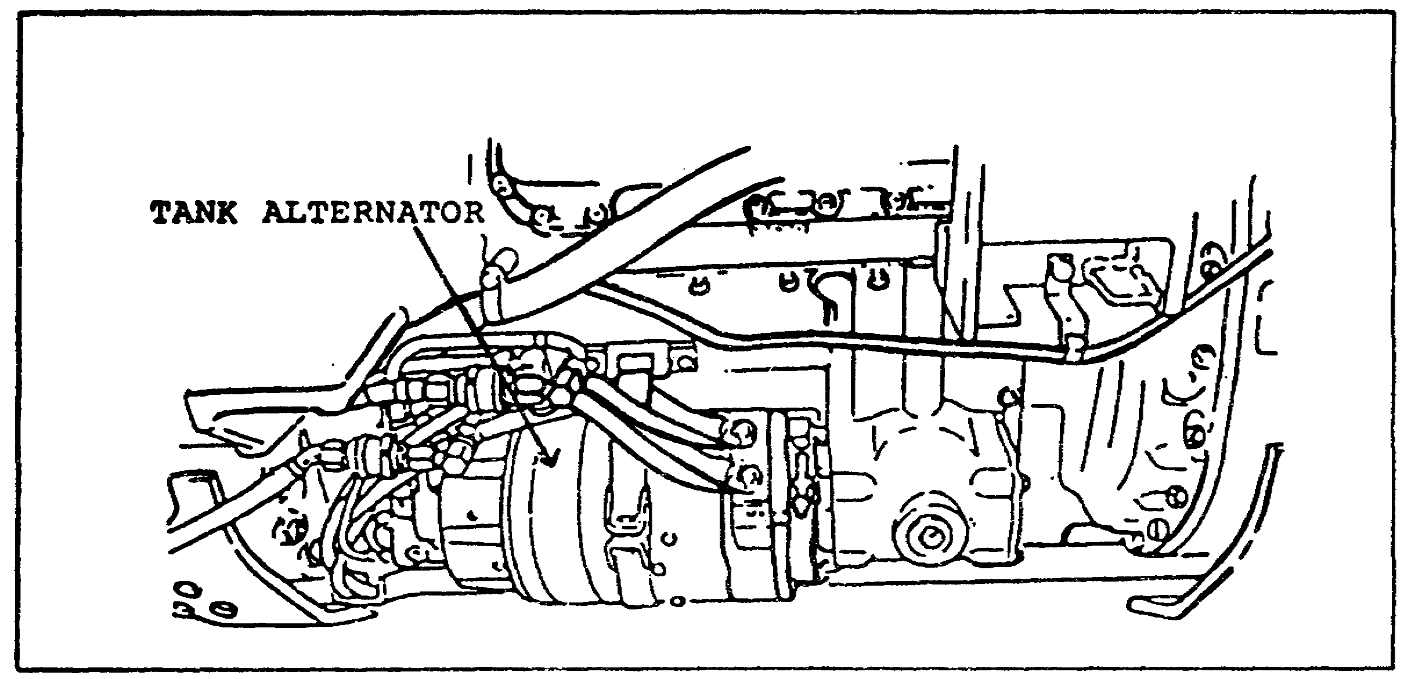
FIGURE 26. M1 TANK ALTERNATOR.

b. Voltage Regulator. A solid state voltage regulator is mounted in the right rear sponson area, behind the batteries. It regulates the vehicle system output voltage by controlling the current in the alternator's do field winding from 27.6 to 28.5. The regulator also provides overvoltage protection for the alternator (figure 27).

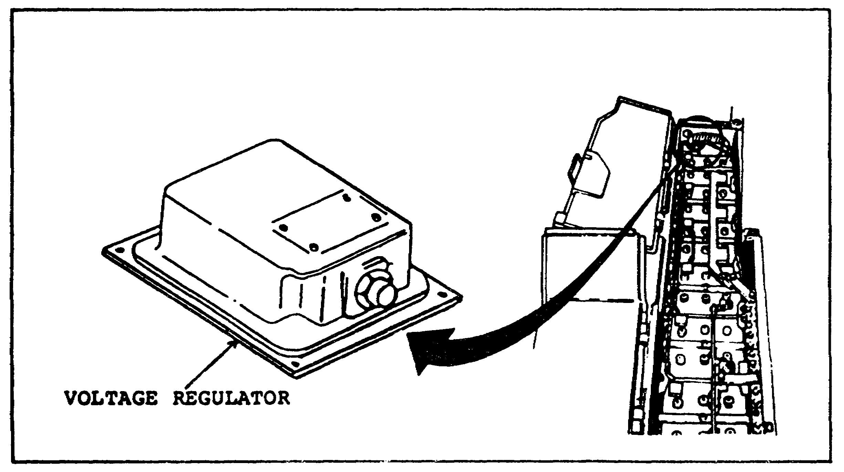
FIGURE 27. M1 TANK VOLTAGE REGULATOR.

32
PRINCIPLES M1 STARTING & CHARGE SYS - OD0476 - LESSON 2/PE 2

PRACTICAL EXERCISE 2

Instructions

On a plain sheet of paper, write down the answers to the following questions. When you have answered them, turn the page and check your answers.

1. The M1 tank uses a 24 volt direct current (vdc) electrical system. How many batteries does it take to create this electricity?

2. The electronic control unit (ECU) is an electronic computer that controls several M1 tank components and systems. Name three of these components or systems.

3. Name the M1 component that the ignition exciter is mounted to.

4. What starter component deenergizes automatically when the engine speed reaches approximately 55 percent revolutions per minute?

5. How may volts does it take to drive the M1 starter?

6. Describe the primary function of the M1 hull distribution box.

7. Describe where the alternator is mounted on the M1 tank.

8. Are slip rings and brushes components of the M1 alternator?

9. The solid state M1 voltage regulator regulates the vehicle output voltage by controlling the current in the alternators dc field winding. What are these voltage limits?

33
PRINCIPLES M1 STARTING & CHARGE SYS - OD0476 - LESSON 2/PE 2

LESSON 2. PRACTICAL EXERCISE -ANSWERS

1. 6 lead-acid batteries.

2. a. Controls the engine fuel management system.

b. Controls engine accessories (starter, ignition exciter).

c. Controls driver's monitoring devices (engine speed meter, engine overtesperature light, and engine overspeed light).

3. Oil tank.

4. Starter pilot relay.

5. 24 vdc.

6. Provides a terminating point for the M1's main power inputs from the battery and alternator.

7. The alternator is mounted to the rear of the transmission.

8. No.

9. 27.6 to 28.5 volts.

34
PRINCIPLES M1 STARTING & CHARGE SYS - OD0476 - LESSON 3/TASK 1

LESSON 3

OPERATION OF THE M1 TANK STARTING
AND CHARGING SYSTEMS

TASK 1. Describe the operation of the M1 tank starting system.

CONDITIONS

Within a self-study environment and given the subcourse text, without assistance.

STANDARDS

Within one hour

REFERENCES

No supplementary references are needed for this task.

1. Introduction

This task will discuss the operation of the M1 tank components required for engine starting. The discussion will include a description of the engine start sequence and engine start circuitry.

a. Electronic Control Unit (ECU). The ECU is an electronic computer. The primary function of the ECU during the M1 starting sequence, is to control the voltage going to the starter and ignition exciter. The ECU receives inputs from engine sensors (turbin inlet temperature, power turbin speed high pressure compressor speed) and driver requests (engine/start, twist grip requests, tactical idle and starter only).

b. Ignition Exciter, Ignition Lead, and Igniter Plug. When 24 vdc from the battery is applied to the ignition exciter, it generates 12,000 vdc at 3 to 30 sparks per second. This energy is fed through the ignition lead to the ignitor plug. The ignition lead carries the voltage to the igniter plug which in turn ignites the air fuel mixture.

35
PRINCIPLES M1 STARTING & CHARGE SYS - OD0476 - LESSON 3/TASK 1

c. Starter Pilot Relay. The starter pilot relay receives 24 vdc from the ECU. The operation of this component is primarily to eliminate the need for the operator to hold the starter switch ON until the engine reaches 55 percent revolutions per minute (rpm).

d. Starter. The starter is an electric motor which requires 24 vdc to make it work correctly. During the starting sequence, 24 vdc is set from the starter solenoid which then rotates the high pressure (HP) compressor, via the accessory gearbox (AGB) gearing, for engine starting.

2. Interaction of Minor Components Involved in the M1 Starting System Operation

a. Driver's Master Panel (DMP). The VEHICLE MASTER POWER switch (located on the DMP), energizes the hull electrical system (figure 28, on the following page). The PUSH TO START button provides automatic engine start. The STARTED light, lights green for 10 seconds when the engine has started successfully. The ABORT light, lights yellow to show that the engine electronic control unit has aborted start. This light goes out when the VEHICLE MASTER POWER switch is set to OFF and then back on. The SHUTOFF switch shuts off fuel to the engine. The STARTER ONLY ENGAGED switch provides power to turn the engine starter without ignition (the engine will not start using this switch). When the STARTER ONLY ENGAGED switch is used, the engine ignition system is by-passed, inhibiting the engine start sequence. The TACTICAL IDLE switch selects tactical idle speed of about 1350 rpm.

b. Driver's Instrument Panel (DIP)(figure 29). The ELECTRICAL SYSTEM-voltmeter displays electrical system voltage, and an amber light warns the driver of a low battery state of charge when the engine is not running. A guarded toggle switch is provided to shut down the engine.

36
PRINCIPLES M1 STARTING & CHARGE SYS - OD0476 - LESSON 3/TASK 1

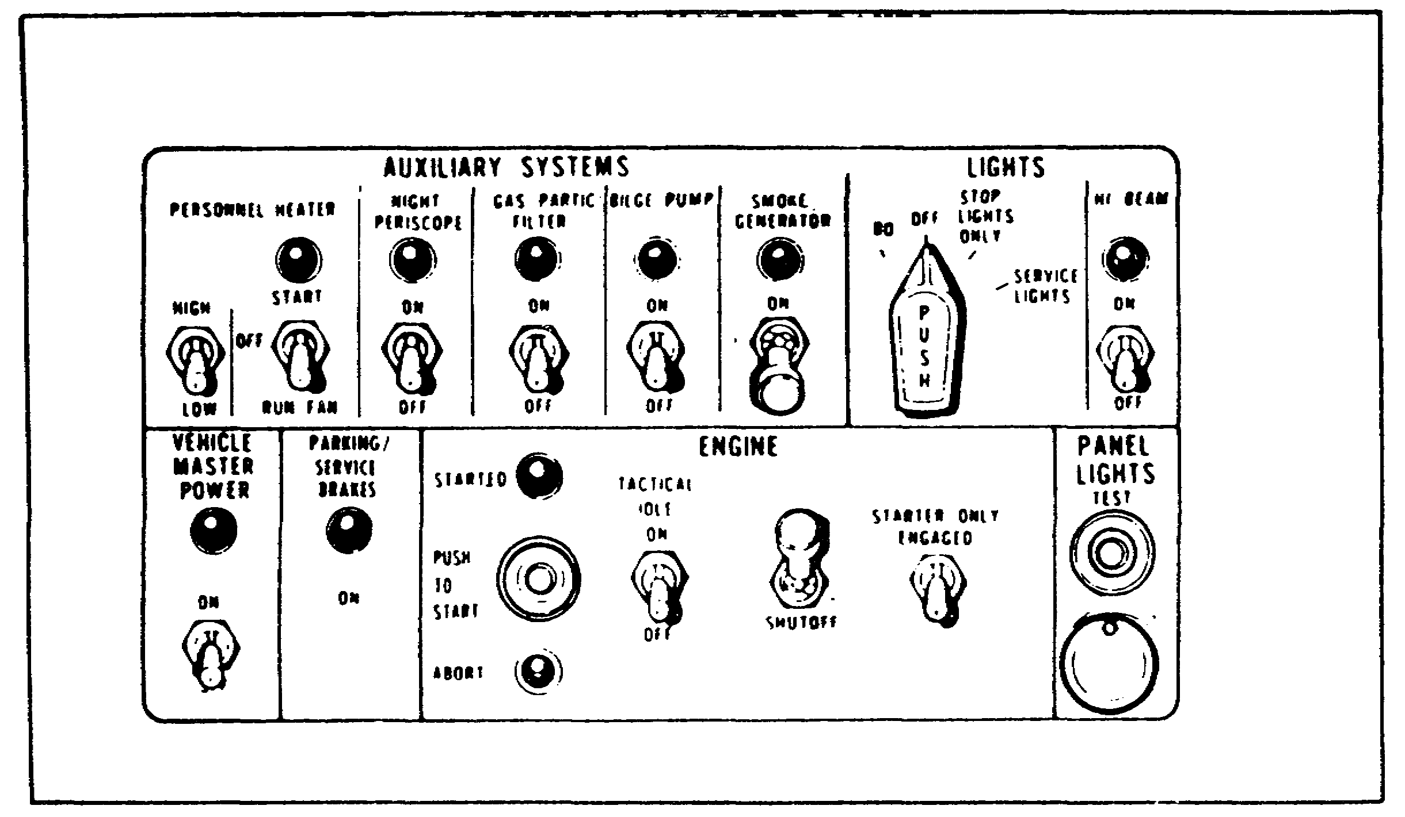
FIGURE 28. DRIVER'S MASTER PANEL.

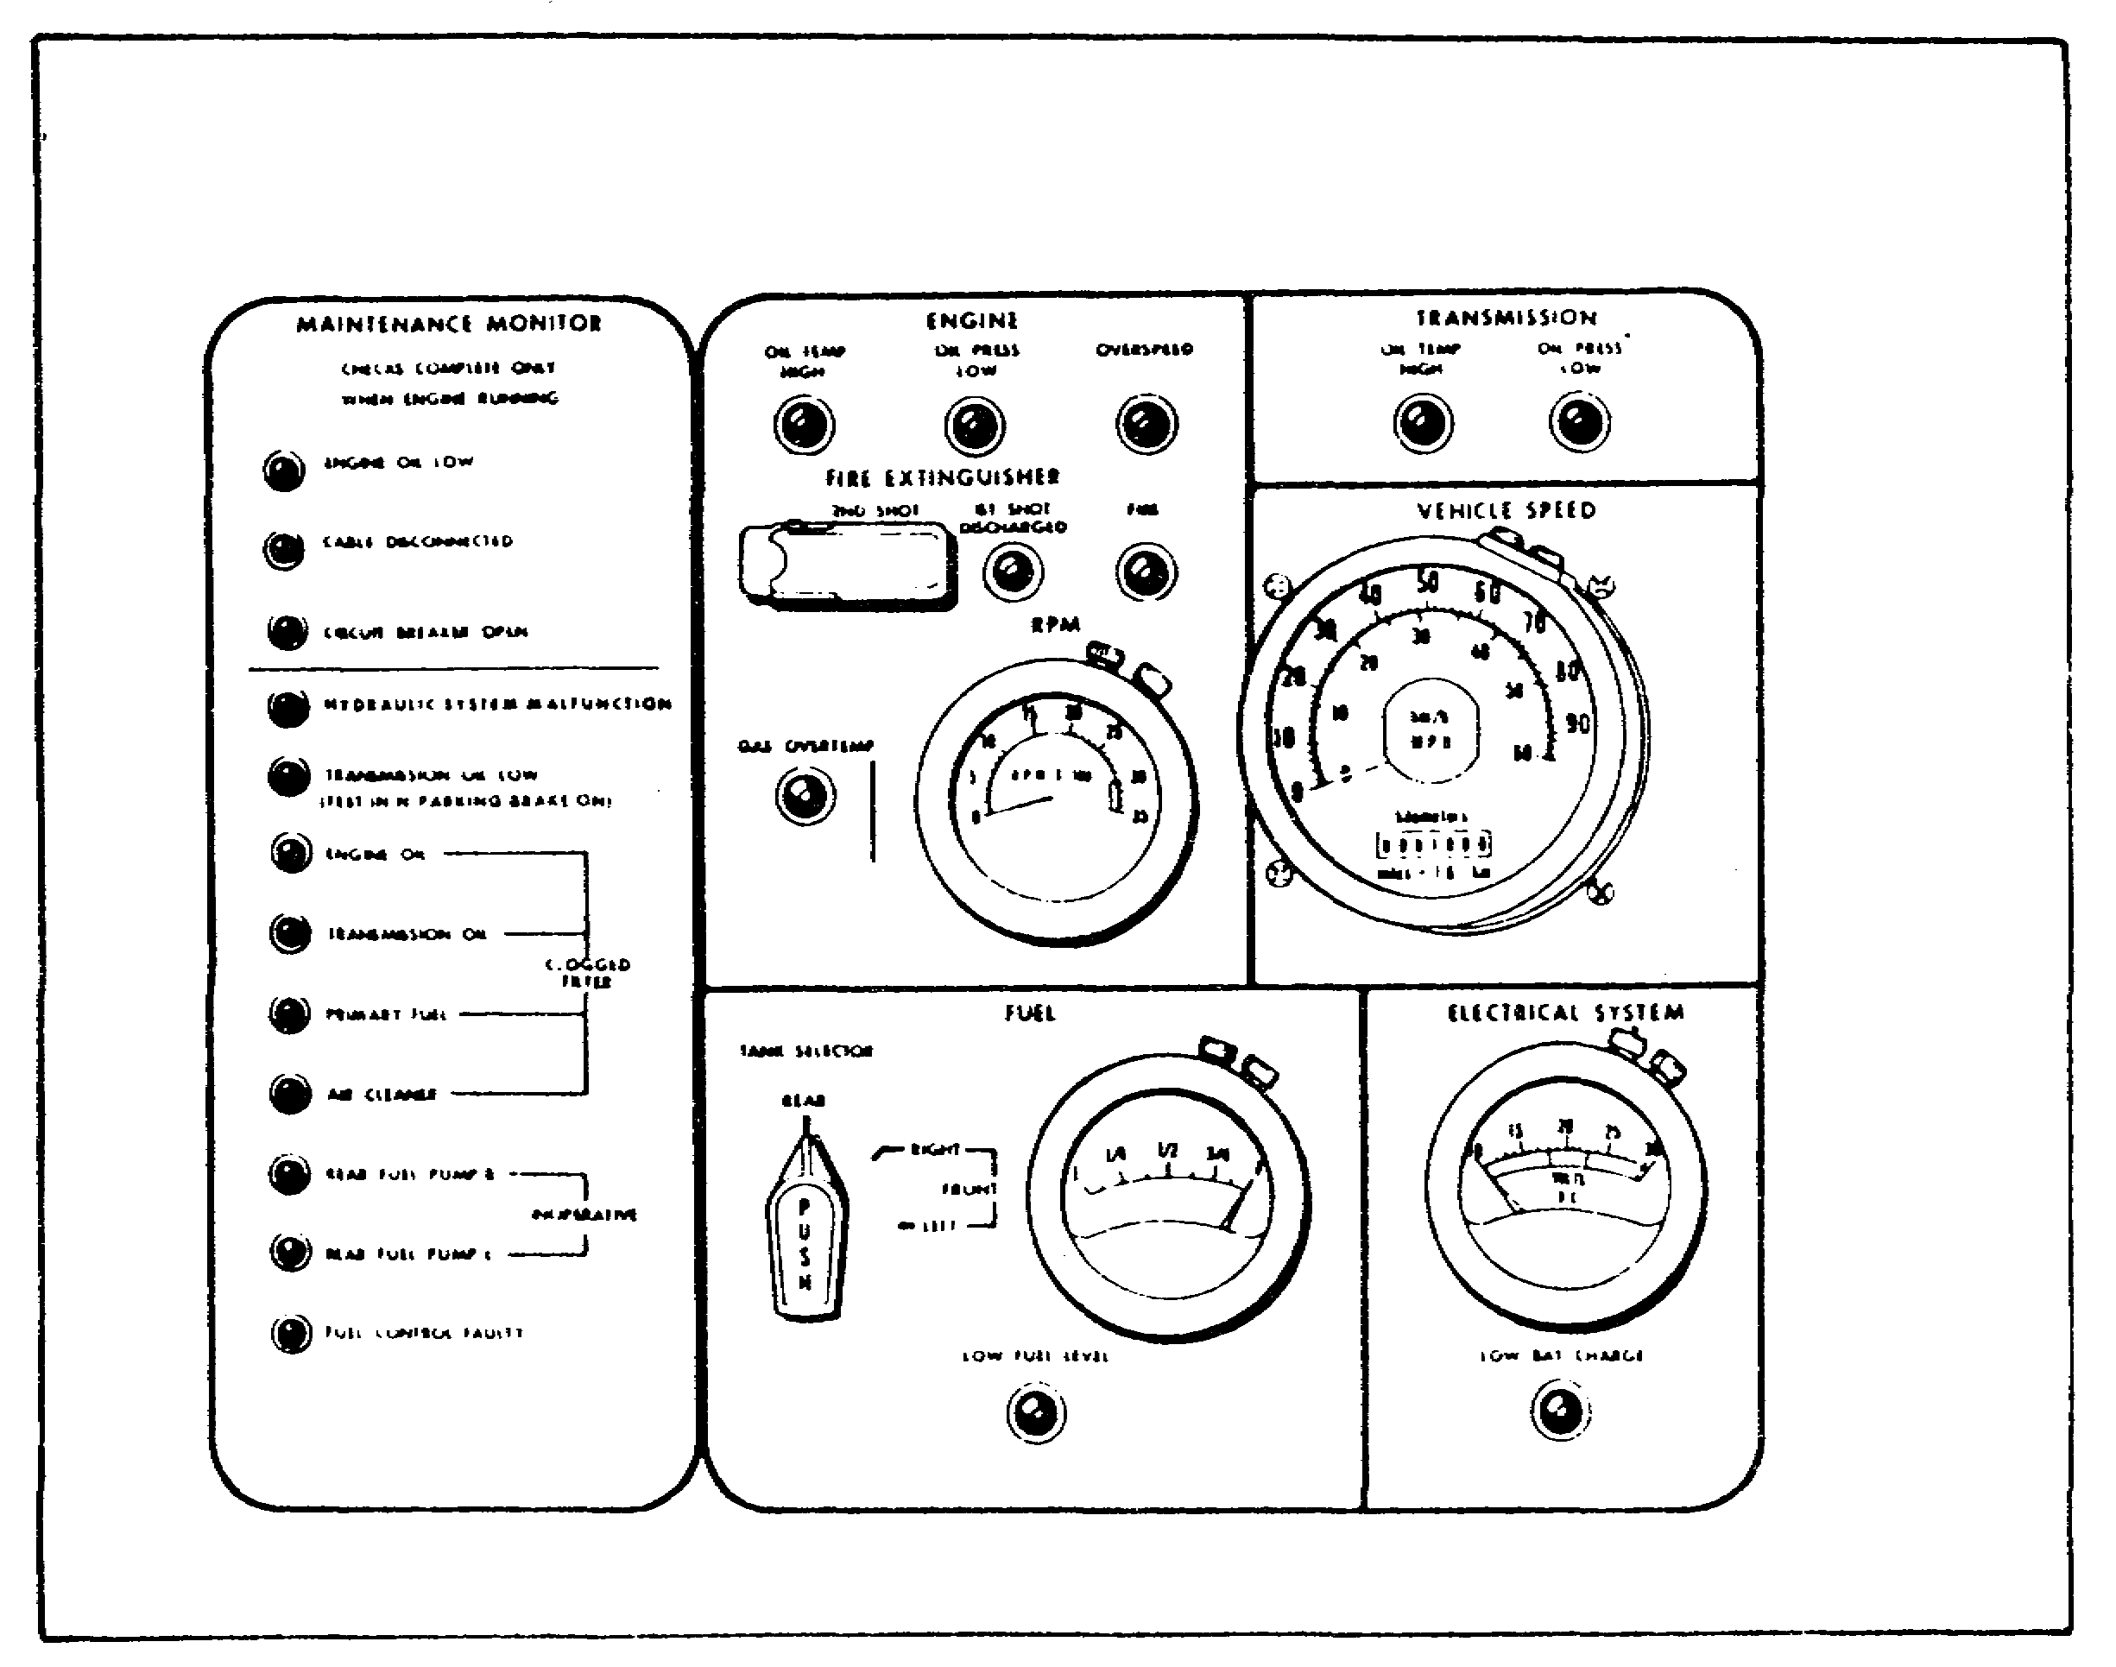
FIGURE 29. DRIVER'S INSTRUMENT PANEL.

37
PRINCIPLES M1 STARTING & CHARGE SYS - OD0476 - LESSON 3/TASK 1

The maintenance monitor section of the instrument pane] provides malfunction indications for 12 vehicle functions. These indicators allow the driver to monitor operations, including starting, overspeed and overtemperature protection, engine shutoff and output speed governing for normal idle, tactical idle, and maximum speed.

c. Electrical Disconnect Panel (EDP). The EDP enables the engine electrical wiring harnesses to be disconnected or connected at one central location to facilitate removal and installation of the powerpack. Provisions are also available for connecting the starter, alternator, transmission, and gas temperature harnesses.

d. Hull Distribution Box (HDB). The HDB contains seven circuit breakers (four manual and three automatic thermal reset), high current contactor and power relays and the necessary internal wiring and external connectors to control and carry the electrical power distribution box. The four manual switch type breakers protect the fire detection suppression, master power control, voltage regulator, and personnel heater circuits.

e. Hull Networks Box (HNB). The HNB contains four power contactors and relays, printed circuit boards with relay switching logic, an auto reset circuit breaker, termination junctions, external connectors and the necessary wiring to route the electrical circuits through the box. An external panel mounted internal to the box contains provisions for 30 switch type circuit breakers. A digital display engine operating time meter, and auxiliary power outlet and two test connectors are provided on the external surface of the box. The test connectors are used for diagnostic testing.

3. Engine Start Sequence (figure 30, on the following page)

a. The engine is started using the engine PUSH TO START button on the driver's master panel. The VEHICLE MASTER POWER must be ON and the transmission shift control set to NEUTRAL. The following is the sequence of events that occur during a successful start sequence.

38
PRINCIPLES M1 STARTING & CHARGE SYS - OD0476 - LESSON 3/TASK 1

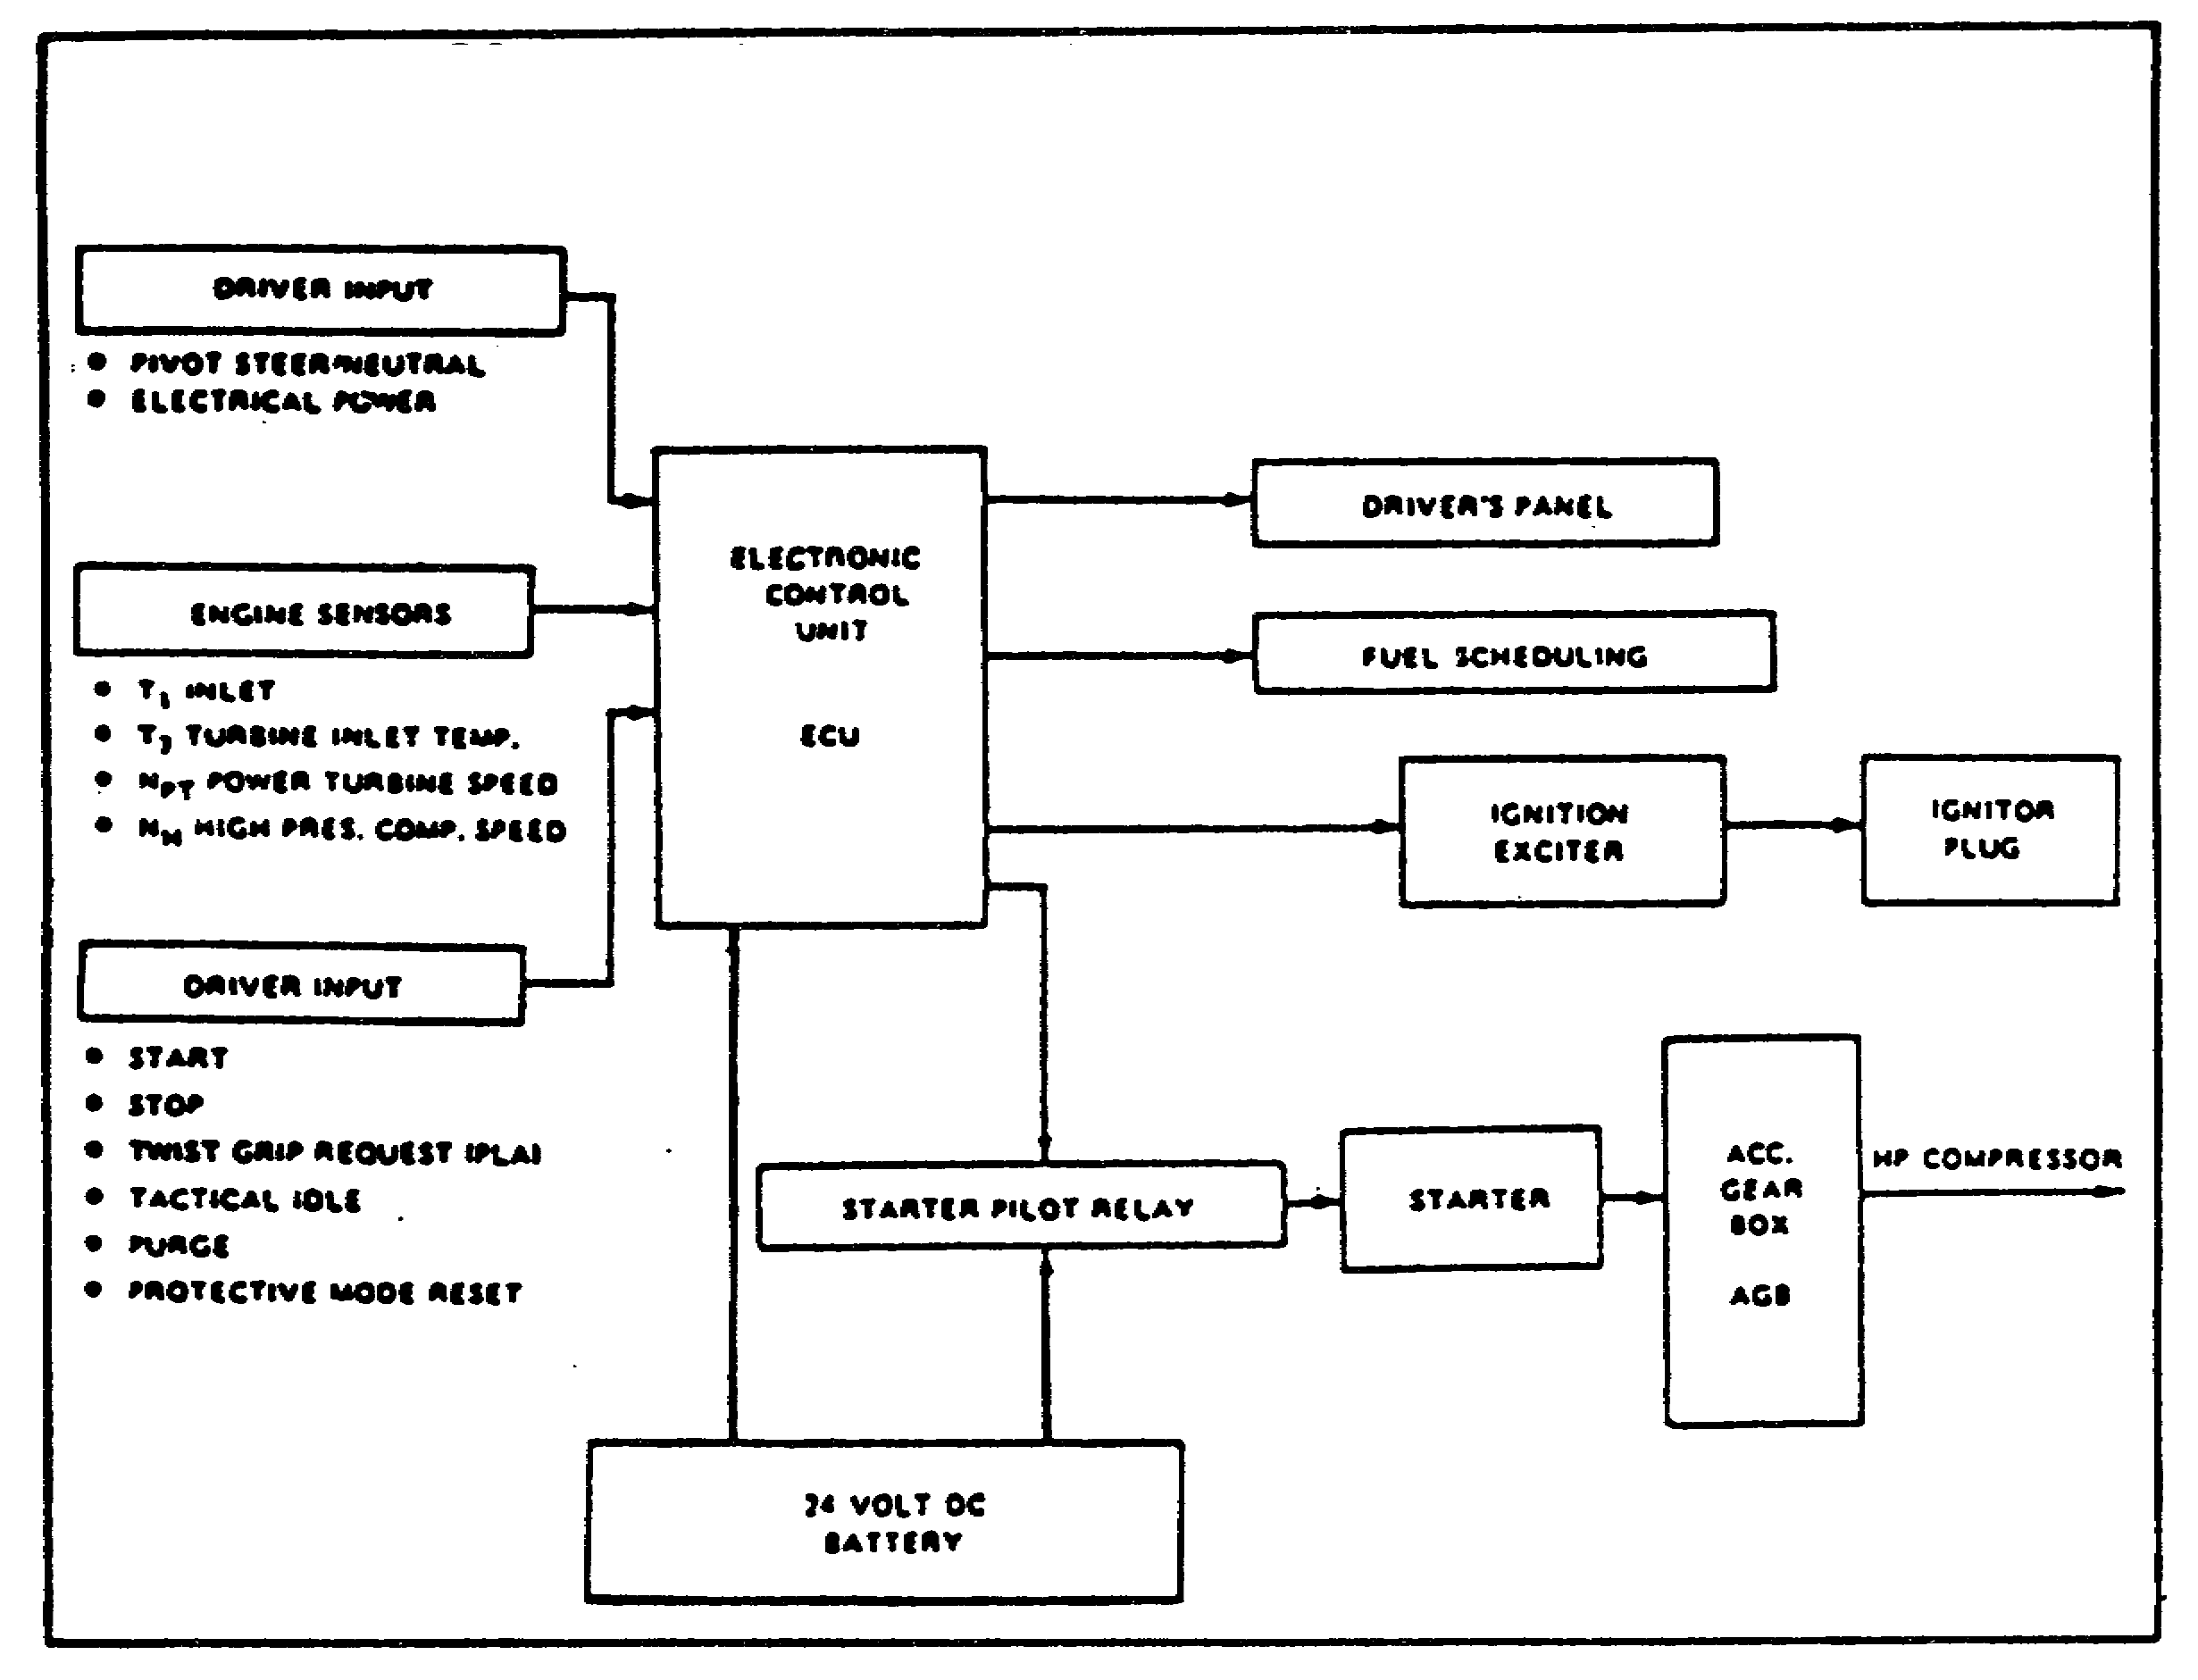
FIGURE 30. BLOCK DIAGRAM -ENGINE START SEQUENCE.

Depression and release of the PUSH TO START button, complete the circuit for the engine electronic control unit (ECU), which initiates the following sequence:

(1) 24 vdc is supplied to the starter solenoid.

(2) Rotational energy from the starter is transferred to the high pressure (HP) compressor to crank the engine.

(3) The ignition exciter provides both high voltage and an exceptionally hot spark. (24 vdc is applied to the igniter exciter, which generates 12,000 vdc at 3 to 30 sparks per second.)

(4) Voltage is fed, through the lead assembly, to the igniter plug.

(5) At five percent of high pressure compressor speed, the main fuel valve is energized by the electronic control unit and starting fuel is metered.

39
PRINCIPLES M1 STARTING & CHARGE SYS - OD0476 - LESSON 3/TASK 1

b. Simultaneously, voltage is applied to the starter pilot relay, completing a circuit to the starter solenoid which, in turn, energizes the starter. As the starter turns, the gears of the accessory gearbox module cranks the high pressure compressor to start the engine.

c. The igniter plug ignites the fuel/air mixture.

d. The electronic control unit monitors HP compressor speed during the start sequence.

e. At 55 percent of HP compressor speed, the start sequence is completed and the ECU removes electrical power from the starter and ignition exciter.

4. Engine Start Circuitry

a. Engine Started. When the PUSH TO START switch is pressed and released, 24 vdc from bus 2W3-1 is applied to the start circuitry through the gauged PUSH TO START switch, performing two functions (figure 31, on the following page). The first is to apply a start signal to the ECU. The second energizes relay HNB K6, HNB K4 and the set side of latching relay HNB A2K1. Normally, open contacts of relay K4 and A2K1 close and lock up K4 and K6 from bus 2W3-1 through CR8. Normally, open contacts of K4 close and provide 24 vdc operating voltage to the ECU from bus 2W3-1, and 24 vdc to engine bus 2W4 through CB9. Since A2K1 is a latching relay, its contacts remain closed even though 24 vdc has been removed from the set side of the coil.

(1) When the start signal is applied to the ECU, the ECU energizes the main and backup fuel valve to the closed position, energizes HNB A2K2 and A2K3 relays, and applies 24 vdc to the starter pilot relay and ignition exciter. 24 vdc to the pilot relay energizes the starter solenoid, causing rotational energy from the starter to be transferred to the high pressure compressor to crank the engine. 24 vdc to the ignition exciter generates 12,000 vdc to the igniter plug.

40
PRINCIPLES M1 STARTING & CHARGE SYS - OD0476 - LESSON 3/TASK 1

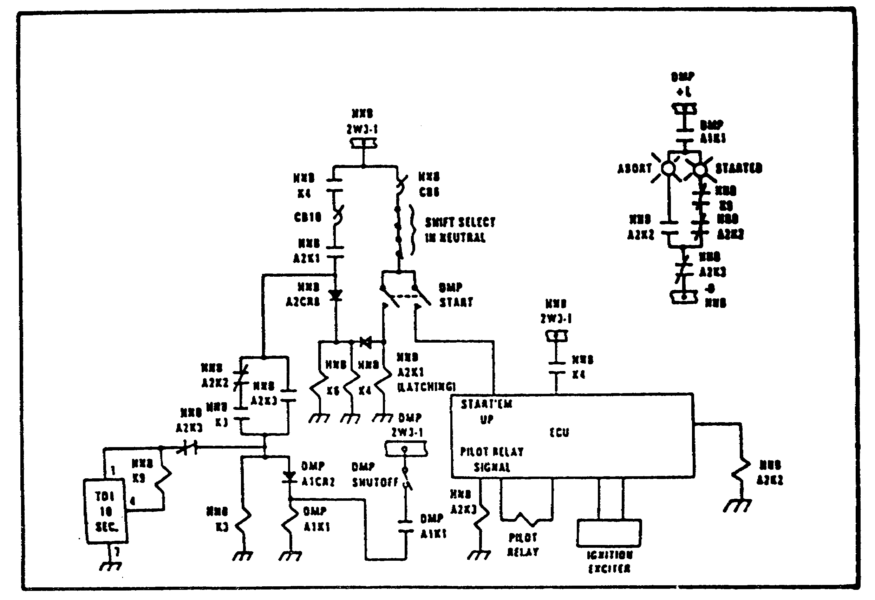
FIGURE 31. M1 TANK STARTER CIRCUITRY.

(2) When HNB A2K3 energizes, normally open contacts A2K3 close, providing 24 vdc from bus 2W3-1 to energize relay HNB 13 and DMP A1K1 through closed contacts of K4, closed contacts A2K1 and CB10. Energizing HNB K3 turns on the engine fuel pumps. Relay DMP AK11 locks up through contacts A1K and the ENGINE SHUTOFF switch from bus SW3-1-1.

(3) At five percent of high pressure compressor speed, the ECU energizes the main fuel valve and fuel is metered to the engine, igniting the igniter plug. At the same time, HNB A2K2 deenergizes and its normally closed contacts (in series with contacts HNB K3) close, providing a lock up path for relay HNB K3.

(4) At 55 percent of high pressure compressor speed, the ECU removes electrical power from the starter, ignition exciter, and relay HNB A2K3. When power is removed from relay A2K3, normally closed contacts of A2K3 close, applying 24 vdc from bus 2W3-1 through the lock up circuit of contacts A2K2 and K3, energizing the

41
PRINCIPLES M1 STARTING & CHARGE SYS - OD0476 - LESSON 3/TASK 1

10 second time delay TD1. At the same time, A2K3 normally closed contacts close, turning on the STARTED light. After 10 seconds, TD1 times out and allows HNB K9 to be energized. When K9 energizes, HNB K9 normally closed contacts open, turning off the STARTED light, and normally open contacts close, energizing the TDL-1 bus from bus 2W4.

(5) It should be noted that 2W4 and TDL-1 buses are used to provide power for circuitry related to the driver's indicators.

b. Steady State Operation. By means of three electrical harnesses (maintenance indicator, thermocouple, and fuel management harness) the ECU continuously monitors oil temperature, oil pressure, oil filter condition, engine inlet temperature, driver demand, inlet temperature, and fuel flow.

c. Engine Fails to Start.

(1) If the engine fails to start (566 percent of high pressure compressor speed is not reached) within 60 seconds after pressing the PUSH TO START switch, ECU:

o Deenergizes ignition exciter and cuts off ignition.

o Deenergizes pilot starter relay signal which stops engine cranking.

o Energizes fuel cutoff solenoid and stops fuel feed to the engine.

o Energizes main fuel shutoff relay A2K3 in the hull networks box.

(2) When relay A2K3 energizes and A2K3 deenergizes, 24 vdc is removed from relay HNB K3 which, in turn, shuts off the fuel pumps and turns on the ABORT light on the driver's waster panel.

5. Engine Shutdown Circuit

Engine shutdown can occur one of four ways:

o Automatic abort on start;

o Using the SHUTOFF switch on the driver's master panel;

42
PRINCIPLES M1 STARTING & CHARGE SYS - OD0476 - LESSON 3/TASK 1

o Using the 2nd SHOT FIRE EXTINGUISHER switch on the driver's instrument panel, or

o An automatic abort after the engine has started.

a. Abort on Start. Circuitry description for abort on start is the same as "engine fails to start." (Refer to para. 4c above.)

b. Engine Shutdown using SHUTOFF Switch on Driver's Master Panel, (figure 32).

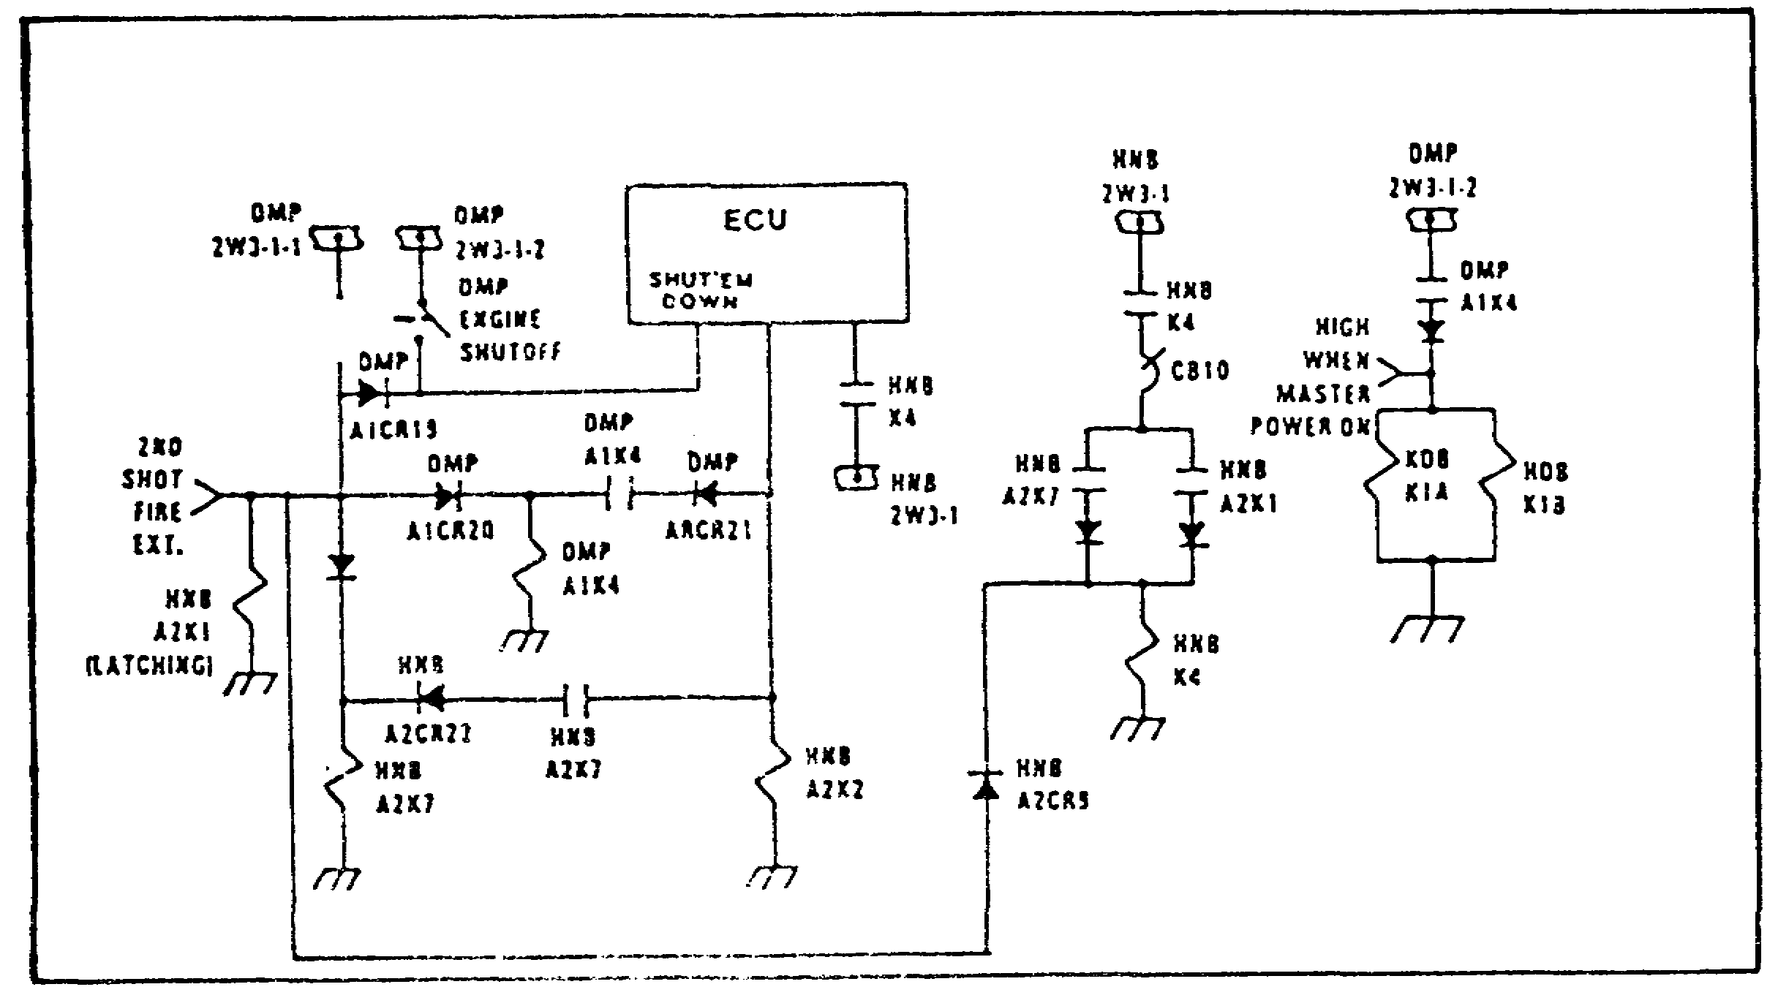
FIGURE 32. ENGINE SHUTDOWN.

(1) When the SHUTOFF switch is placed in the down position and released, 24 vdc is applied to the shutoff circuitry through the gauged SHUTOFF switch and performs two functions. One function applies a shutoff signal to the ECU. The other, energizes relays HNB A2K7, DMP A1K4 and the reset side of latching relay HNB A2K1. When the reset side of latching relay A2K1 is energized, it removes the lockup path for relay HNB K4 and deenergizes the lockup path for the fuel pump relay circuit of HNB K3. When relay KNB K3 deenergizes, the fuel pumps shut off. Even though the lockup path for K4 is removed, K4 remains locked up through the SHUTOFF switch until HNB A2K7 normally open contacts close. K4 must remain energized to keep 24 vdc power applied to the ECU (operating voltage) until the engine shutdown is complete.

43
PRINCIPLES M1 STARTING & CHARGE SYS - OD0476 - LESSON 3/TASK 1

(2) When relay DMP A1K4 energizes, normally open contacts of A1K4 close, keeping master power relay HNB K1A and K12B energized. This is to ensure that master power (2W3 bus) remains energized and is available to the ECU for the complete shutdown sequence in the event power is inadvertently turned off from the driver's or commander's station.

(3) When the shutoff signal is applied to the ECU, the ECU applies a 24 vdc signal to relay HNB A2K2 and locks up relay DMP A1K4 through its own contacts. It also locks up relay HNB A2K7 through its own contacts and sends a 24 vdc signal to the fuel handling unit on the engine to energize the fuel cutoff valve. The 24 vdc will be applied to the relays and valve for 30 to 60 seconds. This will allow the engine sufficient time to rundown. After the 30-60 second time period has elapsed, the ECU shutdown signal will be removed, deenergizing HNB relays. A2K2, A2K7, and K4 and removing 24 vdc operating voltage from the ECU. All start circuitry is now back to its original deenergized state, ready for another start sequence. Removing the ECU shutdown signal also removes power from relay DMP A1K4. Relay DMP A1K4 deenergizes and master power control is returned to the driver's and commander's stations.

(4) The engine ABORT light does not come on when shutting down the engine by using the SHUTOFF switch because closing the switch removes power from relay DMP A1K1. Relay DMP A1K1 deenergizes and removes lamp power from the ABORT light.

6. STARTER ONLY Circuit

The STARTER ONLY switch, located on the driver's master panel, is used to purge engine air flow without having to start the engine. It disables both fuel and ignition circuits during cranking. It is a momentary switch which must be held in the up position during the cranking cycle. When the STARTER ONLY ENGAGED switch is closed, it provides 24 vdc to relay HNB K4 and a purge signal to the ECU (figure 33). Energizing relay K4 closes normally open contacts of K4, applying 24 vdc operating voltage to the ECU. Applying a purge signal enables the ECU to generate a 24 vdc signal to energize the pilot relay which, in turn, energizes the starter solenoid from

44
PRINCIPLES M1 STARTING & CHARGE SYS - OD0476 - LESSON 3/TASK 1

battery voltage. When the solenoid energizes, the engine cranks. At the same time, the ECU sends a 24 vdc signal to the engine, closing the main fuel valve to the engine.

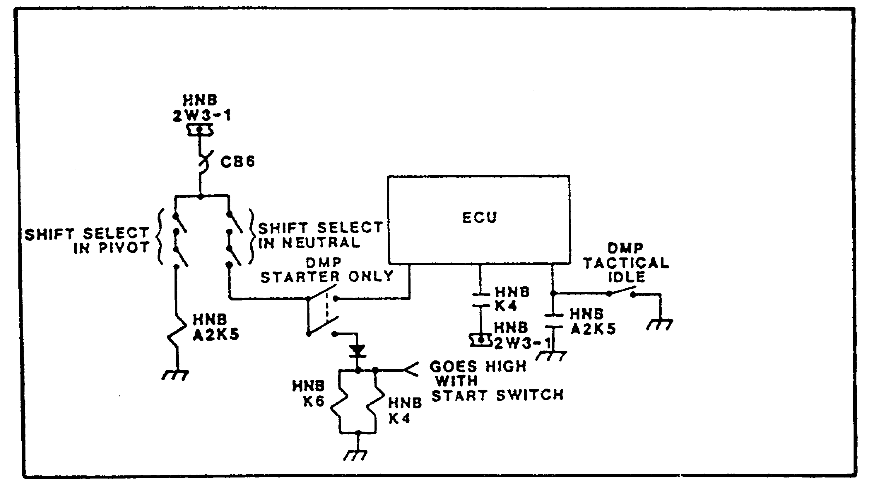
FIGURE 33. ENGINE SPECIAL FUNCTION LOGIC.

7. Engine Operation Warnings and Cautions

The following WARNINGS and CAUTIONS must be observed when starting and operating the engine:

WARNINGS

Do not start the engine unless the tank commander has a clear view of the rear of the tank. The tank commander must warn personnel to stay away from the rear of the tank. Personnel behind the tank could be burned by engine exhaust.

Make sure steer-throttle control is centered before starting engine. If steer-throttle control is turned left or right, tank will pivot when PUSH TO START button is pressed and might injure someone.

Do not leave driver's station after engine is started.

45
PRINCIPLES M1 STARTING & CHARGE SYS - OD0476 - LESSON 3/TASK 1

CAUTIONS

Allow engine to idle for two minutes before shutdown or engine may be damaged.

Do not shut off vehicle master power from driver's or commander's station until engine has been shut down, engine has stopped turning, and ENGINE SHUTOFF switch is back at up position or engine may be damaged.

Make sure TURRET POWER switch on commander's panel has been set to OFF. Damage to electrical components can result from using engine starter when turret power is on.

46
PRINCIPLES M1 STARTING & CHARGE SYS - OD0476 - LESSON 3/TASK 2

LESSON 3

OPERATION OF THE M1 TANK STARTING
AND CHARGING SYSTEMS

TASK 2. Describe the operation of the M1 tank charging system.

CONDITIONS

Within a self-study environment and given the subcourse text, without assistance.

STANDARDS

Within one hour REFERENCES No supplementary references are needed for this task.

1. Introduction

This task will discuss the operation of the M1 tank charging system components.

a. Alternator Circuitry.

(1) The alternator design currently employed in the M1 vehicle requires no slip rings or brushes. This is accomplished through the use of a stationary armature (output winding). The end result is that radio frequency interference noise (RIF), slipring and brush wear, and undesirable voltgage drops have been eliminated.

(2) The main rotating field is the only portion of the alternator that actually rotates. All other parts are stationary.

(3) The exciter armature rotates within the field generated by the exciter dc field, producing an ac voltage across the rotating rectifier assembly. The rotating rectifier assembly produces a dc output voltage, causing its magnetic field to cut across the

47
PRINCIPLES M1 STARTING & CHARGE SYS - OD0476 - LESSON 3/TASK 2

stationary main alternator output winding which, in turn, produces an ac voltage at the output rectifier. This ac voltage is then rectified by the output rectifier assembly, producing a dc output voltage at points B and E (figure 34); B being plus (+) and E being minus (-). In summary, the alternator follows a sequence going from a magnetic field to an ac voltage, to a do voltage, to a rotating magnetic field, to a stationary ac voltage and finally to a rectified dc voltage as a final output. In essence, you have an alternator within an alternator.

(4) The current transformer is used to provide feedback current to the voltage regulator. It monitors ac current output. The ac current output signal is used by the voltage regulator to control the dc excitor field to maintain a regulated do output at B+ and
E-, as shown in figure 34.

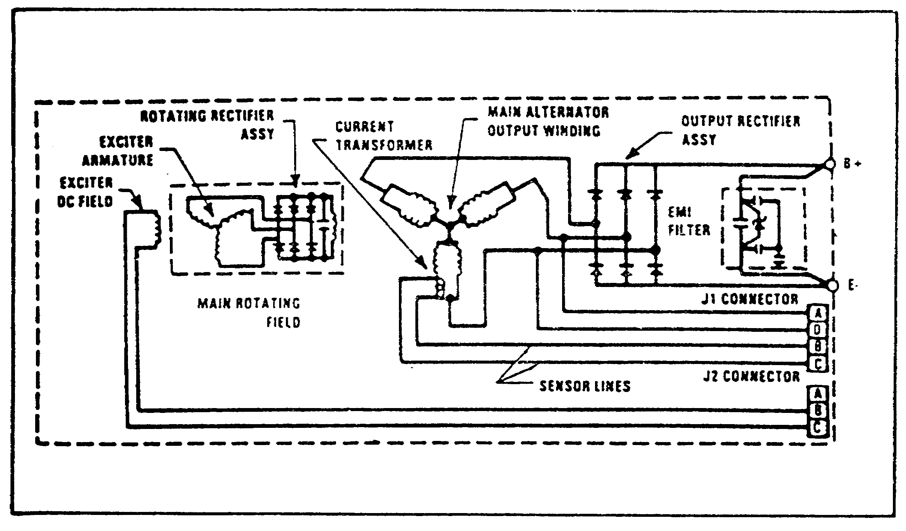
FIGURE 34. ALTERNATOR CIRCUITRY.

(5) Sensor lines are used by the regulator to protect the alternator from an overvoltage condition. If the sensor detects that the alternator output has exceeded 32 vdc, the overvoltage circuitry of the regulator will deactivate the alternator's dc field winding, decreasing the alternator output to zero.

48
PRINCIPLES M1 STARTING & CHARGE SYS - OD0476 - LESSON 3/TASK 2

b. Voltage Regulator.

(1) Operation. The voltage regulator (VR) pass transistor is a series regulating device which acts like a variable resistor. It controls the amount of voltage across the dc exciter field winding in the alternator. When the current transformer in the alternator series current changes in the main alternator output winding, the changes are applied to the base of the series pass transistor. A low signal on the base allows the transistor to conduct more, decreasing the resistance across the transistor and increasing the voltage across the dc field winding. When this happens, the alternator output increases. The opposite occurs when a high signal is applied to the base. This circuit action, by the series pass transistor, regulates the dc output of the alternator (figure 35).

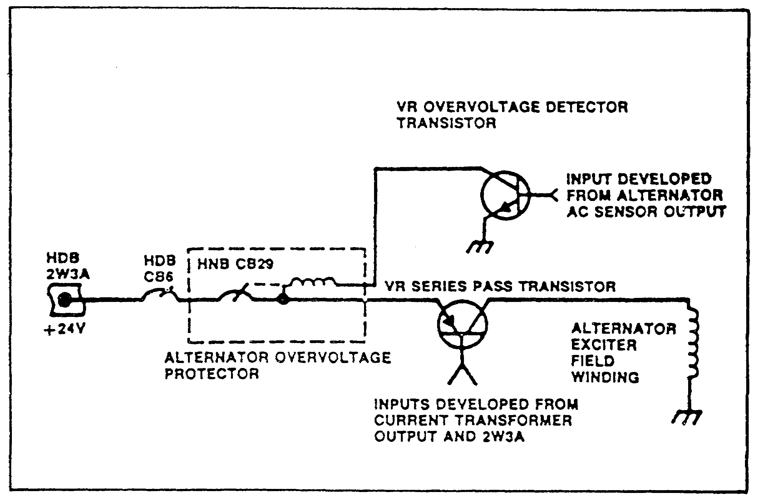
FIGURE 35. VOLTAGE REGULATOR ACTION.

(2) Overvoltage Condition. If an overvoltage condition exists at the output terminals of the alternator (32 to 34 vdc), the sensor lines of the output of the main alternator winding send a signal to the voltage regulator. The signal within the regulator's signal directs a corresponding voltage to the base of the overvoltage transistor.

49
PRINCIPLES M1 STARTING & CHARGE SYS - OD0476 - LESSON 3/TASK 2

The transistor conducts and provides a ground path for the overvoltage protector circuit breaker coil. The coil energizes from the 24 vdc bus 2W3A and opens circuit breaker CB29 in the hull notwork box (HNB). When CB29 opens, the dc voltage from bus 2W3A is removed from the alternator exciter field winding, decreasing the alternator output to zero (figure 35, on the previous page).

50
PRINCIPLES M1 STARTING & CHARGE SYS - OD0476 - LESSON 3/PE 3

PRACTICAL EXERCISE 3

1. Instructions

Read the scenario and respond to the requirement that follows.

2. Scenario

It is 0430 hours, Friday, 13 January, and you are at home having a nightmare about the bills you ran up during the Christmas holiday. Suddenly, the phone rings with the Company CQ informing you that you have been selected to participate in REFORGER 86. In your present position, as 263S40 instructing M1 tank electrical systems at Aberdeen Proving Ground, the powers to be have decided you are just the man to evaluate the maintenance capabilities of M1 units assigned in Germany during this training exercise.

3. Situation

While on the C-141 to Germany, you decide to prepare a questionnaire dealing with the M1 starting and charging systems, to evaluate soldier proficiency.

Requirement

Below is a list of questions that you feel will adequately cover the operation of M1 starting and charging system components. You are now faced with creating an answer sheet for these questions.

1. Describe the primary function of the electronic control unit during the M1 starting sequence.

2. How many sparks per second does the ignition exciter produce?

3. Name the M1 gear reduction unit that performs actual engine cranking.

4. Identify the switch that must be placed ON, prior to pressing the PUSH TO START switch on the driver's master panel for M1 starting.

51
PRINCIPLES M1 STARTING & CHARGE SYS - OD0476 - LESSON 3/PE 3

5. At what percent of high pressure compressor speed will the fuel valve be energized by the electronic control unit?

6. Describe the electronic control unit (ECU) action if the engine fails to start within 60 seconds.

7. When should the STARTER ONLY switch be used?

8. As a WARNING, the steer-throttle control should be centered before starting the engine. What could happen if the steer-throttle was turned to the left or right?

9. The alternator design currently employed in the M1 tank requires no slip rings or brushes. What are three advantages of using this alternator design?

10. Name the electrical component that monitors AC current output in the alternator.

11. Name the M1 component that controls the amount of voltage across the dc exciter field winding.

52
PRINCIPLES M1 STARTING & CHARGE SYS - OD0476 - LESSON 3/PE 3

LESSON 3. PRACTICAL EXERCISE -ANSWERS

Requirement

1. Control the voltage going to the starter and ignition exciter

2. 3 to 30 sparks per second

3. Accessory gearbox (AGB)

4. VEHICLE MASTER POWER switch

5. Five percent

6. a. ECU deenergizes ignition exciter and cuts off ignition

b. ECU deenergizes pilot starter relay signal which stops engine cranking

c. ECU energizes fuel cutoff solenoid and stops fuel feed to the engine

d. ECU energizes main fuel shutoff relay A2K3 in the hull networks box

7. To purge engine air flow without having to start the engine

8. The tank could pivot when the PUSH TO START button was pressed, causing possible personnel injury

9. a. Radio frequency interference (RFI) is eliminated

b. Slip ring and alternator brush wear is eliminated

c. Undesirable voltage drops are eliminated

10. Current transformer

11. Voltage regulator pass transistor

53
PRINCIPLES M1 STARTING & CHARGE SYS - OD0476 - REFERENCES

REFERENCES

54
PRINCIPLES M1 STARTING & CHARGE SYS - OD0476 - REFERENCES

REFERENCES

The following documents were used as resource materials in developing this subcourse:

TM 9-2350-255-10-1
TM 9-8000

55

